

**American International University-Bangladesh**

Faculty of Science & Technology (CSE)

ADVANCE DATABASE MANAGEMENT SYSTEM

Summer 2024-25

Section: A

**Final Term Project Documentation**

**Swimming Pool Management System**

Supervised by

**JUENA AHMED NOSHIN**

|  |  |  |
| --- | --- | --- |
| **Group Members** | **ID** | **Contribution** |
| **MD. SAZZAD KHAN** | **22-49172-3** | **35% -** Normalization, Table Creation Using SQL, Data Insertion Using SQL, Basic PL/SQL, Advanced PL/SQL.Exception Handling both PL/SQL and Advanced PL/SQL |
| **MD KAIS RAFAT BIN RABBI KOMOL** | **23-52332-2** | **23% -** Introduction, Project Proposal, Schema Diagram, Conclusion |
| **ABHISAK DAS AMIT** | **22-49207-3** | **21% - User** Interface Planning, Code Implementation,User Interface Implementation using **C#** |
| **AVISHEK CHANDA PRATYAY** | **21-45489-3** | **21% -** Scenario Description, ER Diagram, Relational Algebra |

**Scenario Description**

The Swimming Pool Management System is designed to efficiently manage the activities, resources, and services offered by a swimming pool facility through an integrated approach. At the core of the system are the members, each identified by a unique MemberID, with complete profiles containing details such as name, email, phone, join date, membership type, and red status. Each member can make many bookings, but every booking is associated with one specific member, ensuring proper record-keeping. Similarly, a member can make multiple transactions, though each transaction belongs to a single member, maintaining a clear financial trail.

Members can reserve bookings for pool usage, attend events, or request training sessions. Trainersare also managed within the system, identified by TrainerID, with details such as name, phone, email, and specialty. Since members may require guided swimming sessions, a booking may include one trainers, while trainers themselves can be part of separate bookings, allowing flexible allocation of expertise in fitness training, swimming lessons, or rehabilitation. Pools themselves are uniquely identified by PoolID, with attributes like location and capacity. Each booking is linked to one pool, but a pool may be reserved in many different bookings over time. Likewise, events are scheduled in one specific pool, though the same pool can host multiple events, provided capacity limits are respected.

The central operation of the system revolves around the booking process, where each booking is identified by a BookingID and contains details of the member, trainer, and pool involved, along with scheduled dates and times. This ensures orderly management, prevents conflicts, and optimizes resource utilization. Events, such as competitions, training camps, or community activities, are also supported by the system. Each event has an EventID along with details like name, date, and time, and is scheduled for a particular pool. Since events can be attended by many members and each member may participate in multiple events, the system maintains a many-to-many relationship between members and events. In addition, events are supervised by staff, where one or more staff may manage an event, and each staff member can oversee multiple events, ensuring smooth execution.

Staff members themselves are tracked by StaffID, with details such as name, phone, email, and role. Each staff member holds exactly one role, but multiple staff members can share the same role, providing a structured workforce. Staff are responsible for managing events, maintaining pools, and supporting overall operations to assist members effectively.

The financial operations of the facility are integrated through transactions, where each transaction, identified by a TransactionID, records the date and amount paid by members for bookings or events. A member may carry out many transactions, and each transaction is linked to exactly one payment type.

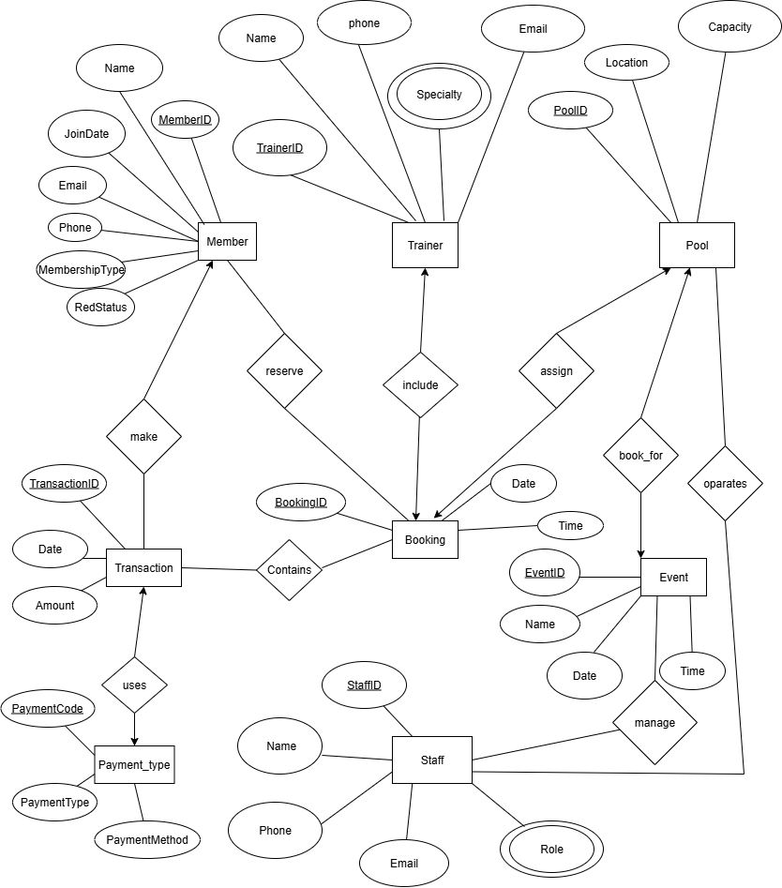**ER Diagram**

**Normalization**

**Relation: Reserve**

**UNF**

Reserve(MemberID, Name, Email, Phone, JoinDate, MembershipType, RedStatus, BookingID, BookingDate, BookingTime)

**1NF**

There is no multi-valued attribute. Relation already in 1NF.

1. MemberID, Name, Email, Phone, JoinDate, MembershipType, RedStatus, BookingID, BookingDate, BookingTime.

**2NF**

1. MemberID, Name, Email, Phone, JoinDate, MembershipType, RedStatus.
2. BookingID, BookingDate, BookingTime.

**3NF**

1. MemberID, Name, JoinDate.
2. Email, Phone, MembershipType, RedStatus.
3. BookingID, BookingDate, BookingTime.

**Table Creation**

1. MemberID, Name, JoinDate, **Email**.
2. Email, Phone, MembershipType, RedStatus.
3. BookingID, BookingDate, BookingTime.
4. **MemberID, BookingID.**

**Relation: Make**

**UNF**

Make(MemberID, Name, Email, Phone, JoinDate, MembershipType, RedStatus, TransactionID, TransactionDate, Amount)

**1NF**

There is no multi-valued attribute. Relation already in 1NF.

1. MemberID, Name, Email, Phone, JoinDate, MembershipType, RedStatus, TransactionID, TransactionDate, Amount.

**2NF**

1. MemberID, Name, Email, Phone, JoinDate, MembershipType, RedStatus.
2. TransactionID, TransactionDate, Amount.

**3NF**

1. MemberID, Name, JoinDate.
2. Email, Phone, MembershipType, RedStatus.
3. TransactionID, TransactionDate, Amount.

**Table Creation**

1. MemberID, Name, JoinDate, **Email**.
2. Email, Phone, MembershipType, RedStatus.
3. TransactionID, TransactionDate, Amount, **MemberID**.

**Relation: Uses**

**UNF**

Uses(TransactionID, TransactionDate, Amount, PaymentCode, PaymentType, PaymentMethod)

**1NF**

There is no multi-valued attribute. Relation already in 1NF.

1. TransactionID, TransactionDate, Amount, PaymentCode, PaymentType, PaymentMethod.

**2NF**

1. TransactionID, TransactionDate, Amount.
2. PaymentCode, PaymentType, PaymentMethod.

**3NF**

1. TransactionID, TransactionDate, Amount.
2. PaymentCode, PaymentType, PaymentMethod.

**Table Creation**

1. TransactionID, TransactionDate, Amount.
2. PaymentCode, PaymentType, PaymentMethod, **TransactionID**.

**Relation: Include**

**UNF**

Include(TrainerID, Name, Email, Phone, Specialty, BookingID, BookingDate, BookingTime)

**1NF**

Specialty is a multi-valued attribute.

1. TrainerID, Name, Email, Phone, Specialty, BookingID, BookingDate, BookingTime.
2. TrainerID, Specialty.

**2NF**

1. TrainerID, Name, Email, Phone, Specialty.
2. TrainerID, Specialty.
3. BookingID, BookingDate, BookingTime.

**3NF**

1. TrainerID, Name, Specialty.
2. TrainerID, Specialty.
3. Email, Phone.
4. BookingID, BookingDate, BookingTime.

**Table Creation**

1. TrainerID, Name, **Email**, **BookingID**.
2. **TrainerID**, Specialty.
3. Email, Phone.
4. BookingID, BookingDate, BookingTime.

**Relation: Assign**

**UNF**

Assign(PoolID, Location, Capacity, BookingID, BookingDate, BookingTime)

**1NF**

There is no multi-valued attribute. Relation already in 1NF.

1. PoolID, Location, Capacity, BookingID, BookingDate, BookingTime.

**2NF**

1. PoolID, Location, Capacity.
2. BookingID, BookingDate, BookingTime.

**3NF**

1. PoolID, Location, Capacity.
2. BookingID, BookingDate, BookingTime.

**Table Creation**

1. PoolID, Location, Capacity, **BookingID**.
2. BookingID, BookingDate, BookingTime.

**Relation: Book_for**

**UNF**

Book_for(PoolID, Location, Capacity, EventID, Name, EventDate, EventTime)

**1NF**

There is no multi-valued attribute. Relation already in 1NF.

1. PoolID, Location, Capacity, EventID, Name, EventDate, EventTime.

**2NF**

1. PoolID, Location, Capacity.
2. EventID, Name, EventDate, EventTime.

**3NF**

1. PoolID, Location, Capacity.
2. EventID, Name, EventDate, EventTime.

**Table Creation**

1. PoolID, Location, Capacity.
2. EventID, Name, EventDate, EventTime, **PoolID**.

**Relation: Operates**

**UNF**

Operates(PoolID, Location, Capacity, StaffID, Name, Email, Phone, Role)

**1NF**

Role is a multi-valued attribute.

1. PoolID, Location, Capacity, StaffID, Name, Email, Phone.
2. StaffID, Role**.**

**2NF**

1. PoolID, Location, Capacity.
2. StaffID, Name, Email, Phone.
3. StaffID, Role.

**3NF**

1. PoolID, Location, Capacity.
2. StaffID, Name.
3. Email, Phone.
4. StaffID, Role.

**Table Creation**

1. PoolID, Location, Capacity.
2. StaffID, Name, **Email**.
3. Email, Phone.
4. **PoolID, StaffID.**
5. **StaffID**, Role

**Relation: Manage**

**UNF**

Manage(EventID, Name, EventDate, EventTime, StaffID, Name, Email, Phone, Role)

**1NF**

Role is a multi-valued attribute.

1. EventID, Name, EventDate, EventTime, StaffID, Name, Email, Phone.
2. StaffID, Role**.**

**2NF**

1. EventID, Name, EventDate, EventTime.
2. StaffID, Name, Email, Phone.
3. StaffID, Role.

**3NF**

1. EventID, Name, EventDate, EventTime.
2. StaffID, Name.
3. Email, Phone.
4. StaffID, Role.

**Table Creation**

1. EventID, Name, EventDate, EventTime.
2. StaffID, Name, **Email**.
3. Email, Phone.
4. **EventID, StaffID.**
5. **StaffID**, Role

**Relation: Contains**

**UNF**

Contains(BookingID, BookingDate, BookingTime, TransactionID, TransactionDate, Amount)

**1NF**

There is no multi-valued attribute. Relation already in 1NF.

1. BookingID, BookingDate, BookingTime, TransactionID, Date, Amount.

**2NF**

1. BookingID, BookingDate, BookingTime.
2. TransactionID, TransactionDate, Amount.

**3NF**

1. BookingID, BookingDate, BookingTime.
2. TransactionID, TransactionDate, Amount.

**Table Creation**

1. BookingID, BookingDate, BookingTime.
2. TransactionID, TransactionDate, Amount.
3. **BookingID,** **TransactionID.**

**Final Table Creation:**

1. **MemberInfo:** MemberID, Name, JoinDate, **Email**.
2. **MemberContactInfo:** Email, Phone, MembershipType, RedStatus.
3. **BookingInfo:** BookingID, BookingDate, BookingTime.
4. **MemberBookingInfo:** **BookingID, MemberID.**
5. **TransactionInfo:** TransactionID, TransactionDate, Amount, **MemberID**.
6. **PaymentTypeInfo:** PaymentCode, PaymentType, PaymentMethod, **TransactionID**.
7. **TrainerInfo:** TrainerID, Name, **Email, BookingID**.
8. **TrainerSpecialtyInfo: TrainerID**, Specialty.
9. **TrainerContactInfo:** Email, Phone.
10. **PoolInfo:** PoolID, Location, Capacity, **BookingID**.
11. **EventInfo:** EventID, Name, EventDate, EventTime, **PoolID**.
12. **StaffInfo:** StaffID, Name, **Email**.
13. **StaffRoleInfo: StaffID**, Role.
14. **StaffContactInfo:** Email, Phone.
15. **PoolStaffInfo: PoolID, StaffID.**
16. **EventStaffInfo: EventID, StaffID.**
17. **BookingTransactionInfo: BookingID,** **TransactionID.**

**Schema Diagram**

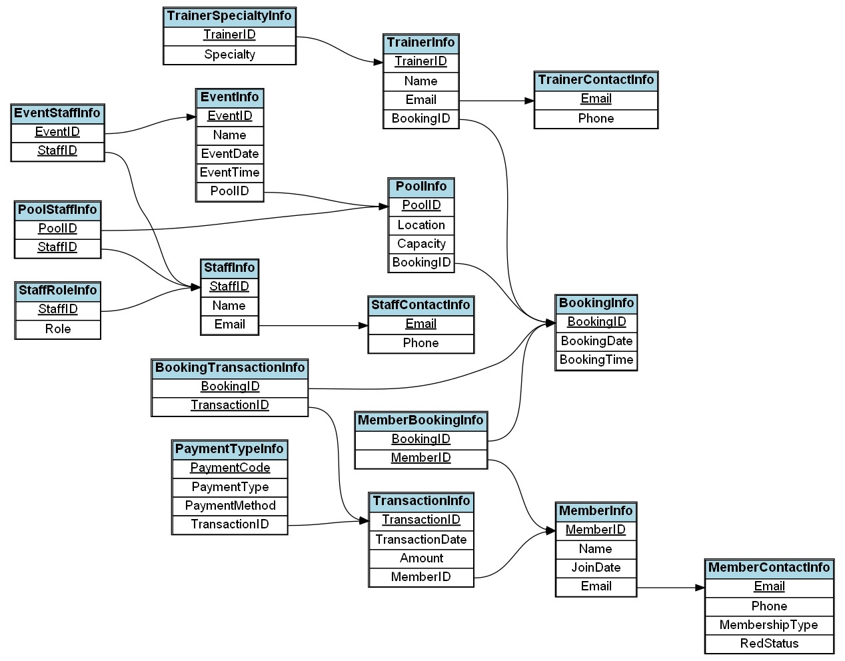

**Table Creation Using SQL**

1. **MemberInfo:**

CREATE TABLE MemberInfo (

MemberID NUMBER PRIMARY KEY NOT NULL,

Name VARCHAR2(100) NOT NULL,

JoinDate DATE DEFAULT SYSDATE NOT NULL,

Email VARCHAR2(100) NOT NULL,

CONSTRAINT fk_MemberInfo_Email FOREIGN KEY (Email)

REFERENCES MemberContactInfo (Email)

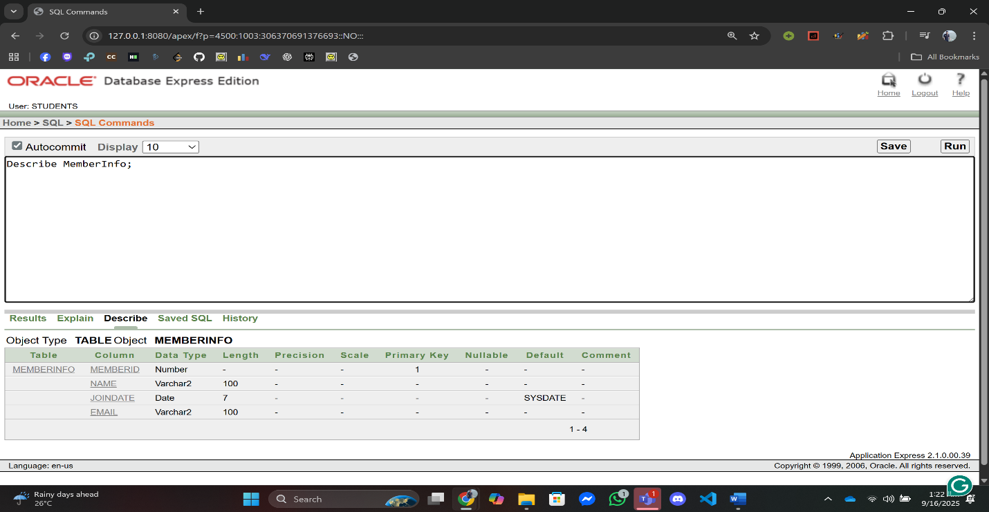);

1. **MemberContactInfo:**

CREATE TABLE MemberContactInfo (

Email VARCHAR2(100) PRIMARY KEY NOT NULL,

Phone VARCHAR2(15) NOT NULL,

MembershipType VARCHAR2(30) NOT NULL,

RedStatus VARCHAR2(3) DEFAULT 'NO' NOT NULL

);

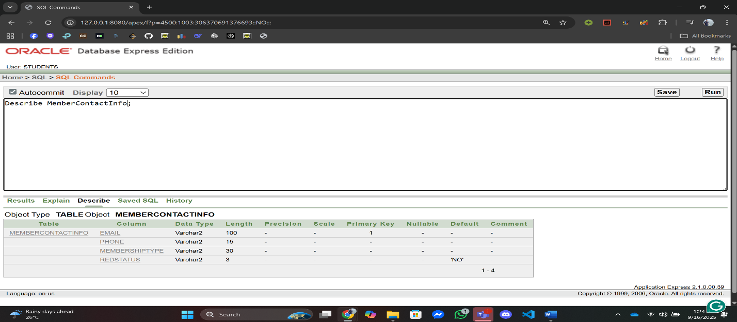

1. **BookingInfo**

CREATE TABLE BookingInfo (

BookingID NUMBER NOT NULL,

BookingDate DATE DEFAULT SYSDATE NOT NULL,

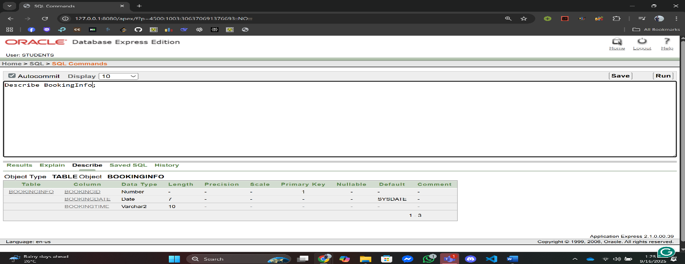 BookingTime VARCHAR2(10) DEFAULT TO_CHAR(SYSDATE, 'HH24:MI:SS') NOT NULL);

1. **MemberBookingInfo**

CREATE TABLE MemberBookingInfo (

BookingID NUMBER NOT NULL,

MemberID NUMBER NOT NULL,

PRIMARY KEY (BookingID, MemberID),

CONSTRAINT fk_MBI_BookingID FOREIGN KEY (BookingID) REFERENCES BookingInfo(BookingID),

CONSTRAINT fk_MBI_MemberID FOREIGN KEY (MemberID) REFERENCES MemberInfo(MemberID)

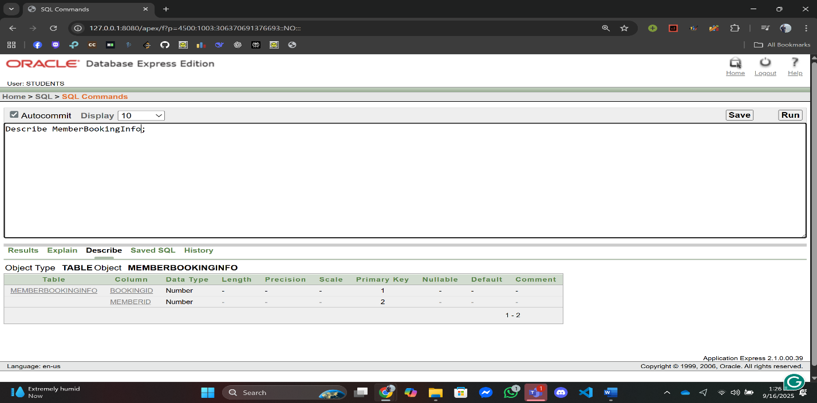);

1. **TransactionInfo**

CREATE TABLE TransactionInfo (

TransactionID NUMBER PRIMARY KEY NOT NULL,

TransactionDate DATE DEFAULT SYSDATE NOT NULL,

Amount NUMBER(10, 2) NOT NULL,

MemberID NUMBER NOT NULL,

CONSTRAINT fk_Transaction_MemberID FOREIGN KEY (MemberID) REFERENCES MemberInfo(MemberID));

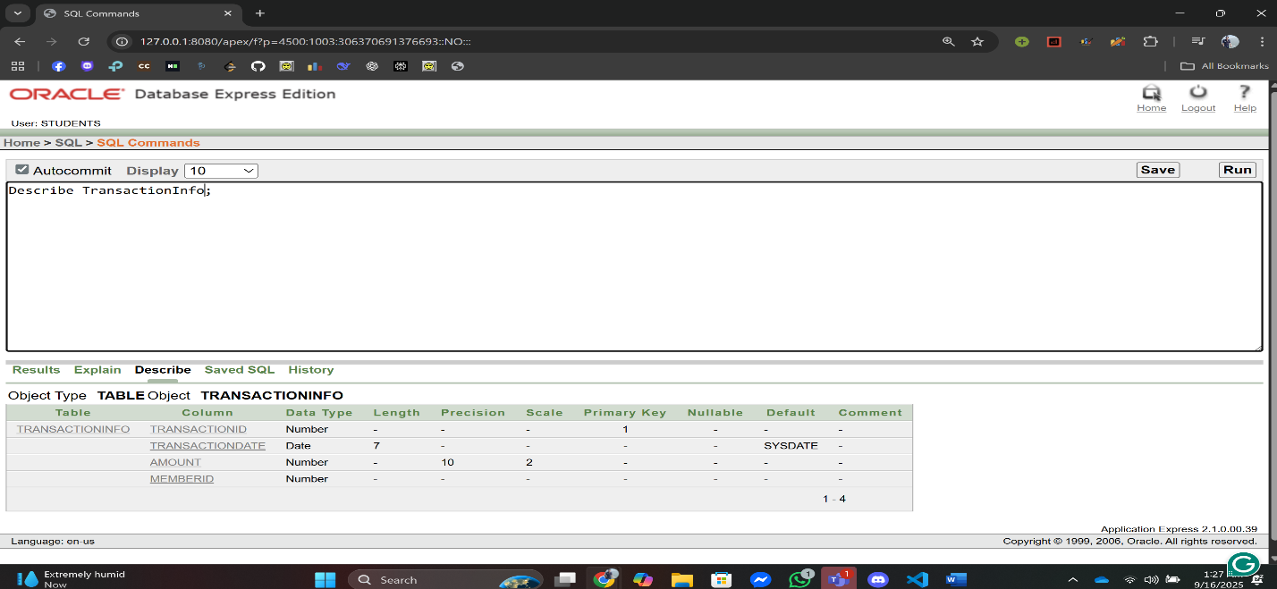

1. **PaymentTypeInfo:**

CREATE TABLE PaymentTypeInfo (

PaymentCode NUMBER PRIMARY KEY NOT NULL,

PaymentType VARCHAR2(50) NOT NULL,

PaymentMethod VARCHAR2(30) NOT NULL,

TransactionID NUMBER NOT NULL,

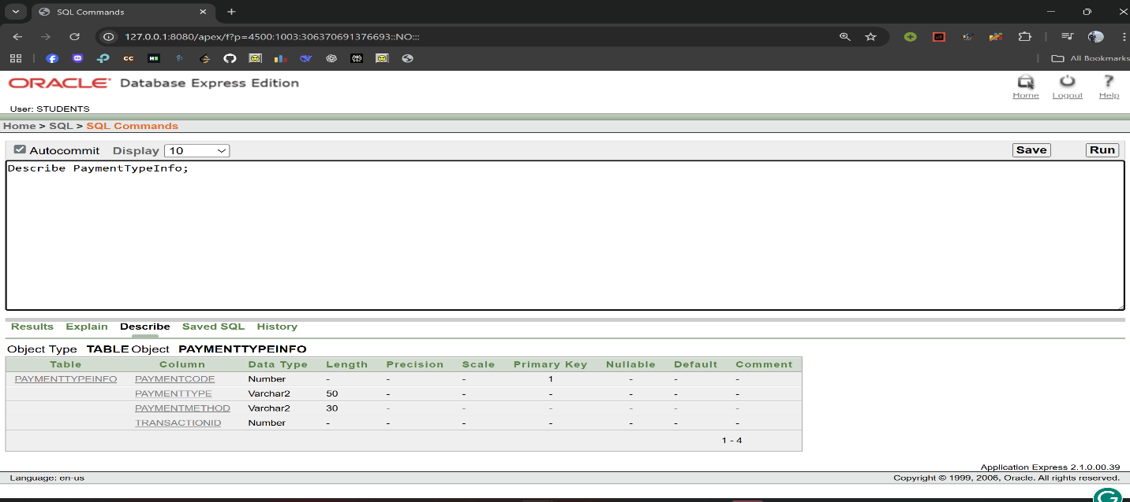 CONSTRAINT fk_PayType_TransactionID ));

1. **TrainerInfo:**

CREATE TABLE TrainerInfo (

TrainerID NUMBER PRIMARY KEY NOT NULL,

Name VARCHAR2(100) NOT NULL,

Email VARCHAR2(100) NOT NULL,

BookingID NUMBER NOT NULL,

CONSTRAINT fk_TrainerInfo_Email FOREIGN KEY (Email) REFERENCES TrainerContactInfo(Email),

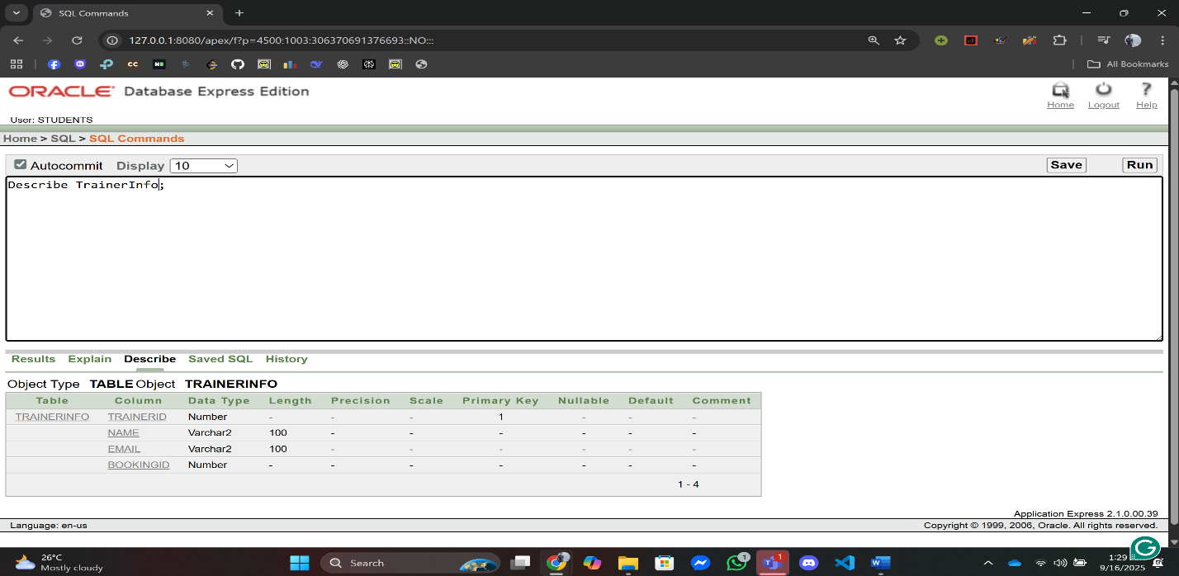 CONSTRAINT fk_TrainerInfo_BookingID FOREIGN KEY (BookingID) REFERENCES BookingInfo(BookingID));

1. **TrainerSpecialtyInfo:**

CREATE TABLE TrainerSpecialtyInfo (

TrainerID NUMBER NOT NULL,

Specialty VARCHAR2(50) NOT NULL,

CONSTRAINT fk_TrainerSpecialty_TrainerID FOREIGN KEY (TrainerID) REFERENCES TrainerInfo(TrainerID));

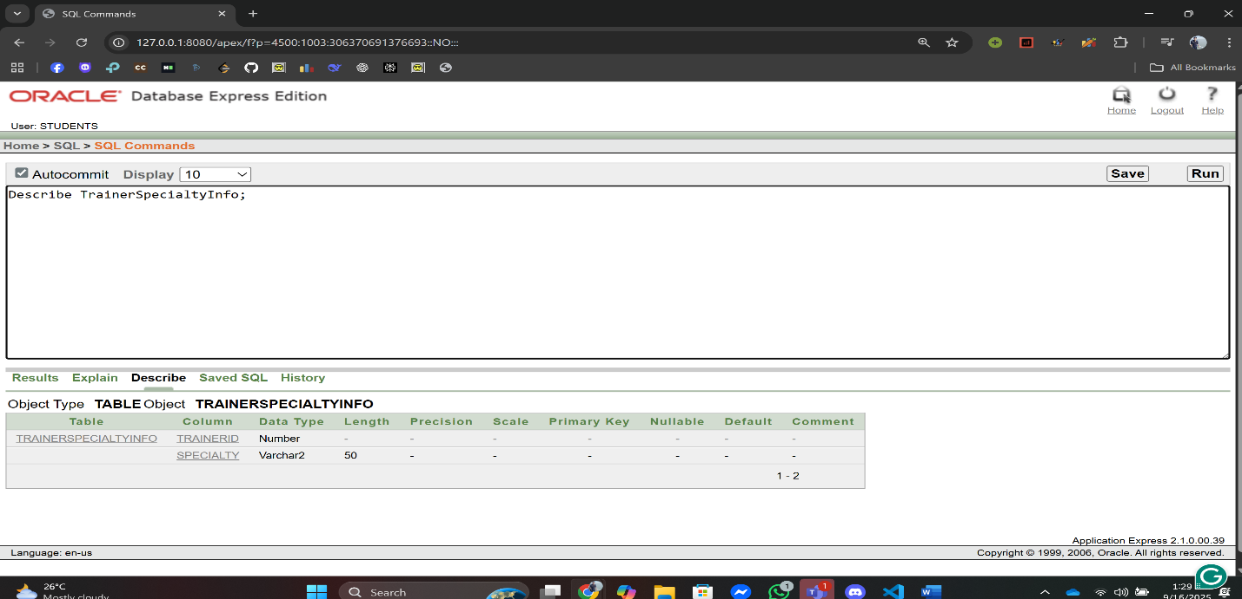

1. **TrainerContactInfo:**

CREATE TABLE TrainerContactInfo (

Email VARCHAR2(50) NOT NULL,

Phone VARCHAR2(15) NOT NULL,

CONSTRAINT pk_trainer_contact PRIMARY KEY (Email)

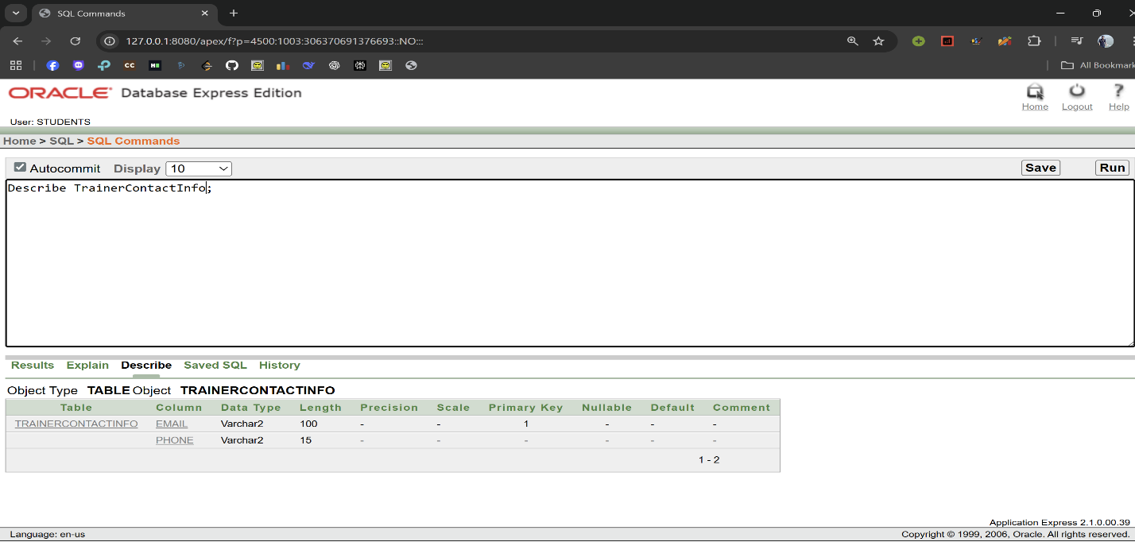);

1. **PoolInfo:**

CREATE TABLE PoolInfo (

PoolID NUMBER PRIMARY KEY NOT NULL,

Location VARCHAR2(100) NOT NULL,

Capacity NUMBER NOT NULL,

BookingID NUMBER NOT NULL,

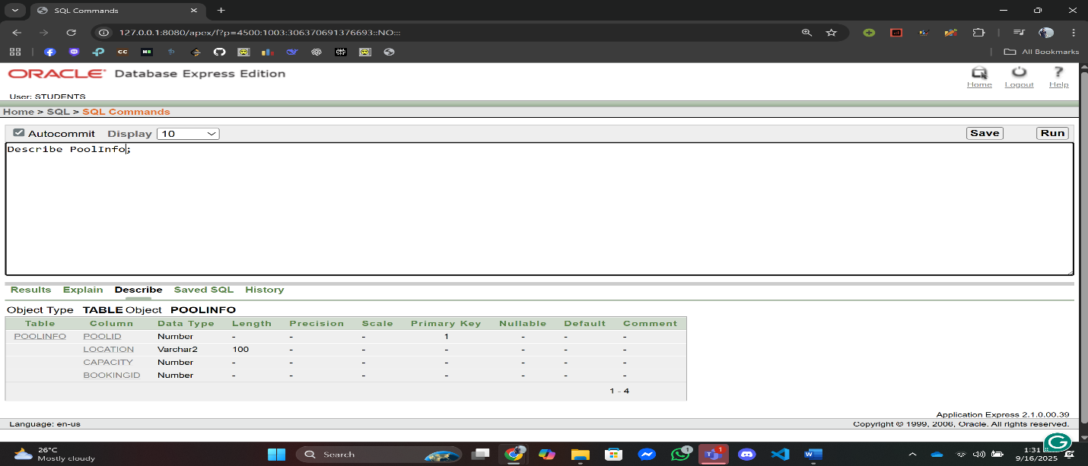 CONSTRAINT fk_Pool_BookingID FOREIGN KEY (BookingID) REFERENCES BookingInfo(BookingID));

1. **EventInfo:**

CREATE TABLE EventInfo (

EventID NUMBER PRIMARY KEY NOT NULL,

Name VARCHAR2(100) NOT NULL,

EventDate DATE DEFAULT SYSDATE NOT NULL,

EventTime VARCHAR2(10) NOT NULL,

PoolID NUMBER NOT NULL,

CONSTRAINT fk_Event_PoolID FOREIGN KEY (PoolID) REFERENCES PoolInfo(PoolID)

);

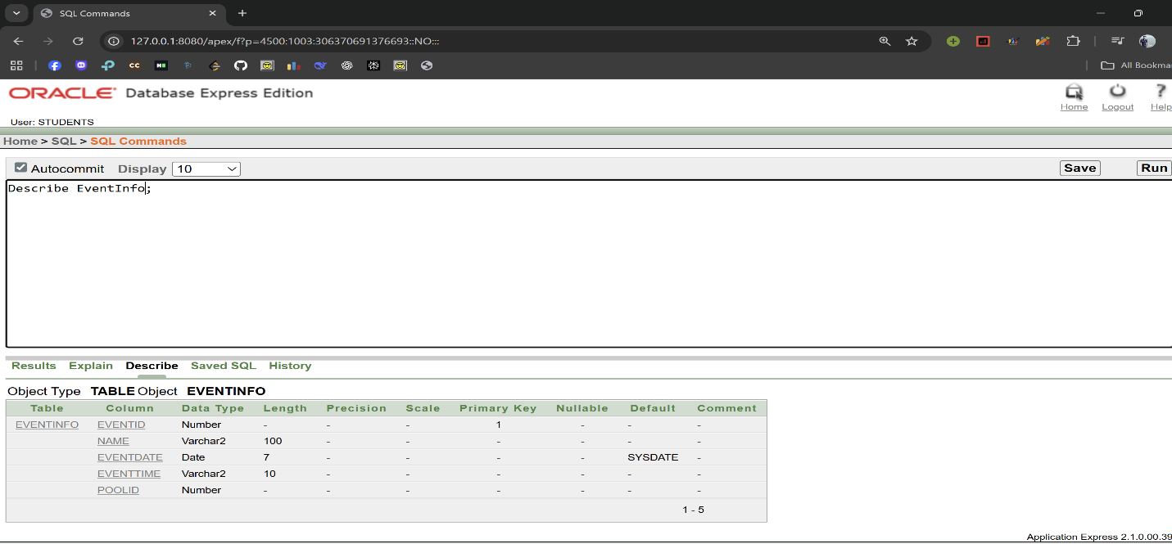

1. **StaffInfo:**

CREATE TABLE StaffInfo (

StaffID NUMBER PRIMARY KEY NOT NULL,

Name VARCHAR2(100) NOT NULL,

Email VARCHAR2(100) NOT NULL,

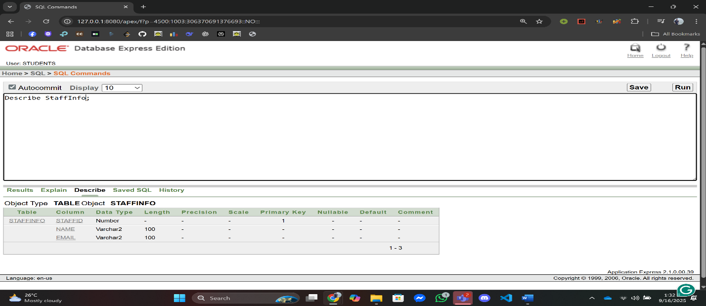 CONSTRAINT fk_StaffInfo_Email FOREIGN KEY (Email) REFERENCES StaffContactInfo(Email));

1. **StaffRoleInfo:**

CREATE TABLE StaffRoleInfo (

StaffID NUMBER NOT NULL,

Role VARCHAR2(50) NOT NULL,

CONSTRAINT fk_StaffRole_StaffID FOREIGN KEY (StaffID) REFERENCES StaffInfo(StaffID)

);

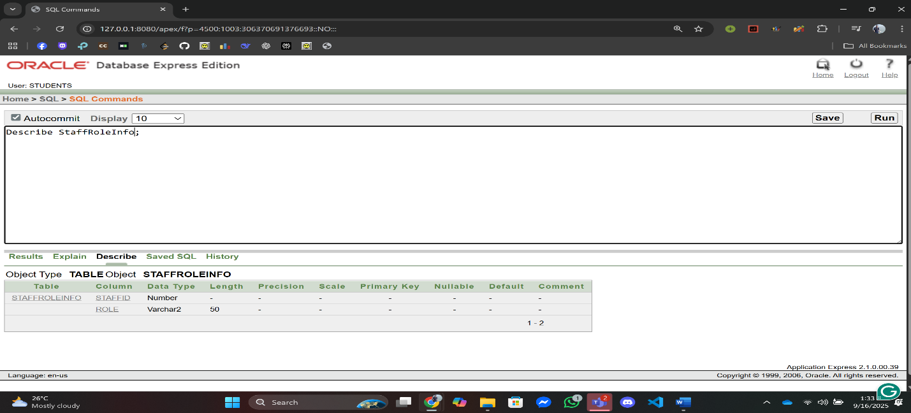

1. **StaffContactInfo:**

CREATE TABLE StaffContactInfo (

Email VARCHAR2(50) NOT NULL,

Phone VARCHAR2(15) NOT NULL,

CONSTRAINT pk_staff_contact PRIMARY KEY (Email)

);

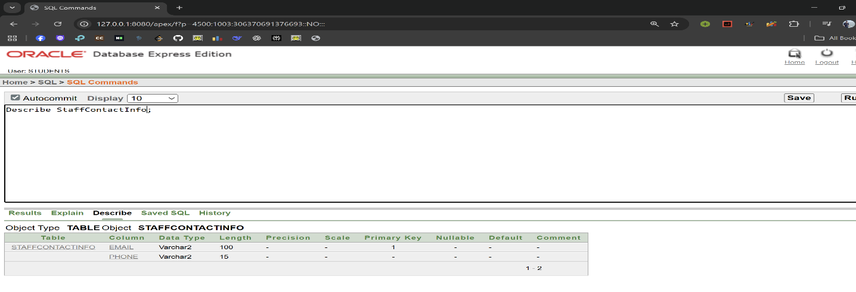

1. **PoolStaffInfo:**

CREATE TABLE PoolStaffInfo (

PoolID NUMBER NOT NULL,

StaffID NUMBER NOT NULL,

PRIMARY KEY (PoolID, StaffID),

CONSTRAINT fk_PoolStaff_PoolID FOREIGN KEY (PoolID) REFERENCES PoolInfo(PoolID),

CONSTRAINT fk_PoolStaff_StaffID FOREIGN KEY (StaffID) REFERENCES StaffInfo(StaffID)

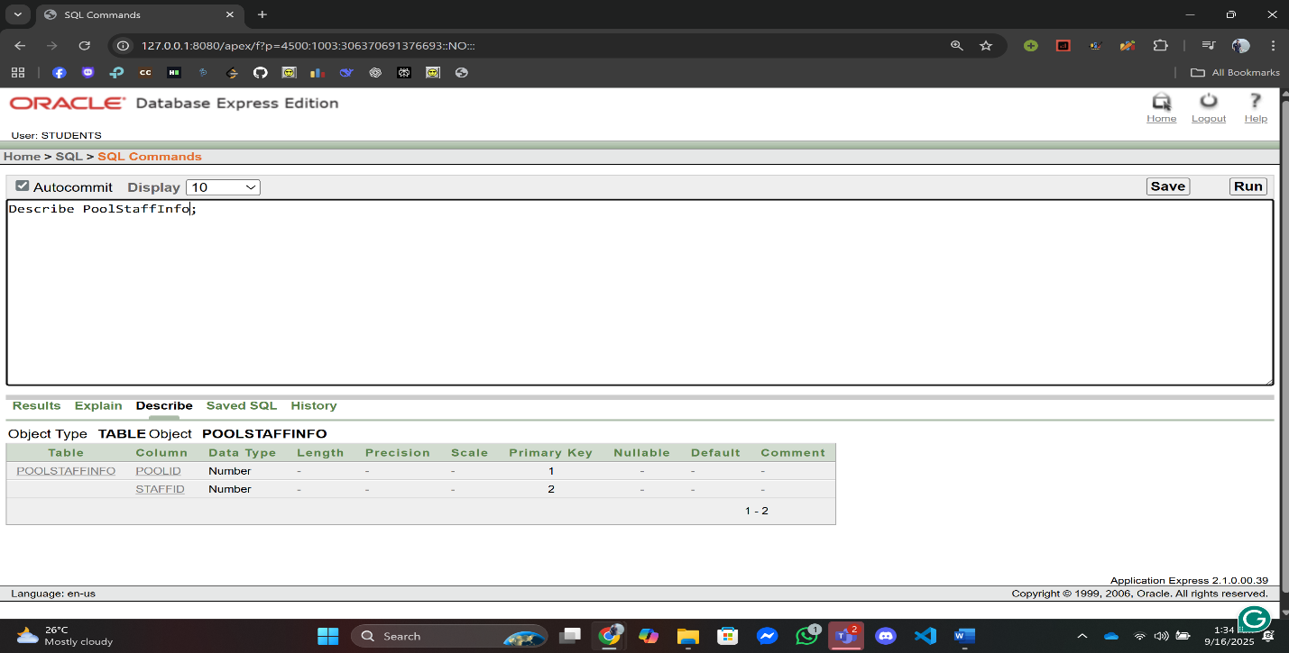);

1. **EventStaffInfo:**

CREATE TABLE EventStaffInfo (

EventID NUMBER NOT NULL,

StaffID NUMBER NOT NULL,

CONSTRAINT pk_eventstaff PRIMARY KEY (EventID, StaffID),

CONSTRAINT fk_esi_event FOREIGN KEY (EventID) REFERENCES EventInfo(EventID),

CONSTRAINT fk_esi_staff FOREIGN KEY (StaffID) REFERENCES StaffInfo(StaffID)

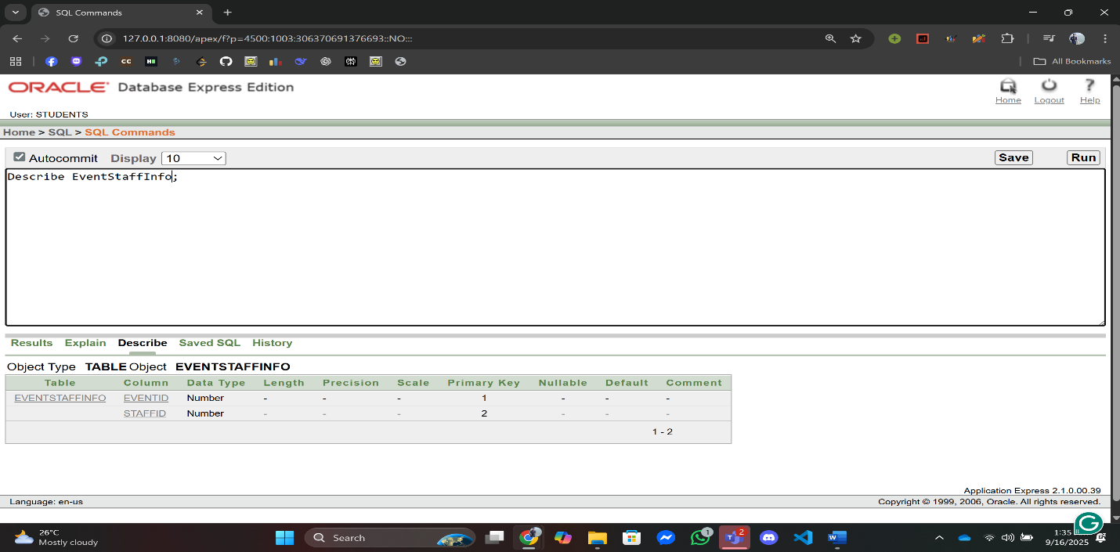);

1. **BookingTransactionInfo:**

CREATE TABLE BookingTransactionInfo (

BookingID NUMBER NOT NULL,

TransactionID NUMBER NOT NULL,

PRIMARY KEY (BookingID, TransactionID),

CONSTRAINT fk_BookTrans_BookingID FOREIGN KEY (BookingID) REFERENCES BookingInfo(BookingID),

CONSTRAINT fk_BookTrans_TransactionID FOREIGN KEY (TransactionID) REFERENCES TransactionInfo(TransactionID)

);

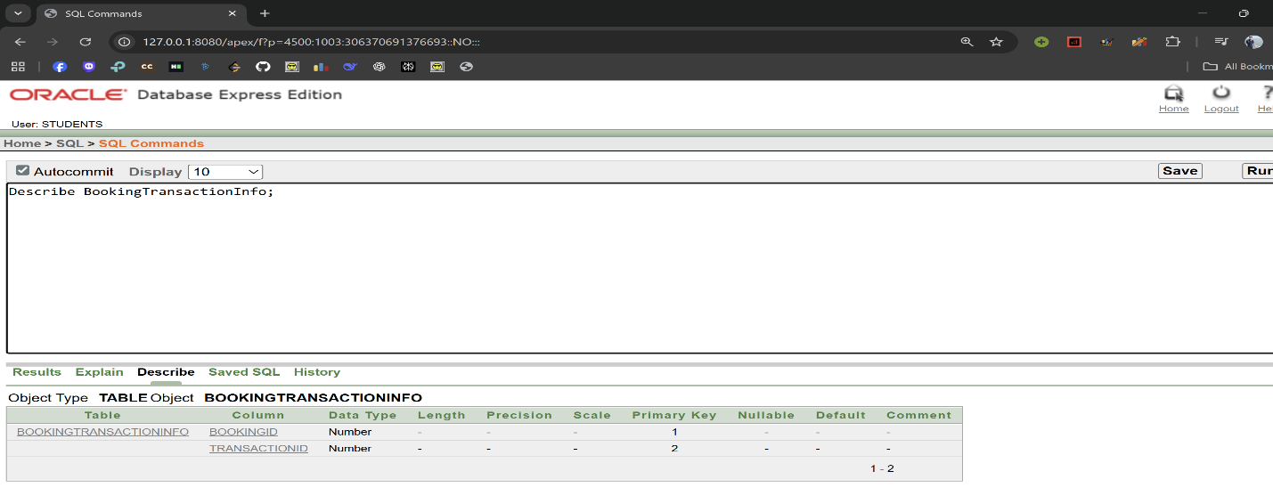

**Data Insertion Using SQL**

1. **MemberContactInfo:**

INSERT INTO MemberContactInfo (Email, Phone, MembershipType, RedStatus)

VALUES ('sazzad@example.com', '01711000001', 'Gold', DEFAULT);

INSERT INTO MemberContactInfo (Email, Phone, MembershipType, RedStatus)

VALUES ('rahim@example.com', '01711000002', 'Silver', DEFAULT);

INSERT INTO MemberContactInfo (Email, Phone, MembershipType, RedStatus)

VALUES ('karim@example.com', '01711000003', 'Platinum', DEFAULT);

INSERT INTO MemberContactInfo (Email, Phone, MembershipType, RedStatus)

VALUES ('apu@example.com', '01711000004', 'Gold', DEFAULT);

INSERT INTO MemberContactInfo (Email, Phone, MembershipType, RedStatus)

VALUES ('mehedi@example.com', '01711000005', 'Silver', DEFAULT);

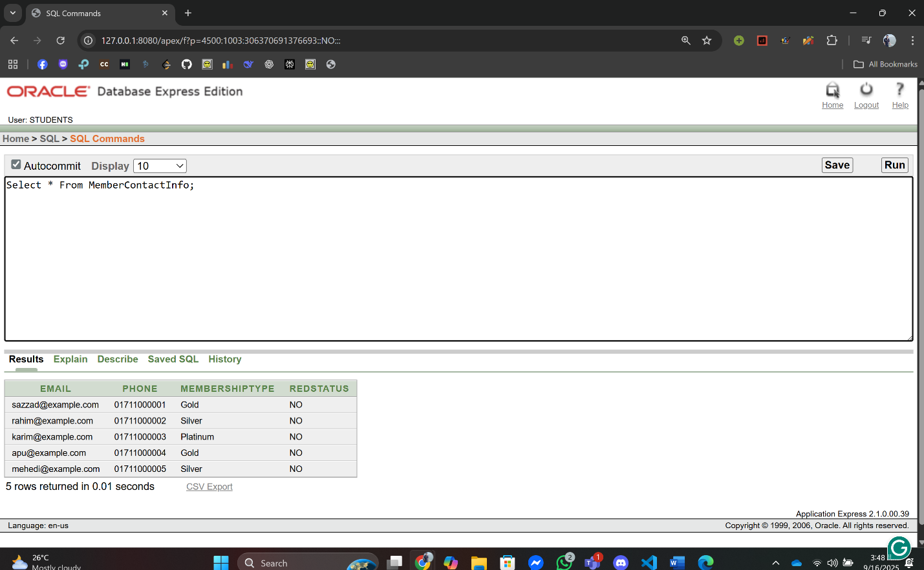

1. **MemberInfo:**

INSERT INTO MemberInfo (MemberID, Name, JoinDate, Email)

VALUES (1, 'Sazzad Khan', DEFAULT, 'sazzad@example.com');

INSERT INTO MemberInfo (MemberID, Name, JoinDate, Email)

VALUES (2, 'Rahim Uddin', DEFAULT, 'rahim@example.com');

INSERT INTO MemberInfo (MemberID, Name, JoinDate, Email)

VALUES (3, 'Karim Sheikh', DEFAULT, 'karim@example.com');

INSERT INTO MemberInfo (MemberID, Name, JoinDate, Email)

VALUES (4, 'Apu Rani', DEFAULT, 'apu@example.com');

INSERT INTO MemberInfo (MemberID, Name, JoinDate, Email)

VALUES (5, 'Mehedi Hasan', DEFAULT, 'mehedi@example.com');

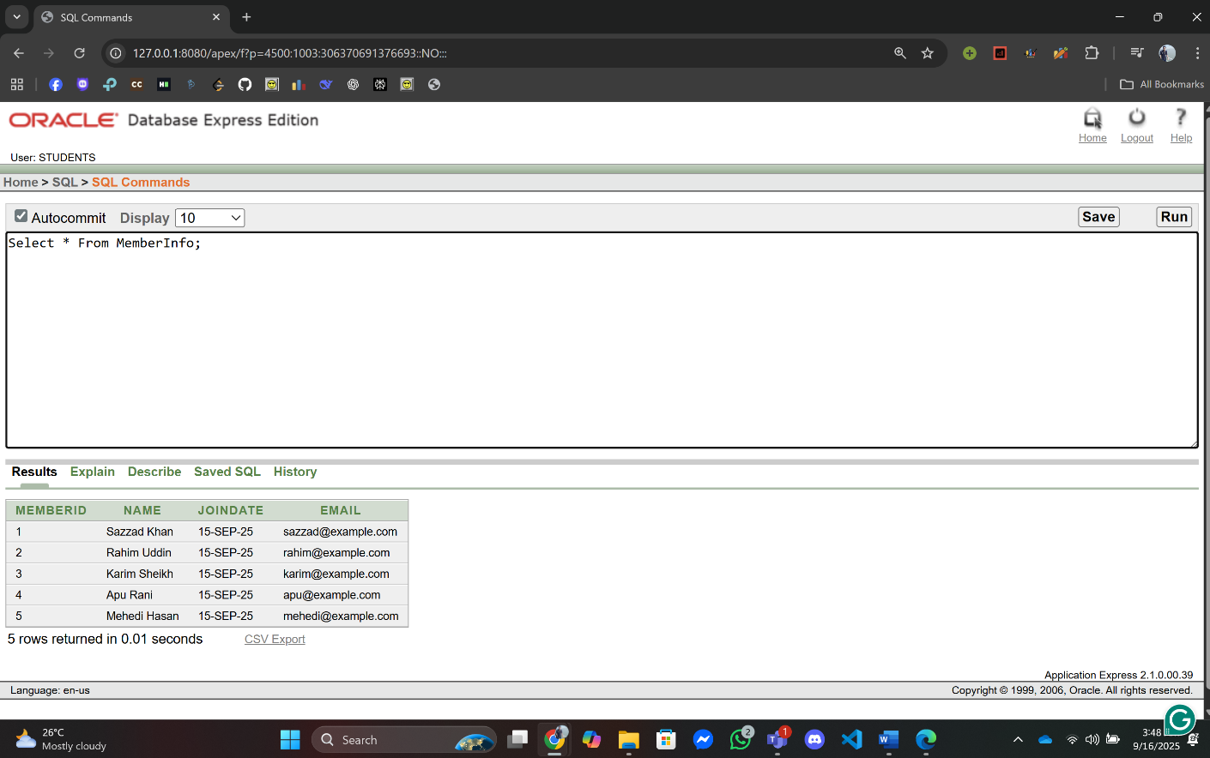

**3.** **BookingInfo:**

INSERT INTO BookingInfo (BookingID, BookingDate, BookingTime) VALUES (101, TO_DATE('2025-09-15','YYYY-MM-DD'), '10:00');

INSERT INTO BookingInfo (BookingID, BookingDate, BookingTime) VALUES (102, TO_DATE('2025-09-16','YYYY-MM-DD'), '11:00');

INSERT INTO BookingInfo (BookingID, BookingDate, BookingTime) VALUES (103, TO_DATE('2025-09-17','YYYY-MM-DD'), '12:00');

INSERT INTO BookingInfo (BookingID, BookingDate, BookingTime) VALUES (104, TO_DATE('2025-09-18','YYYY-MM-DD'), '13:00');

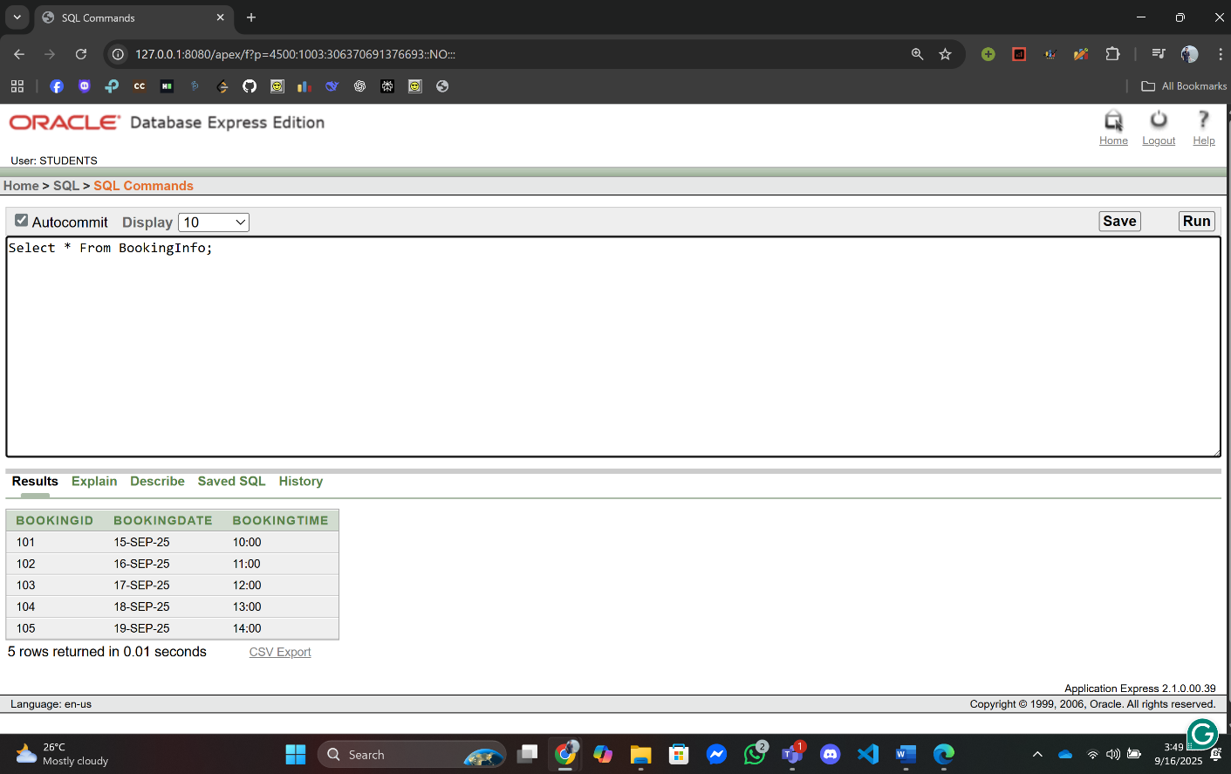 INSERT INTO BookingInfo (BookingID, BookingDate, BookingTime) VALUES (105, TO_DATE('2025-09-19','YYYY-MM-DD'), '14:00');

**4.** **MemberBookingInfo:**

INSERT INTO MemberBookingInfo (BookingID, MemberID) VALUES (101, 1);

INSERT INTO MemberBookingInfo (BookingID, MemberID) VALUES (102, 2);

INSERT INTO MemberBookingInfo (BookingID, MemberID) VALUES (103, 3);

INSERT INTO MemberBookingInfo (BookingID, MemberID) VALUES (104, 4);

INSERT INTO MemberBookingInfo (BookingID, MemberID) VALUES (105, 5);

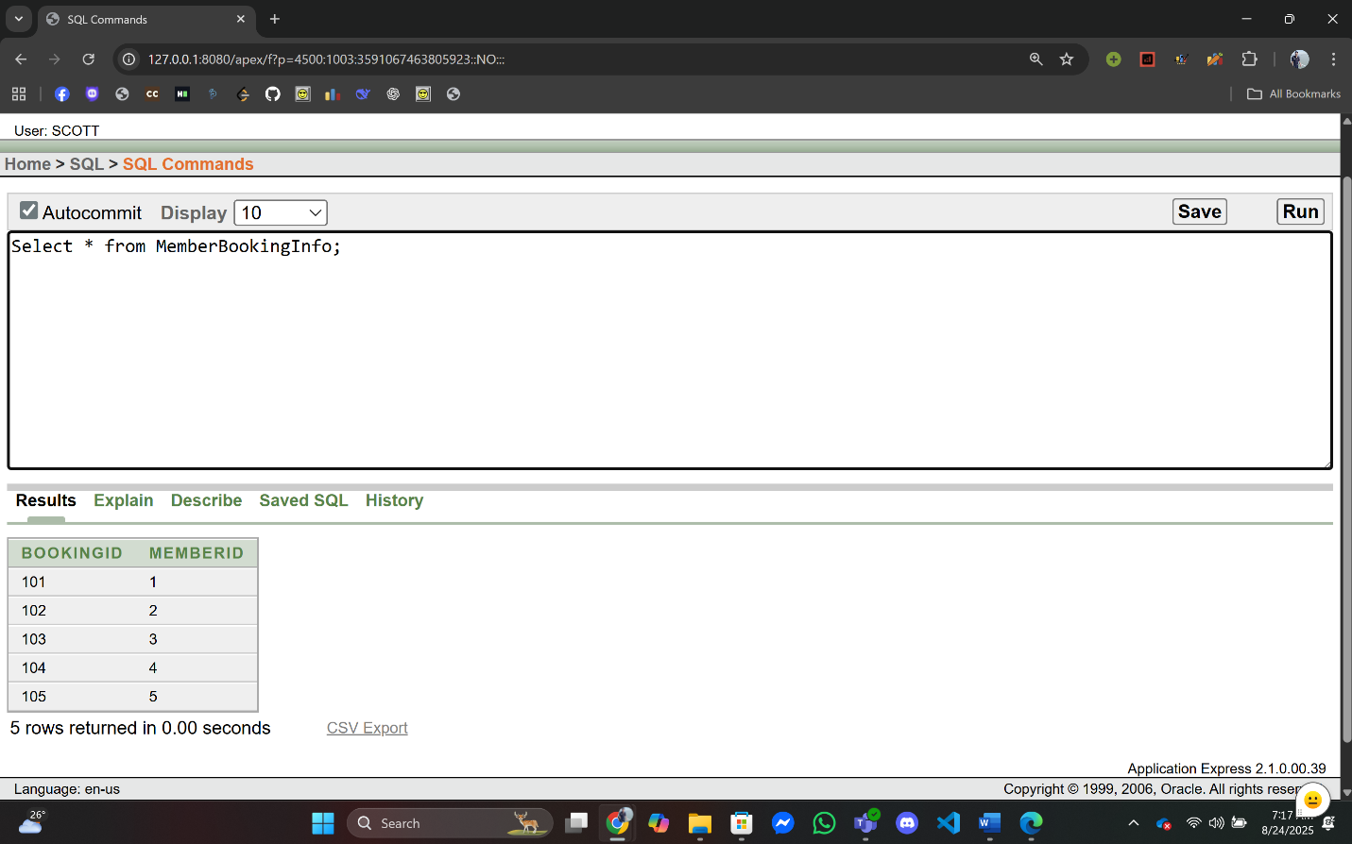

**05.** **TransactionInfo:**

INSERT INTO TransactionInfo (TransactionID, TransactionDate, Amount, MemberID) VALUES (2001, TO_DATE('2025-09-15','YYYY-MM-DD'), 1000.0, 1);

INSERT INTO TransactionInfo (TransactionID, TransactionDate, Amount, MemberID) VALUES (2002, TO_DATE('2025-09-16','YYYY-MM-DD'), 1100.0, 1);

INSERT INTO TransactionInfo (TransactionID, TransactionDate, Amount, MemberID) VALUES (2003, TO_DATE('2025-09-17','YYYY-MM-DD'), 1200.0, 3);

INSERT INTO TransactionInfo (TransactionID, TransactionDate, Amount, MemberID) VALUES (2004, TO_DATE('2025-09-18','YYYY-MM-DD'), 1300.0, 4);

INSERT INTO TransactionInfo (TransactionID, TransactionDate, Amount, MemberID)

VALUES (2005, TO_DATE('2025-09-19','YYYY-MM-DD'), 1400.0, 4);

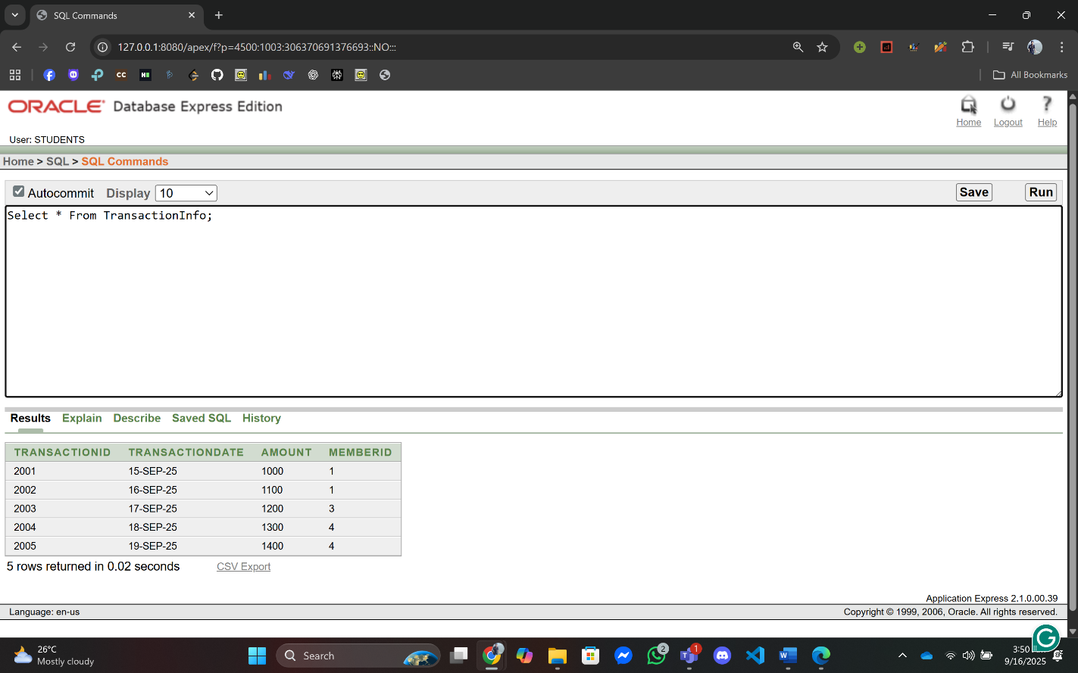

6.

7.

**06.PaymentTypeInfo:**

INSERT INTO PaymentTypeInfo (PaymentCode, PaymentType, PaymentMethod, TransactionID) VALUES (3001, 'Cash', 'Manual', 2001);

INSERT INTO PaymentTypeInfo (PaymentCode, PaymentType, PaymentMethod, TransactionID) VALUES (3002, 'Credit Card', 'POS', 2002);

INSERT INTO PaymentTypeInfo (PaymentCode, PaymentType, PaymentMethod, TransactionID) VALUES (3003, 'bKash', 'Online', 2003);

INSERT INTO PaymentTypeInfo (PaymentCode, PaymentType, PaymentMethod, TransactionID) VALUES (3004, 'Nagad', 'Mobile', 2004);

INSERT INTO PaymentTypeInfo (PaymentCode, PaymentType, PaymentMethod, TransactionID) VALUES (3005, 'Rocket', 'Online', 2005);

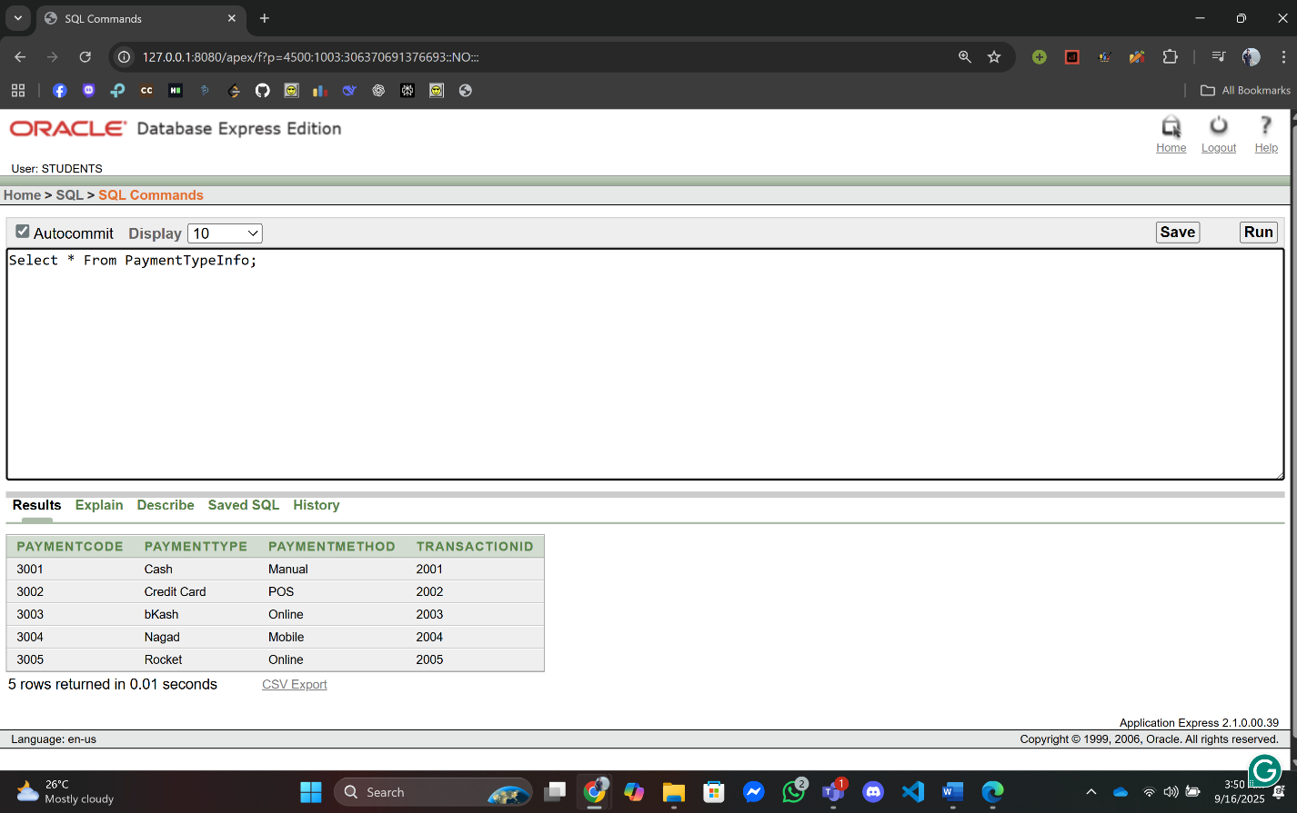

**07.** **TrainerContactInfo:**

INSERT INTO TrainerContactInfo (Email, Phone) VALUES ('rahim.trainer@club.com', '01712000001');

INSERT INTO TrainerContactInfo (Email, Phone) VALUES ('nazmul.trainer@club.com', '01712000002');

INSERT INTO TrainerContactInfo (Email, Phone) VALUES ('rupa.trainer@club.com', '01712000003');

INSERT INTO TrainerContactInfo (Email, Phone) VALUES ('tahsin.trainer@club.com', '01712000004');

INSERT INTO TrainerContactInfo (Email, Phone) VALUES ('mitu.trainer@club.com', '01712000005');

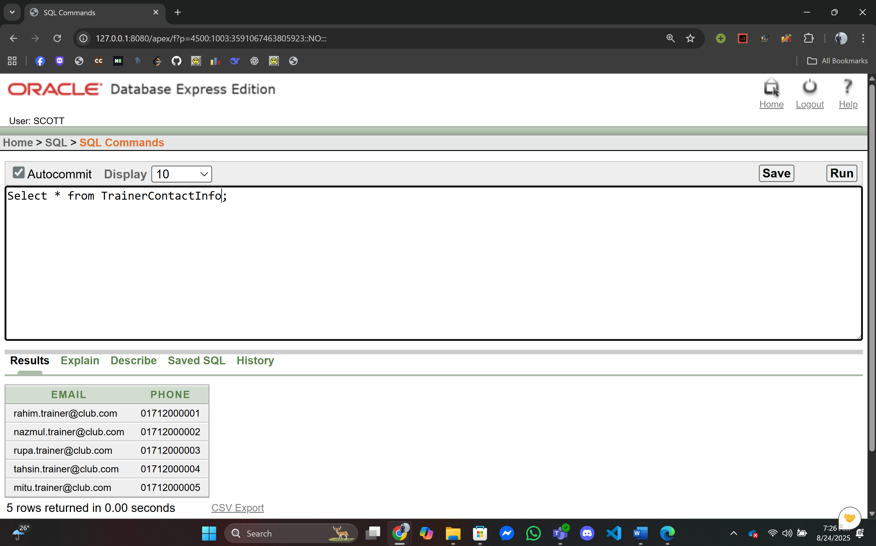

**08. TrainerInfo:**

INSERT INTO TrainerInfo (TrainerID, Name, Email, BookingID) VALUES (4001, 'Rahim Ahmed', 'rahim.trainer@club.com', 101);

INSERT INTO TrainerInfo (TrainerID, Name, Email, BookingID) VALUES (4002, 'Nazmul Begum', 'nazmul.trainer@club.com', 102);

INSERT INTO TrainerInfo (TrainerID, Name, Email, BookingID) VALUES (4003, 'Rupa Islam', 'rupa.trainer@club.com', 103);

INSERT INTO TrainerInfo (TrainerID, Name, Email, BookingID) VALUES (4004, 'Tahsin Ahmed', 'tahsin.trainer@club.com', 104);

INSERT INTO TrainerInfo (TrainerID, Name, Email, BookingID) VALUES (4005, 'Mitu', 'mitu.trainer@club.com', 105);

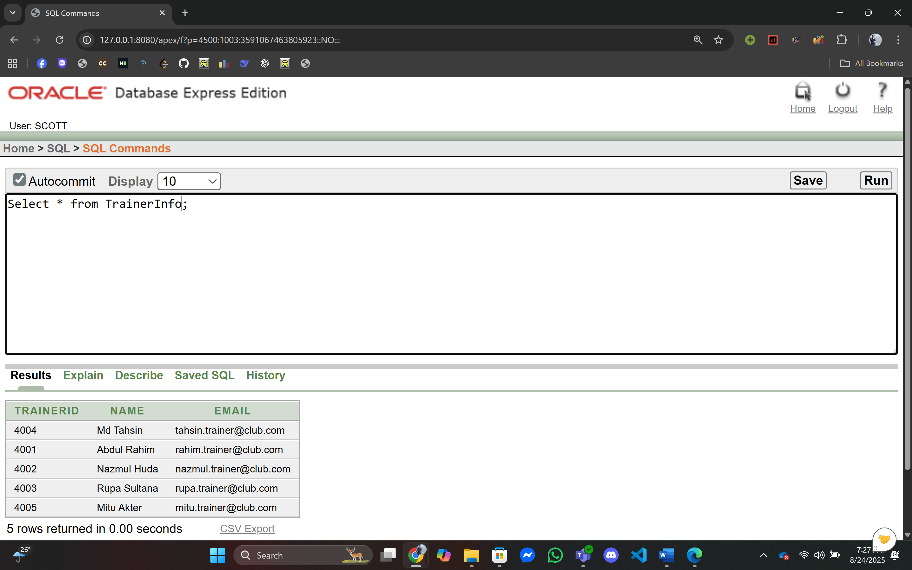

**09.** **TrainerSpecialtyInfo:**

INSERT INTO TrainerSpecialtyInfo (TrainerID, Specialty) VALUES (4001, 'Swimming');

INSERT INTO TrainerSpecialtyInfo (TrainerID, Specialty) VALUES (4002, 'Fitness');

INSERT INTO TrainerSpecialtyInfo (TrainerID, Specialty) VALUES (4003, 'Yoga');

INSERT INTO TrainerSpecialtyInfo (TrainerID, Specialty) VALUES (4003, 'Zumba');

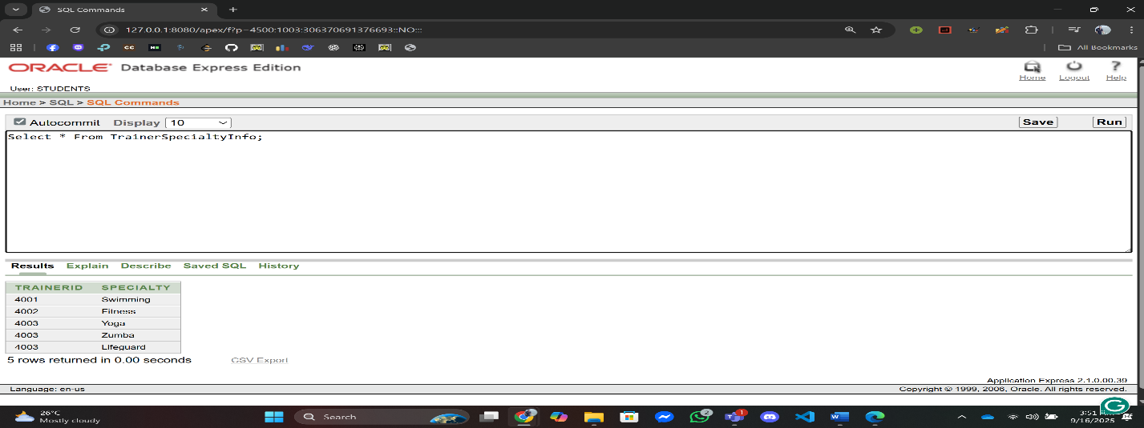 INSERT INTO TrainerSpecialtyInfo (TrainerID, Specialty) VALUES (4003, 'Lifeguard');

**10. PoolInfo:**

INSERT INTO PoolInfo (PoolID, Location, Capacity, BookingID) VALUES (5001, 'Dhaka', 50, 101);

INSERT INTO PoolInfo (PoolID, Location, Capacity, BookingID) VALUES (5002, 'Chattogram', 60, 102);

INSERT INTO PoolInfo (PoolID, Location, Capacity, BookingID) VALUES (5003, 'Khulna', 70, 103);

INSERT INTO PoolInfo (PoolID, Location, Capacity, BookingID) VALUES (5004, 'Rajshahi', 80, 104);

INSERT INTO PoolInfo (PoolID, Location, Capacity, BookingID) VALUES (5005, 'Barishal', 90, 105);

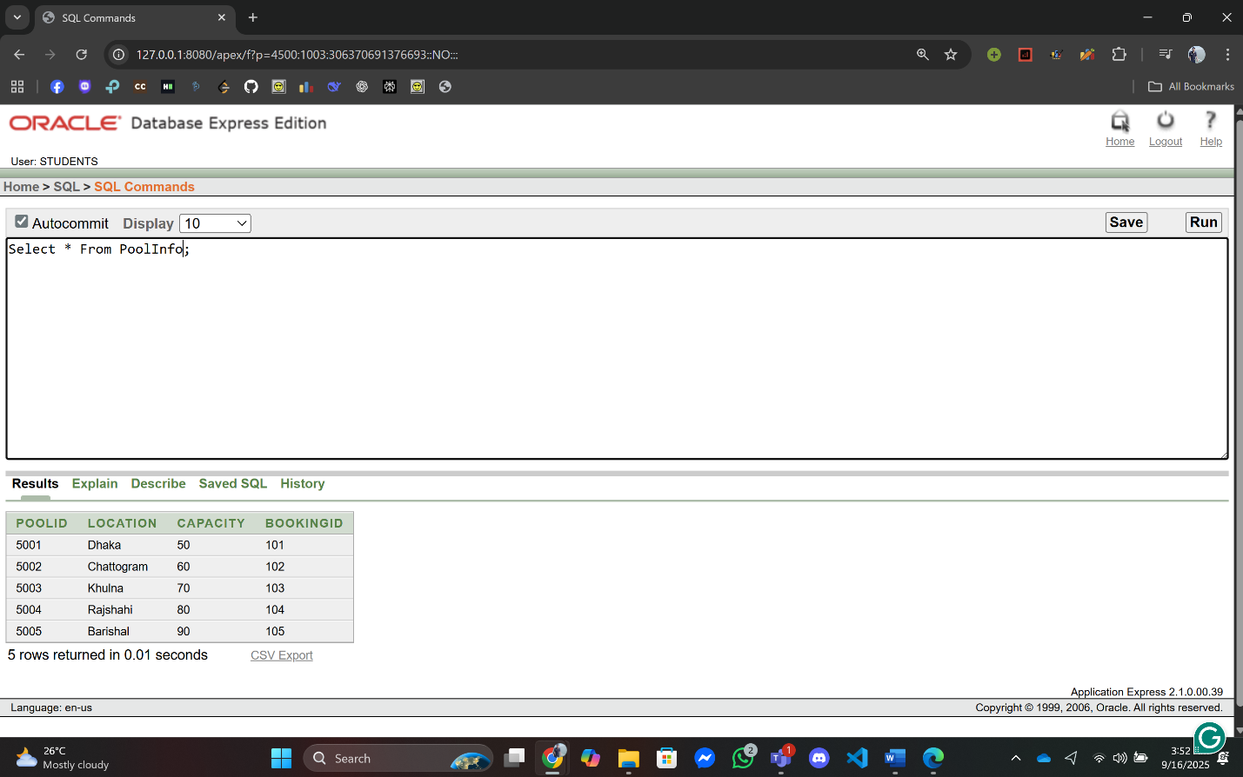

**11. EventInfo:**

INSERT INTO EventInfo (EventID, Name, EventDate, EventTime, PoolID) VALUES (6001, 'Independence Day Swim', TO_DATE('2025-09-15','YYYY-MM-DD'), '15:00', 5001);

INSERT INTO EventInfo (EventID, Name, EventDate, EventTime, PoolID) VALUES (6002, 'Winter Training', TO_DATE('2025-09-20','YYYY-MM-DD'), '16:00', 5002);

INSERT INTO EventInfo (EventID, Name, EventDate, EventTime, PoolID) VALUES (6003, 'Junior Swim Fest', TO_DATE('2025-09-25','YYYY-MM-DD'), '17:00', 5003);

INSERT INTO EventInfo (EventID, Name, EventDate, EventTime, PoolID) VALUES (6004, 'Water Carnival', TO_DATE('2025-09-30','YYYY-MM-DD'), '18:00', 5004);

INSERT INTO EventInfo (EventID, Name, EventDate, EventTime, PoolID) VALUES (6005, 'Staff Meeting', TO_DATE('2025-10-05','YYYY-MM-DD'), '19:00', 5005);

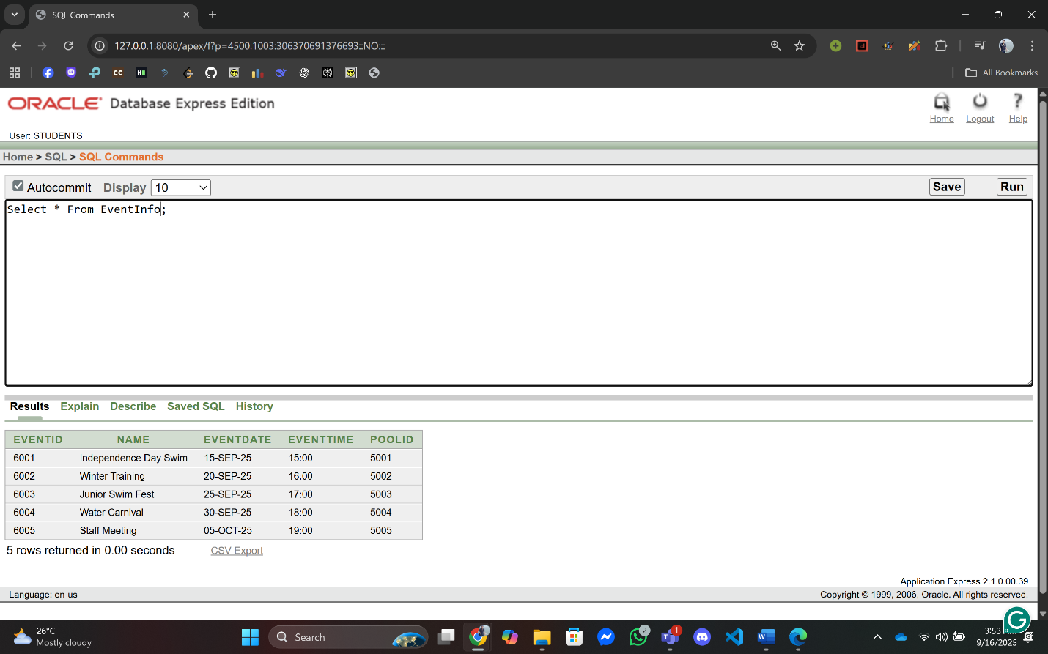

**12. StaffContactInfo:**

INSERT INTO StaffContactInfo (Email, Phone) VALUES ('sazzad.staff@club.com', '01713000001');

INSERT INTO StaffContactInfo (Email, Phone) VALUES ('hasina.staff@club.com', '01713000002');

INSERT INTO StaffContactInfo (Email, Phone) VALUES ('rashed.staff@club.com', '01713000003');

INSERT INTO StaffContactInfo (Email, Phone) VALUES ('farzana.staff@club.com', '01713000004');

INSERT INTO StaffContactInfo (Email, Phone) VALUES ('bappa.staff@club.com', '01713000005');

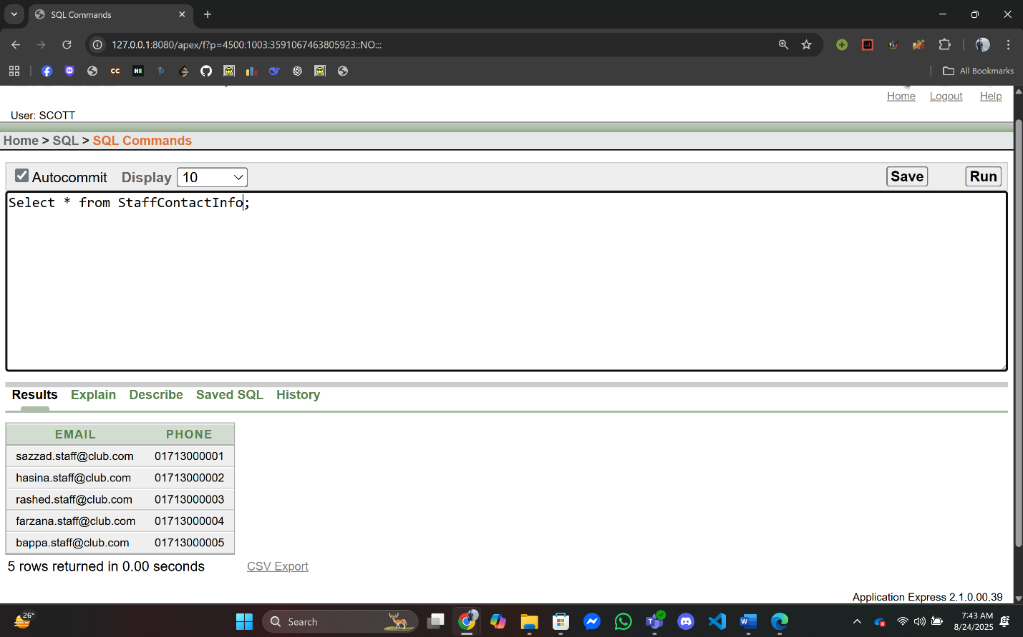

**13. StaffInfo:**

INSERT INTO StaffInfo (StaffID, Name, Email) VALUES (7001, 'Sazzad Khan', 'sazzad.staff@club.com');

INSERT INTO StaffInfo (StaffID, Name, Email) VALUES (7002, 'Kazi Nazrul', 'hasina.staff@club.com');

INSERT INTO StaffInfo (StaffID, Name, Email) VALUES (7003, 'Rafiq Islam', 'rashed.staff@club.com');

INSERT INTO StaffInfo (StaffID, Name, Email) VALUES (7004, 'Jannatul Ferdous', 'farzana.staff@club.com');

INSERT INTO StaffInfo (StaffID, Name, Email) VALUES (7005, 'Kamruzzaman', 'bappa.staff@club.com');

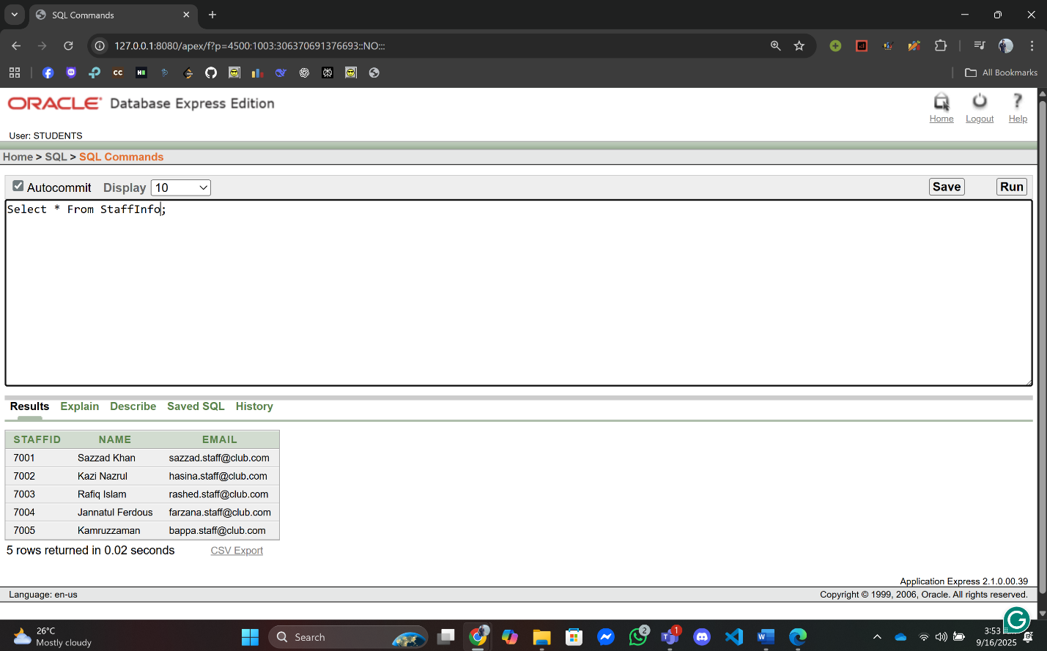

**14. StaffRoleInfo:**

INSERT INTO StaffRoleInfo (StaffID, Role) VALUES (7001, 'Manager');

INSERT INTO StaffRoleInfo (StaffID, Role) VALUES (7002, 'Coach');

INSERT INTO StaffRoleInfo (StaffID, Role) VALUES (7003, 'Receptionist');

INSERT INTO StaffRoleInfo (StaffID, Role) VALUES (7003, 'Guard');

INSERT INTO StaffRoleInfo (StaffID, Role) VALUES (7005, 'Cleaner');

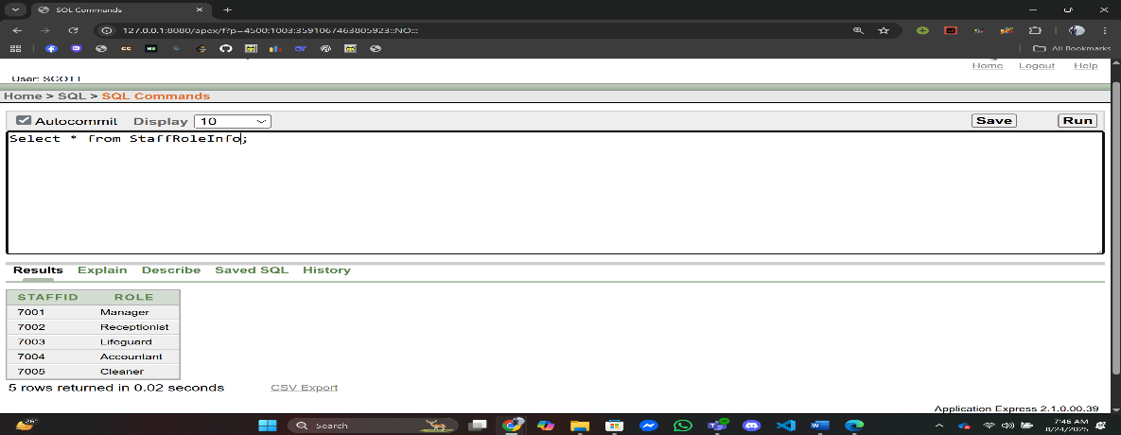

**15.** **PoolStaffInfo:**

INSERT INTO PoolStaffInfo (PoolID, StaffID) VALUES (5001, 7001);

INSERT INTO PoolStaffInfo (PoolID, StaffID) VALUES (5002, 7002);

INSERT INTO PoolStaffInfo (PoolID, StaffID) VALUES (5003, 7003);

INSERT INTO PoolStaffInfo (PoolID, StaffID) VALUES (5004, 7004);

INSERT INTO PoolStaffInfo (PoolID, StaffID) VALUES (5005, 7005);

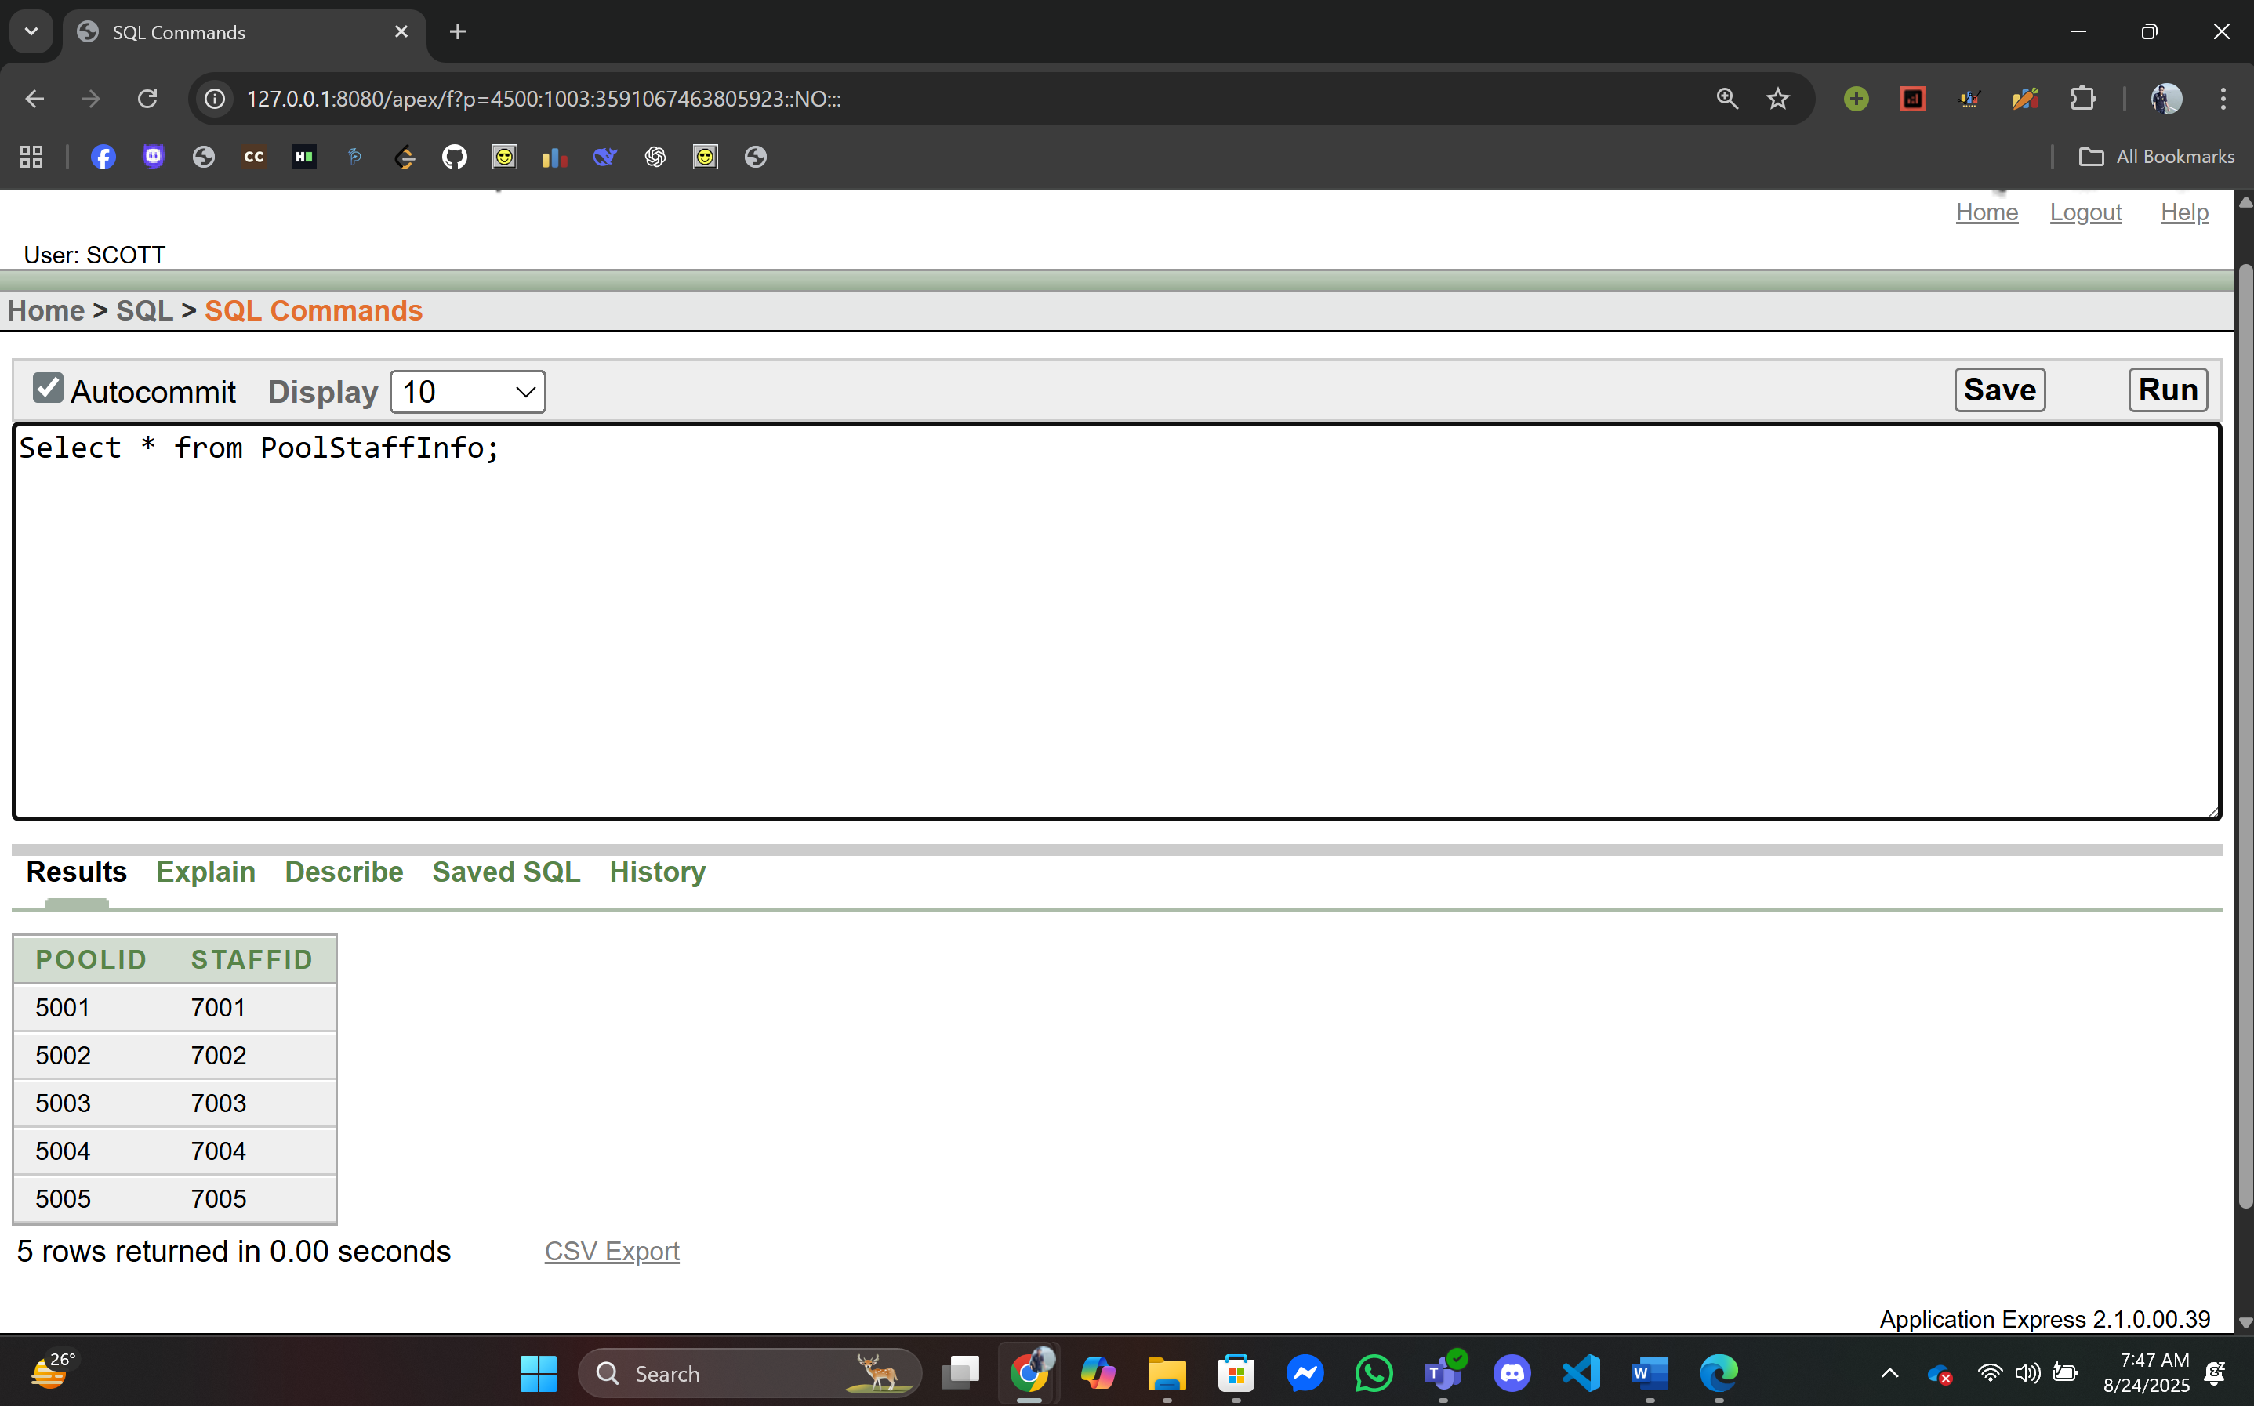

**16. EventStaffInfo:**

INSERT INTO EventStaffInfo (EventID, StaffID) VALUES (6001, 7001);

INSERT INTO EventStaffInfo (EventID, StaffID) VALUES (6002, 7002);

INSERT INTO EventStaffInfo (EventID, StaffID) VALUES (6003, 7003);

INSERT INTO EventStaffInfo (EventID, StaffID) VALUES (6004, 7004);

INSERT INTO EventStaffInfo (EventID, StaffID) VALUES (6005, 7005);

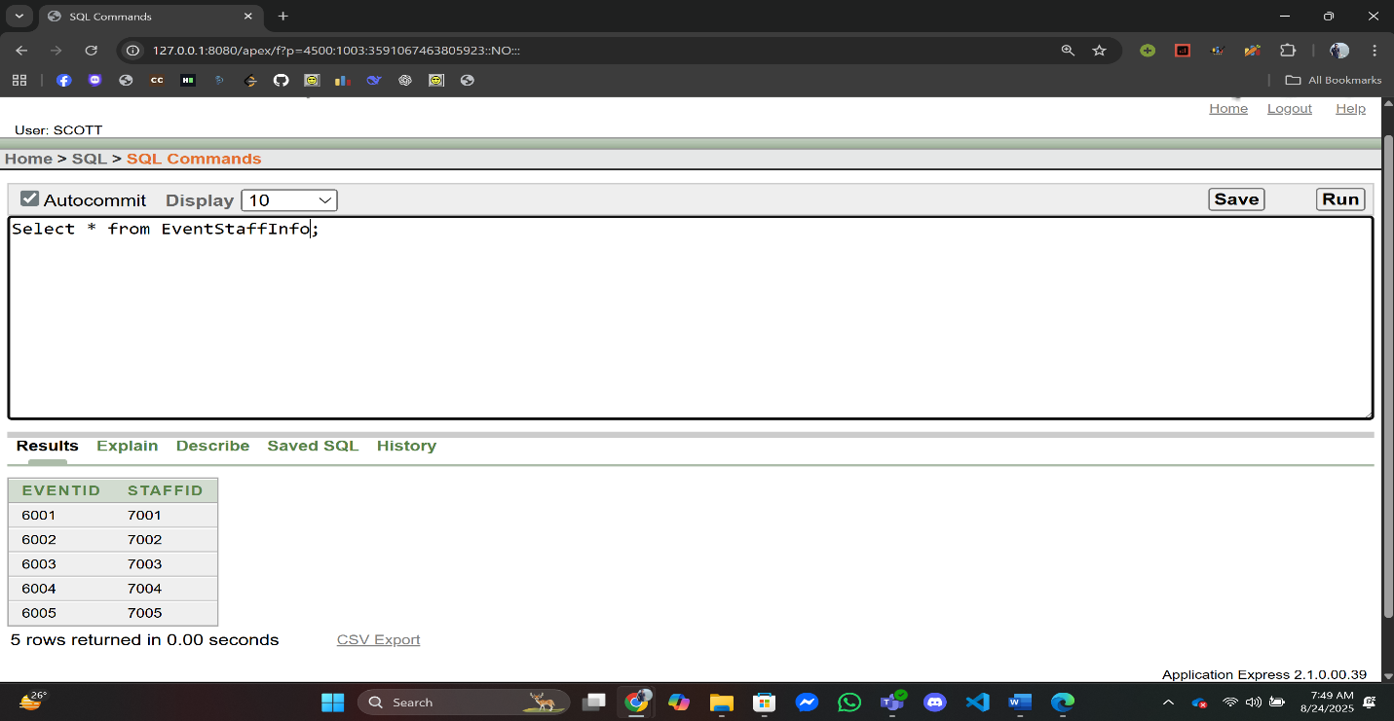

**17.** **BookingTransactionInfo:**

INSERT INTO BookingTransactionInfo (BookingID, TransactionID) VALUES (101, 2001);

INSERT INTO BookingTransactionInfo (BookingID, TransactionID) VALUES (102, 2002);

INSERT INTO BookingTransactionInfo (BookingID, TransactionID) VALUES (103, 2003);

INSERT INTO BookingTransactionInfo (BookingID, TransactionID) VALUES (104, 2004);

INSERT INTO BookingTransactionInfo (BookingID, TransactionID) VALUES (105, 2005);

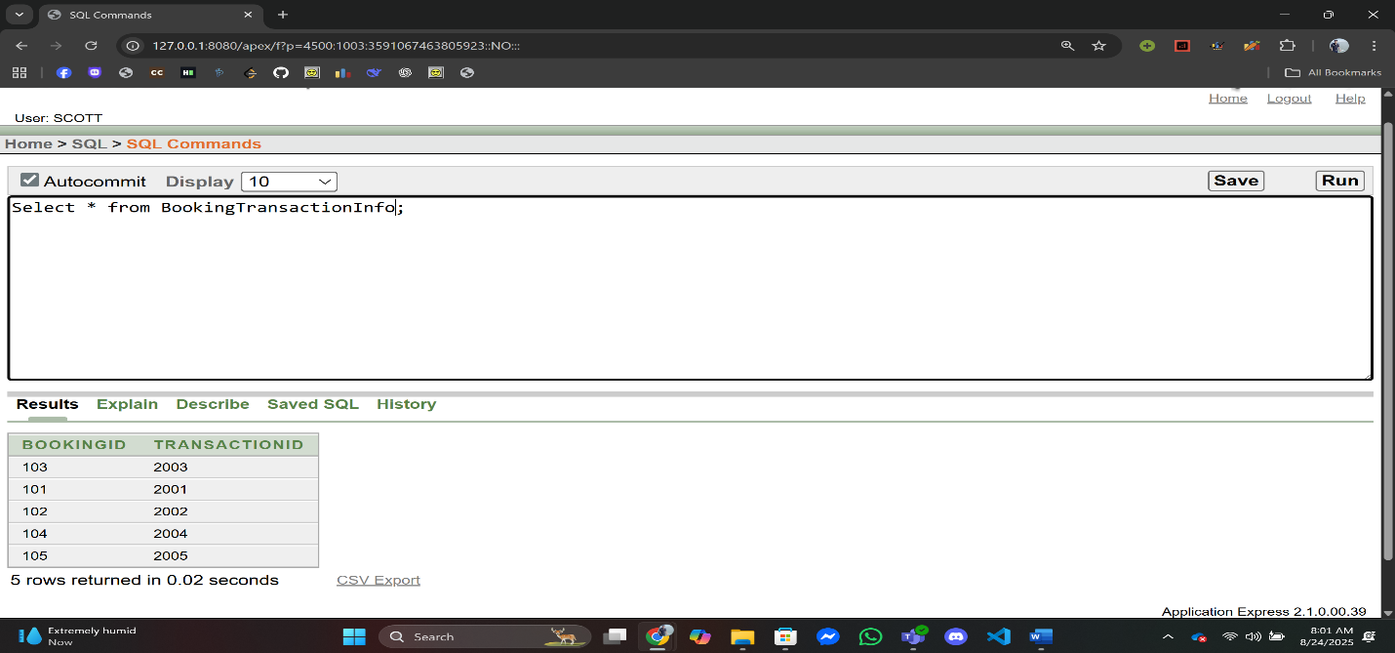

**Exception Handling**

**Basic PL/SQL**

1. **Variable:**

**Q1:** Display The Member Name for MemberID = 1

**Answer:**

--Swimming Pool Management System,Summer,Advance Database Management System,A

DECLARE

v_name MemberInfo.Name%TYPE;

BEGIN

SELECT Name INTO v_name

FROM MemberInfo

WHERE MemberID = 1;

DBMS_OUTPUT.PUT_LINE('Member Name: ' || v_name);

EXCEPTION

WHEN NO_DATA_FOUND THEN

DBMS_OUTPUT.PUT_LINE('No Member Found with ID = 1');

WHEN OTHERS THEN

DBMS_OUTPUT.PUT_LINE('Error: ' || SQLERRM);

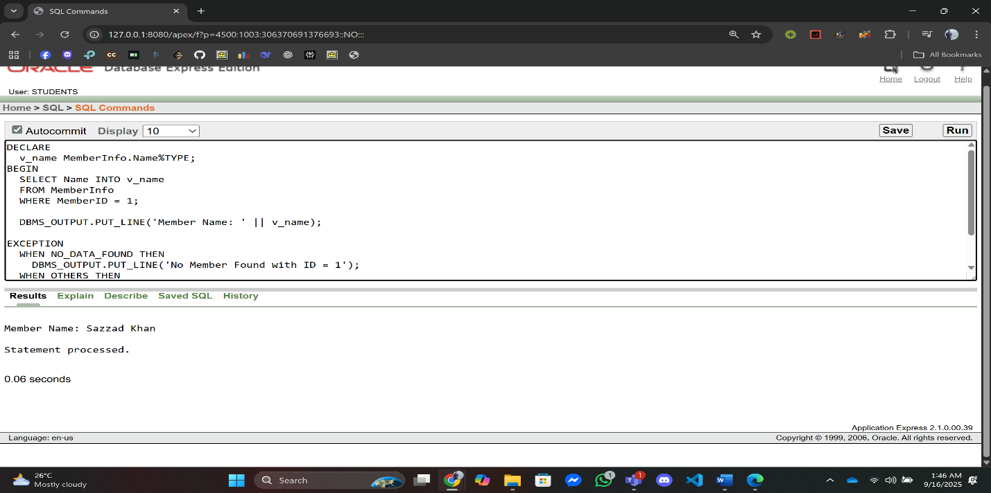END;

**Q2:** Display the Staff Email for Staff Id = 7003.

**Answer:**

--Swimming Pool Management System,Summer,Advance Database Management System,A

DECLARE

v_email StaffInfo.Email%TYPE;

BEGIN

SELECT Email INTO v_email

FROM StaffInfo

WHERE StaffID = 7003;

DBMS_OUTPUT.PUT_LINE('Staff Email: ' || v_email);

EXCEPTION

WHEN NO_DATA_FOUND THEN

DBMS_OUTPUT.PUT_LINE('No Staff Found with ID = 7003');

WHEN OTHERS THEN

DBMS_OUTPUT.PUT_LINE('Error: ' || SQLERRM);

END;

/

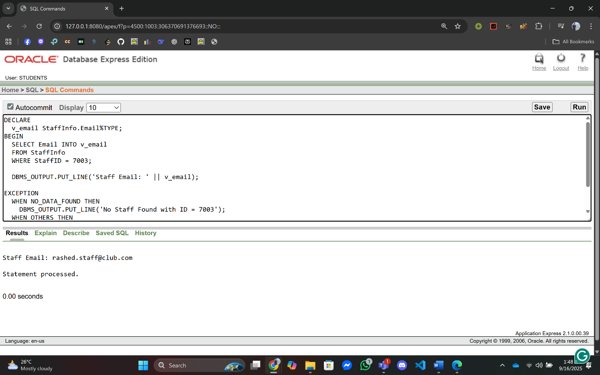

1. **Operator:**

**Q1:** Calculate the total amount after adding 15% tax for Transaction ID = 2001.

**Answer:**

--Swimming Pool Management System,Summer,Advance Database Management System,A

DECLARE

v_amount TransactionInfo.Amount%TYPE;

v_total NUMBER(10,2);

BEGIN

SELECT Amount INTO v_amount

FROM TransactionInfo

WHERE TransactionID = 2001;

v_total := v_amount + (v_amount * 0.15);

DBMS_OUTPUT.PUT_LINE('Total Amount with 15% Tax: ' || v_total);

EXCEPTION

WHEN NO_DATA_FOUND THEN

DBMS_OUTPUT.PUT_LINE('Transaction ID 2001 not found');

WHEN OTHERS THEN

DBMS_OUTPUT.PUT_LINE('Error: ' || SQLERRM);

END;

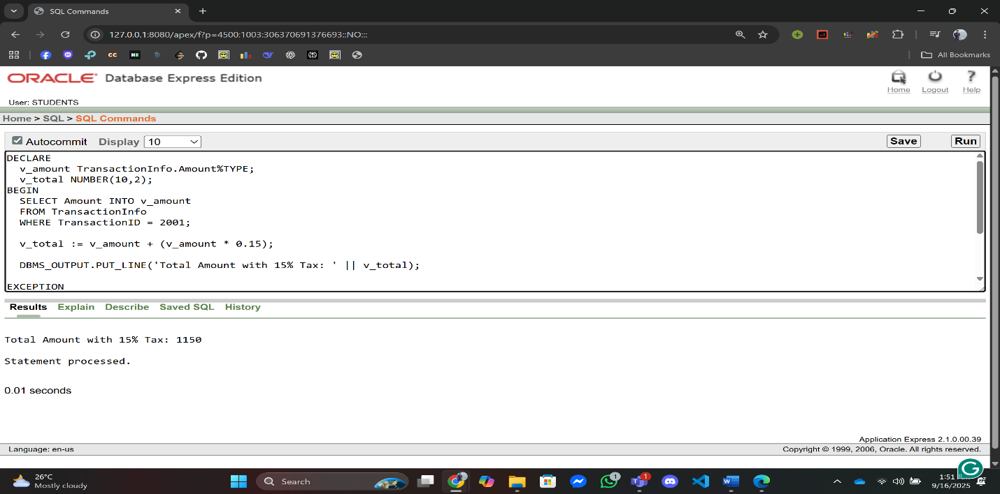/

**Q2:** Add the Pool Capacity 100 for Pool ID = 5004 and Display the New Capacity.

**Answer:**

--Swimming Pool Management System,Summer,Advance Database Management System,A

DECLARE

v_capacity PoolInfo.Capacity%TYPE;

BEGIN

SELECT Capacity INTO v_capacity

FROM PoolInfo

WHERE PoolID = 5004;

v_capacity := v_capacity + 100;

DBMS_OUTPUT.PUT_LINE('New Pool Capacity: ' || v_capacity);

EXCEPTION

WHEN NO_DATA_FOUND THEN

DBMS_OUTPUT.PUT_LINE('Pool ID 5004 not found');

WHEN OTHERS THEN

DBMS_OUTPUT.PUT_LINE('Error: ' || SQLERRM);

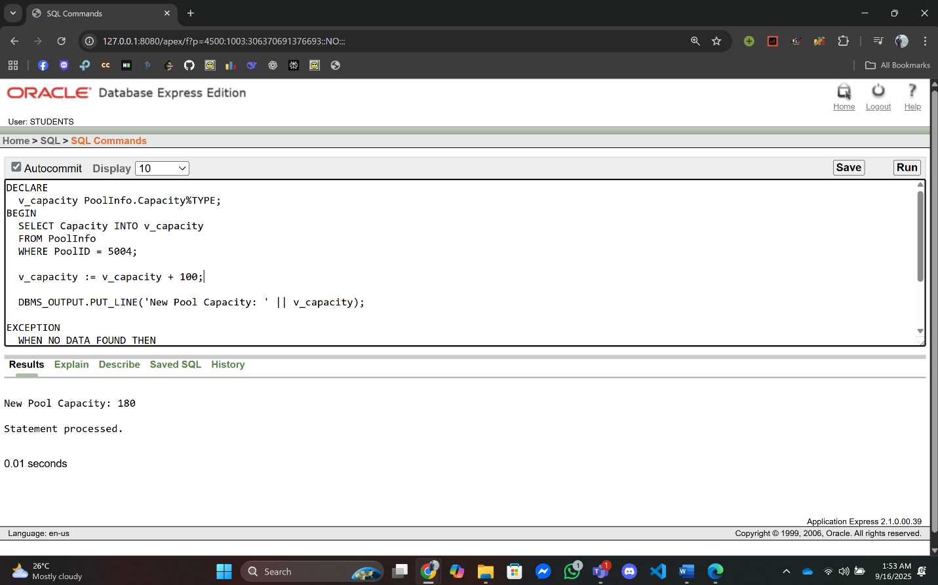END;

1. **Single-row Function:**

**Q1:** Display a member’s name in uppercase for MemberID = 4.

**Answer:**

--Swimming Pool Management System,Summer,Advance Database Management System,A

DECLARE

v_name MemberInfo.Name%TYPE;

BEGIN

SELECT UPPER(Name) INTO v_name

FROM MemberInfo

WHERE MemberID = 4;

DBMS_OUTPUT.PUT_LINE('Uppercase Name: ' || v_name);

EXCEPTION

WHEN NO_DATA_FOUND THEN

DBMS_OUTPUT.PUT_LINE('Member ID 4 not found');

WHEN OTHERS THEN

DBMS_OUTPUT.PUT_LINE('Error: ' || SQLERRM);

END;

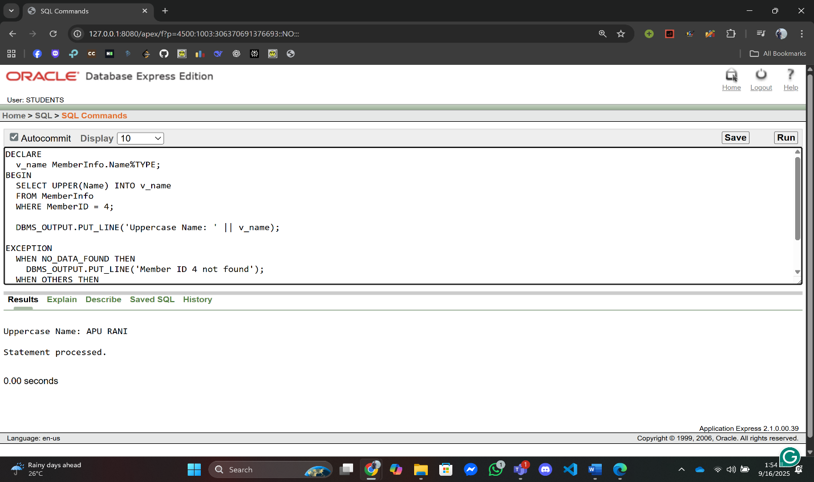/

**Q2:** Display the Booking Date in DD-Month-YYYY format for BookingID = 103.

**Answer:**

--Swimming Pool Management System,Summer,Advance Database Management System,A

DECLARE

v_date VARCHAR2(30);

BEGIN

SELECT TO_CHAR(BookingDate, 'DD-Month-YYYY') INTO v_date

FROM BookingInfo

WHERE BookingID = 103;

DBMS_OUTPUT.PUT_LINE('Booking Date: ' || v_date);

EXCEPTION

WHEN NO_DATA_FOUND THEN

DBMS_OUTPUT.PUT_LINE('Booking ID 103 not found');

WHEN OTHERS THEN

DBMS_OUTPUT.PUT_LINE('Error: ' || SQLERRM);

END;

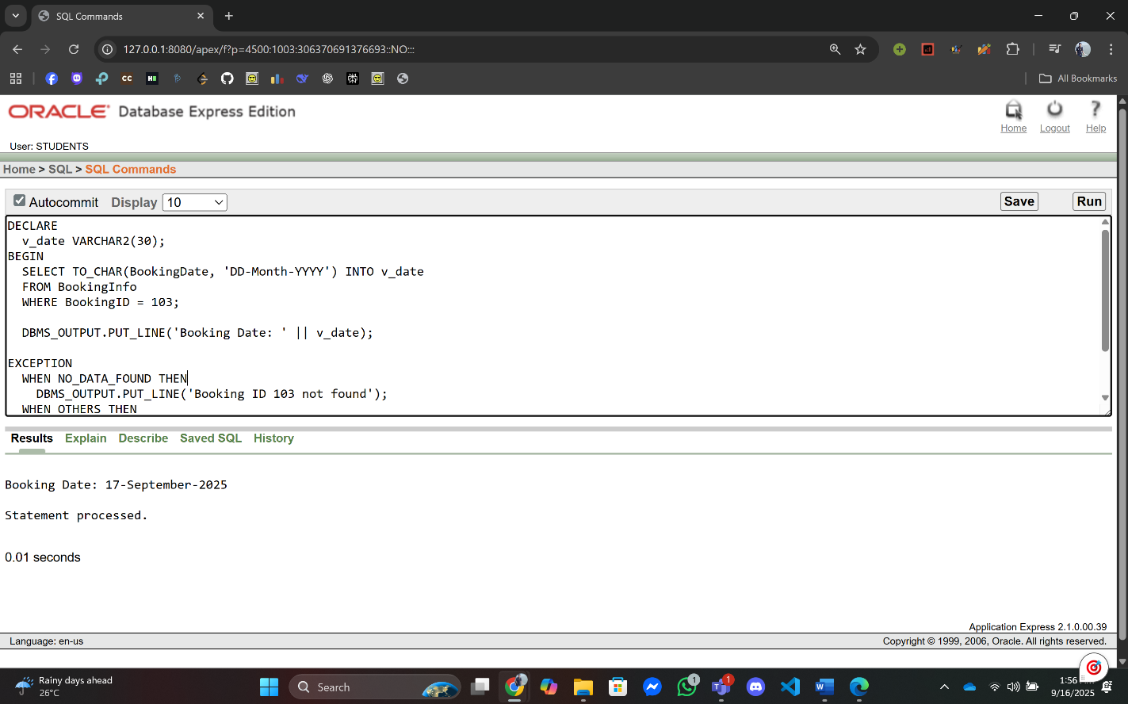/

1. **Group Function:**

**Q1:** Find the total number of bookings.

**Answer:**

--Swimming Pool Management System,Summer,Advance Database Management System,A

DECLARE

v_total NUMBER;

BEGIN

SELECT COUNT(*) INTO v_total

FROM BookingInfo;

DBMS_OUTPUT.PUT_LINE('Total Bookings: ' || v_total);

EXCEPTION

WHEN OTHERS THEN

DBMS_OUTPUT.PUT_LINE('Error: ' || SQLERRM);

END;

/

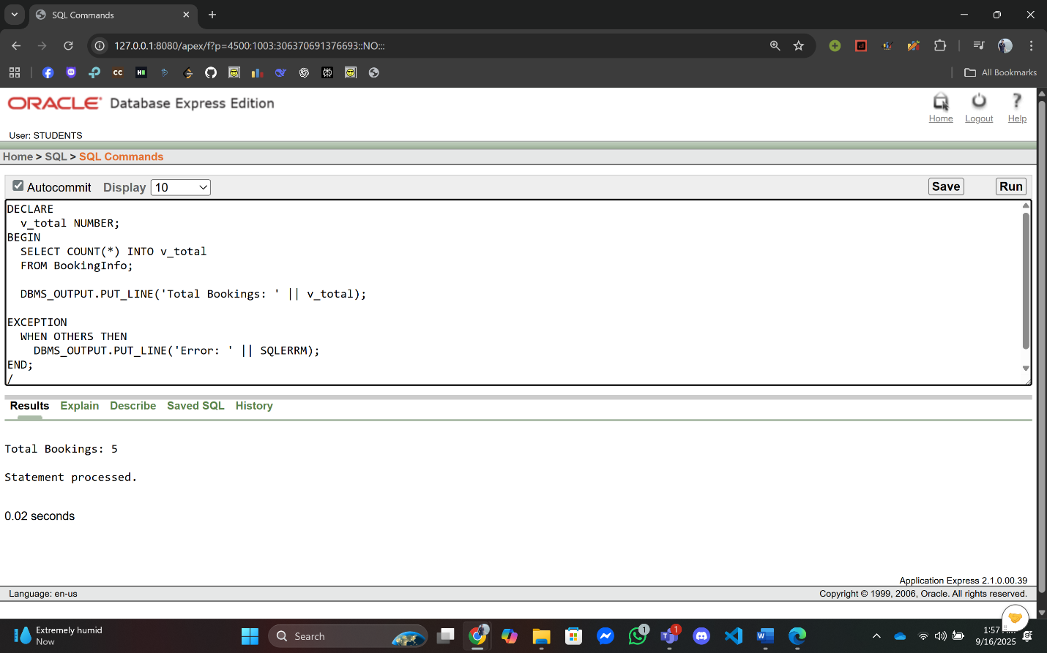

**Q2:** Find the highest transaction amount.

**Answer:**

--Swimming Pool Management System,Summer,Advance Database Management System,A

DECLARE

v_max NUMBER(10,2);

BEGIN

SELECT MAX(Amount) INTO v_max

FROM TransactionInfo;

DBMS_OUTPUT.PUT_LINE('Highest Transaction Amount: ' || v_max);

EXCEPTION

WHEN OTHERS THEN

DBMS_OUTPUT.PUT_LINE('Error: ' || SQLERRM);

END;

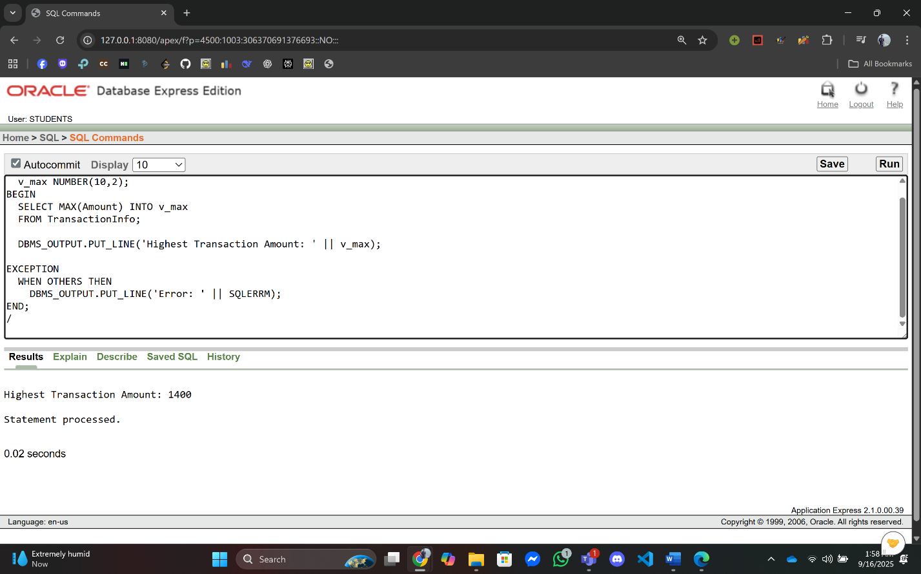/

1. **Loop:**

**Q1:** Print all Member’s Id & Email address.

**Answer:**

--Swimming Pool Management System,Summer,Advance Database Management System,A

DECLARE

CURSOR c IS SELECT MemberID, Email FROM MemberInfo;

v_id MemberInfo.MemberID%TYPE;

v_email MemberInfo.Email%TYPE;

BEGIN

OPEN c;

LOOP

FETCH c INTO v_id, v_email;

EXIT WHEN c%NOTFOUND;

DBMS_OUTPUT.PUT_LINE('MemberID: ' || v_id || ' | Email: ' || v_email);

END LOOP;

CLOSE c;

EXCEPTION

WHEN OTHERS THEN

DBMS_OUTPUT.PUT_LINE('Error: ' || SQLERRM);

END;

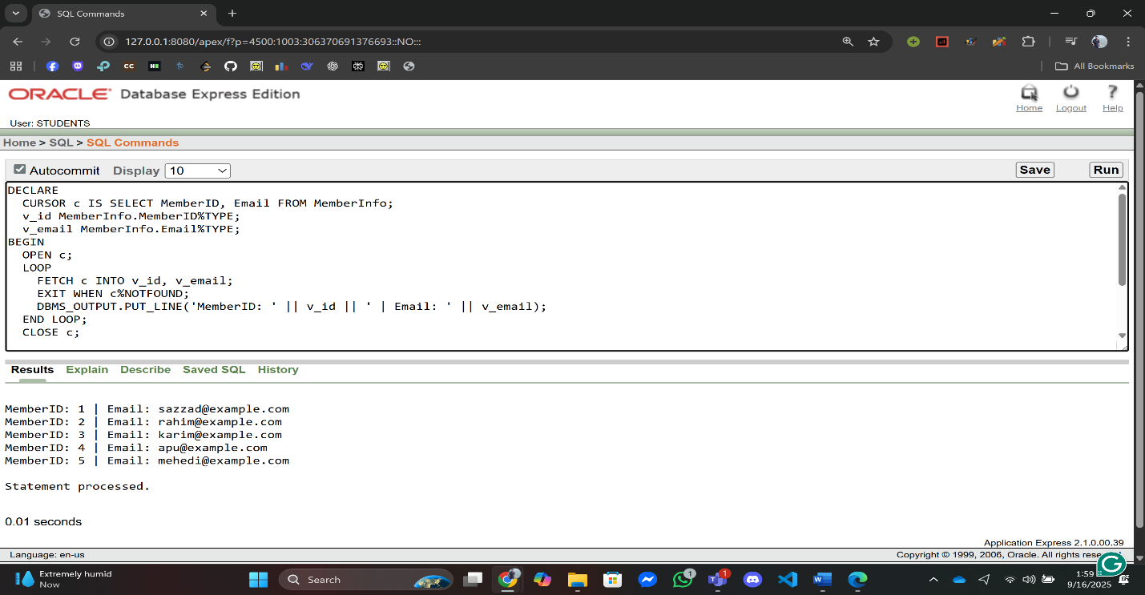/

**Q2:** Print First 3 Transaction Information.

**Answer:**

--Swimming Pool Management System,Summer,Advance Database Management System,A

DECLARE

CURSOR c IS SELECT TransactionID, Amount FROM TransactionInfo WHERE ROWNUM <= 3;

v_tid TransactionInfo.TransactionID%TYPE;

v_amt TransactionInfo.Amount%TYPE;

BEGIN

OPEN c;

LOOP

FETCH c INTO v_tid, v_amt;

EXIT WHEN c%NOTFOUND;

DBMS_OUTPUT.PUT_LINE('TransactionID: ' || v_tid || ' | Amount: ' || v_amt);

END LOOP;

CLOSE c;

EXCEPTION

WHEN OTHERS THEN

DBMS_OUTPUT.PUT_LINE('Error: ' || SQLERRM);

END;

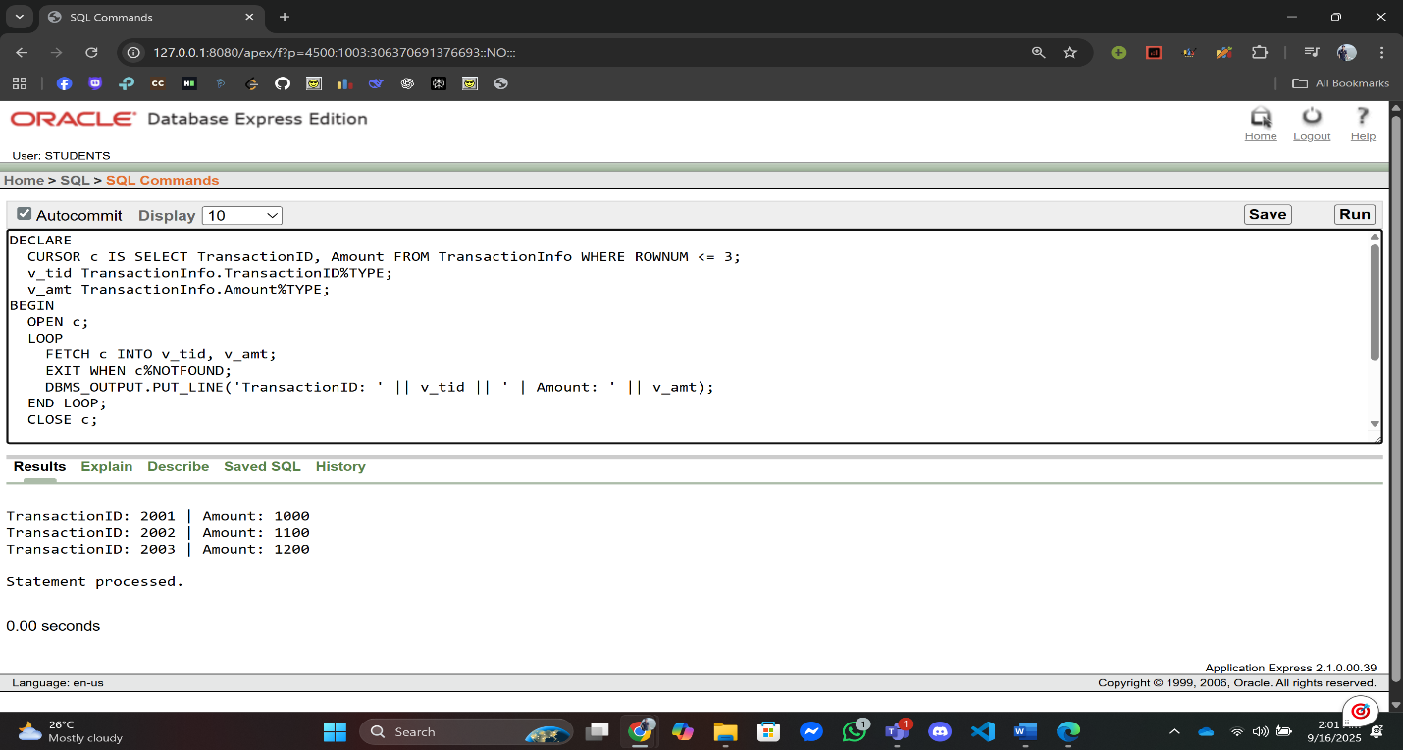 /

1. **Conditional Statements:**

**Q1:** Check if a member is Premium or Gold Platinum or Silver or Regular.

**Answer:**

--Swimming Pool Management System,Summer,Advance Database Management System,A

DECLARE

v_type MemberContactInfo.MembershipType%TYPE;

BEGIN

SELECT MembershipType INTO v_type

FROM MemberContactInfo

WHERE ROWNUM = 1;

IF v_type = 'Premium' THEN

DBMS_OUTPUT.PUT_LINE('Member is Premium');

ELSIF v_type = 'Gold' THEN

DBMS_OUTPUT.PUT_LINE('Member is Gold');

ELSIF v_type = 'Platinum' THEN

DBMS_OUTPUT.PUT_LINE('Member is Platinum');

ELSIF v_type = 'Silver' THEN

DBMS_OUTPUT.PUT_LINE('Member is Silver');

ELSE

DBMS_OUTPUT.PUT_LINE('Member is Regular');

END IF;

EXCEPTION

WHEN NO_DATA_FOUND THEN

DBMS_OUTPUT.PUT_LINE('No Member Found');

WHEN OTHERS THEN

DBMS_OUTPUT.PUT_LINE('Error: ' || SQLERRM);

END;

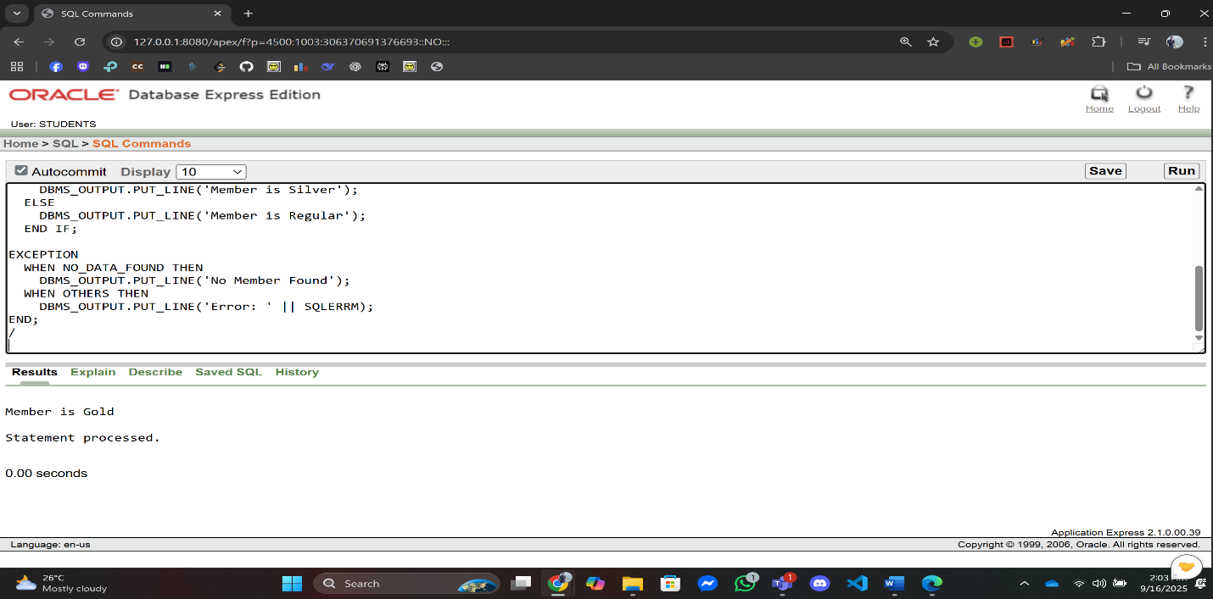

**Q2:** Check if a transaction amount is greater than 2000 for TransactionID = 2002.

**Answer:**

--Swimming Pool Management System,Summer,Advance Database Management System,A

DECLARE

v_amt TransactionInfo.Amount%TYPE;

BEGIN

SELECT Amount INTO v_amt

FROM TransactionInfo

WHERE TransactionID = 2002;

IF v_amt > 2000 THEN

DBMS_OUTPUT.PUT_LINE('Transaction > 2000');

ELSE

DBMS_OUTPUT.PUT_LINE('Transaction <= 2000');

END IF;

EXCEPTION

WHEN NO_DATA_FOUND THEN

DBMS_OUTPUT.PUT_LINE('Transaction ID 2002 not found');

WHEN OTHERS THEN

DBMS_OUTPUT.PUT_LINE('Error: ' || SQLERRM);

END;

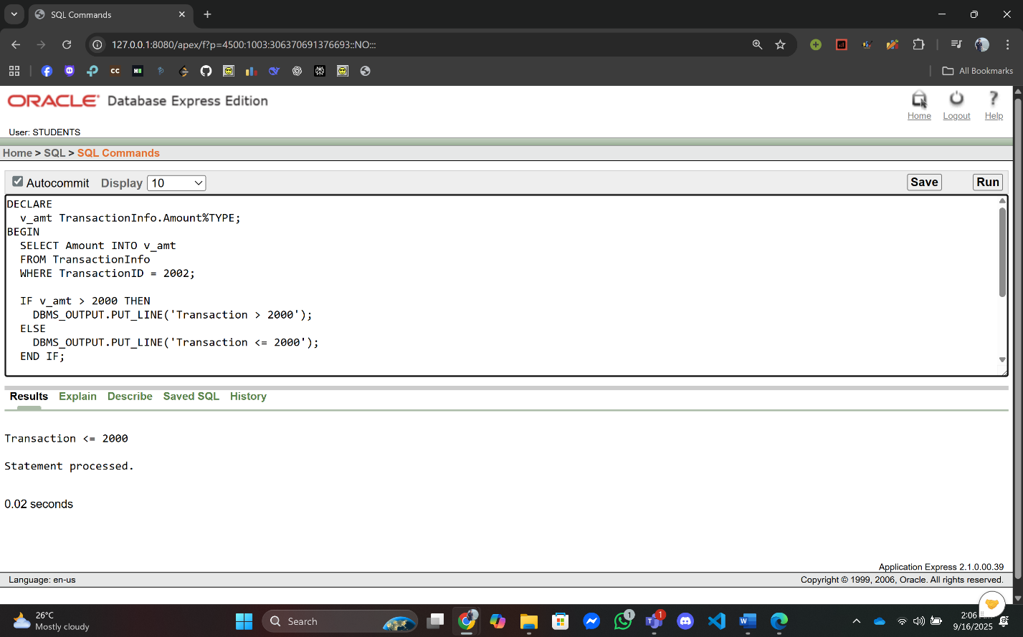

1. **Subquery:**

**Q1:** Find the member who made the earliest booking..

**Answer:**

--Swimming Pool Management System,Summer,Advance Database Management System,A

DECLARE

v_id MemberInfo.MemberID%TYPE;

v_name MemberInfo.Name%TYPE;

BEGIN

SELECT m.MemberID, m.Name

INTO v_id, v_name

FROM MemberInfo m

WHERE m.MemberID = (

SELECT MemberID

FROM MemberBookingInfo

WHERE BookingID = (

SELECT MIN(BookingID) FROM BookingInfo

)

);

DBMS_OUTPUT.PUT_LINE('Earliest Booking by MemberID: ' || v_id || ' Name: ' || v_name);

EXCEPTION

WHEN NO_DATA_FOUND THEN

DBMS_OUTPUT.PUT_LINE('No Member Found');

WHEN OTHERS THEN

DBMS_OUTPUT.PUT_LINE('Error: ' || SQLERRM);

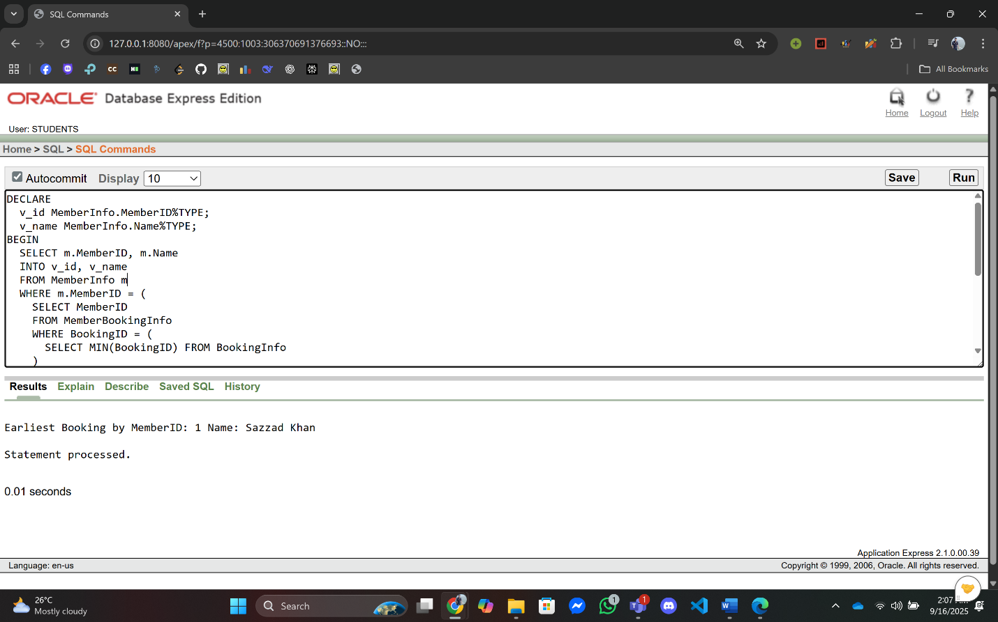END;

**Q2:** Find the member with the highest transaction amount

**Answer:**

--Swimming Pool Management System,Summer,Advance Database Management System,A

DECLARE

v_id MemberInfo.MemberID%TYPE;

v_name MemberInfo.Name%TYPE;

BEGIN

SELECT m.MemberID, m.Name

INTO v_id, v_name

FROM MemberInfo m

WHERE m.MemberID = (

SELECT MemberID

FROM TransactionInfo

WHERE Amount = (SELECT MAX(Amount) FROM TransactionInfo)

);

DBMS_OUTPUT.PUT_LINE('Highest Transaction by MemberID: ' || v_id || ' Name: ' || v_name);

EXCEPTION

WHEN NO_DATA_FOUND THEN

DBMS_OUTPUT.PUT_LINE('No Member Found');

WHEN OTHERS THEN

DBMS_OUTPUT.PUT_LINE('Error: ' || SQLERRM);

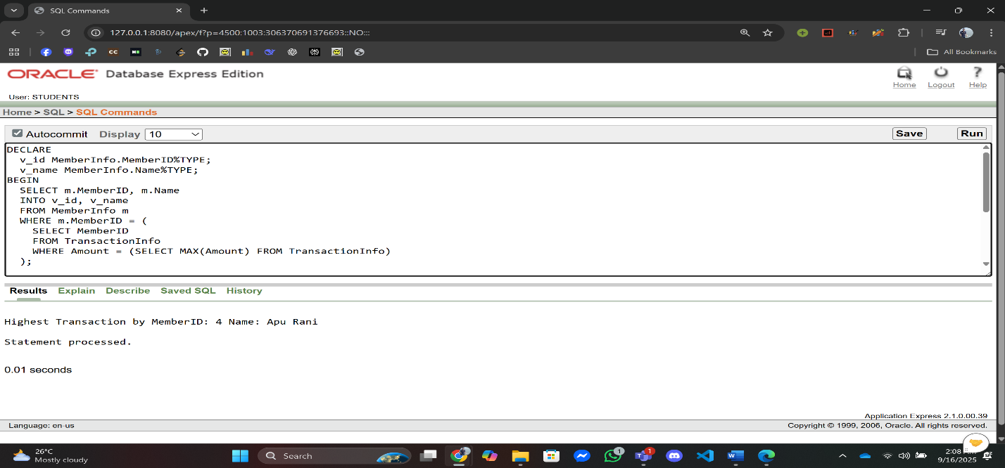END;

1. **Joining:**

**Q1:** Display the Member Name, Booking ID, and Booking Date for all members who have made bookings.

**Answer:**

--Swimming Pool Management System,Summer,Advance Database Management System,A

DECLARE

CURSOR c IS

SELECT m.Name, b.BookingID, b.BookingDate

FROM MemberInfo m

JOIN MemberBookingInfo mb ON m.MemberID = mb.MemberID

JOIN BookingInfo b ON mb.BookingID = b.BookingID;

v_name MemberInfo.Name%TYPE;

v_bid BookingInfo.BookingID%TYPE;

v_date BookingInfo.BookingDate%TYPE;

BEGIN

OPEN c;

LOOP

FETCH c INTO v_name, v_bid, v_date;

EXIT WHEN c%NOTFOUND;

DBMS_OUTPUT.PUT_LINE('Name: ' || v_name || ' | BookingID: ' || v_bid || ' | Date: ' || v_date);

END LOOP;

CLOSE c;

EXCEPTION

WHEN OTHERS THEN

DBMS_OUTPUT.PUT_LINE('Error: ' || SQLERRM);

END;

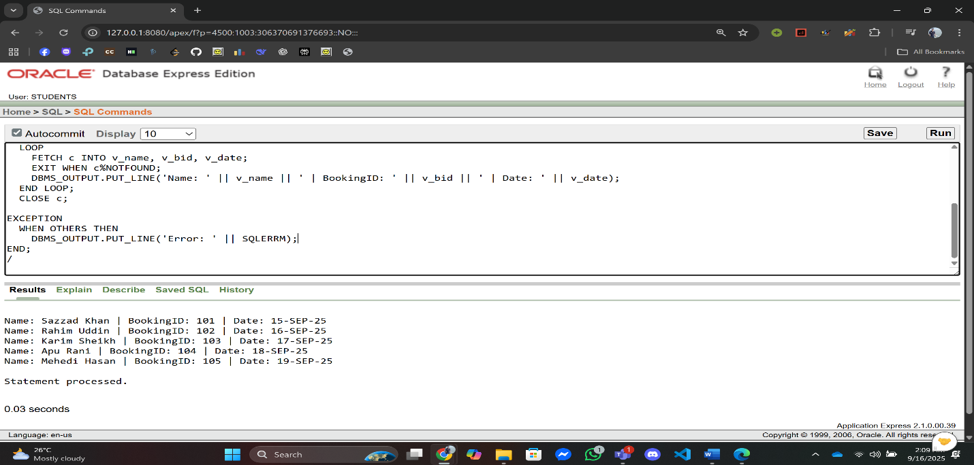

**Q2:** Display the Member Name, Booking Date, and Transaction Amount for all completed bookings.

**Answer:**

--Swimming Pool Management System,Summer,Advance Database Management System,A

DECLARE

CURSOR c IS

SELECT m.Name, b.BookingDate, t.Amount

FROM MemberInfo m

JOIN MemberBookingInfo mb ON m.MemberID = mb.MemberID

JOIN BookingInfo b ON mb.BookingID = b.BookingID

JOIN BookingTransactionInfo bt ON b.BookingID = bt.BookingID

JOIN TransactionInfo t ON bt.TransactionID = t.TransactionID;

v_name MemberInfo.Name%TYPE;

v_date BookingInfo.BookingDate%TYPE;

v_amt TransactionInfo.Amount%TYPE;

BEGIN

OPEN c;

LOOP

FETCH c INTO v_name, v_date, v_amt;

EXIT WHEN c%NOTFOUND;

DBMS_OUTPUT.PUT_LINE('Name: ' || v_name || ' | Date: ' || v_date || ' | Amount: ' || v_amt);

END LOOP;

CLOSE c;

EXCEPTION

WHEN OTHERS THEN

DBMS_OUTPUT.PUT_LINE('Error: ' || SQLERRM);

END;

/

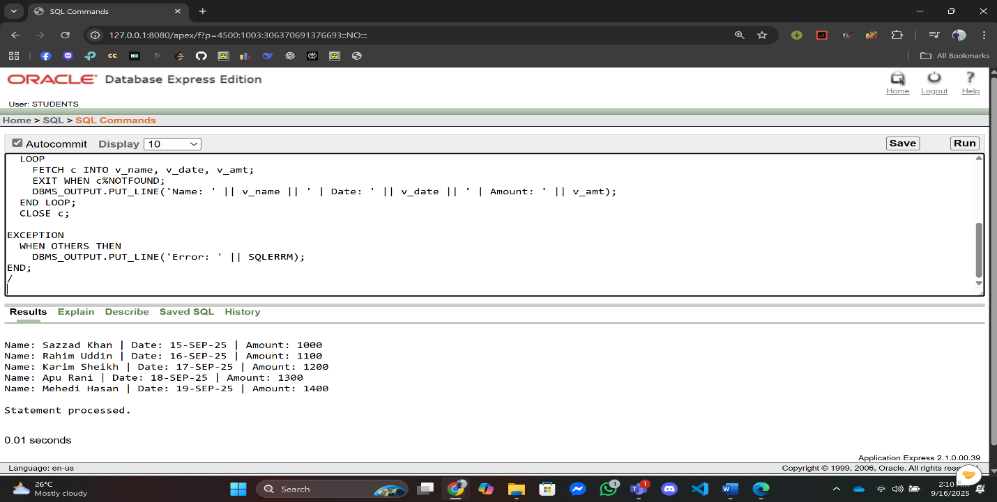

**Advance PL/SQL**

1. **Stored Function:**

**Q1:** Write a function that returns the total number of bookings.

**Answer:**

**Function Creation:**

CREATE OR REPLACE FUNCTION total_Booking_for_Member RETURN NUMBER IS

v_count NUMBER;

BEGIN

SELECT COUNT(*) INTO v_count FROM BookingInfo;

RETURN v_count;

EXCEPTION

WHEN OTHERS THEN

DBMS_OUTPUT.PUT_LINE('total_bookings error: '||SQLERRM);

RETURN NULL;

END total_Booking_for_Member;

**Query:**

--Swimming Pool Management System,Summer,Advance Database Management System,A

DECLARE

result Number;

BEGIN

result := total_Booking_for_Member;

DBMS_OUTPUT.PUT_LINE('Total Booking ' || result);

END;

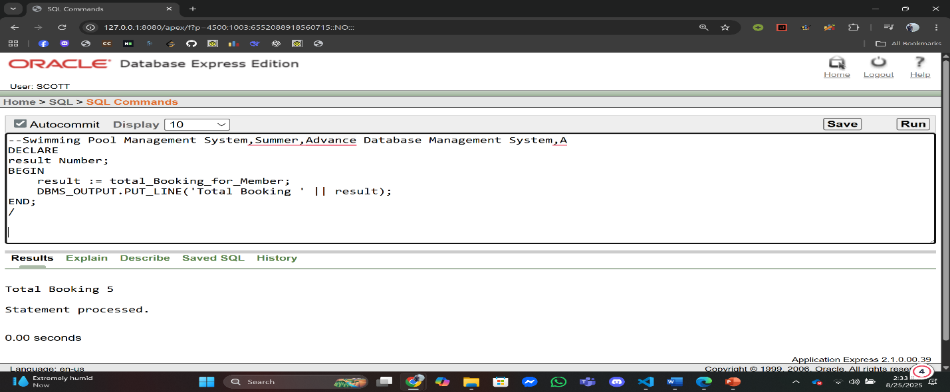/

**Q2:** Write a stored function that takes a TransactionID as input and returns the payment method used for that transaction.

**Answer:**

**Function Creation:**

CREATE OR REPLACE FUNCTION fn_payment_method(p_txn_id IN NUMBER) RETURN VARCHAR2 IS

v_method PaymentTypeInfo.PaymentMethod%TYPE;

BEGIN

SELECT PaymentMethod INTO v_method FROM PaymentTypeInfo WHERE TransactionID = p_txn_id;

RETURN v_method;

EXCEPTION

WHEN NO_DATA_FOUND THEN

DBMS_OUTPUT.PUT_LINE('No payment for TransactionID='||p_txn_id);

RETURN NULL;

WHEN OTHERS THEN

DBMS_OUTPUT.PUT_LINE('fn_payment_method error: '||SQLERRM);

RETURN NULL;

END fn_payment_method;

/

**Query:**

--Swimming Pool Management System,Summer,Advance Database Management System,A

DECLARE

result varchar(50);

BEGIN

result := fn_payment_method(2004);

DBMS_OUTPUT.PUT_LINE('Payment Method is ' || result);

END;

/

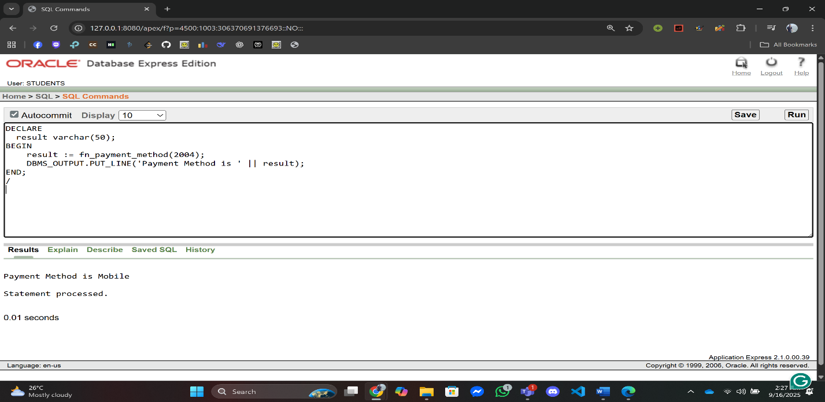

1. **Stored Procedure:**

**Q1:** Write a procedure that displays all staff names working in a specific pool.

**Answer:**

**Procedure Creation:**

CREATE OR REPLACE PROCEDURE pr_show_staff_by_pool(p_poolid IN NUMBER) IS

BEGIN

FOR r IN (

SELECT s.StaffID, s.Name

FROM PoolStaffInfo psi

JOIN StaffInfo s ON psi.StaffID = s.StaffID

WHERE psi.PoolID = p_poolid

) LOOP

DBMS_OUTPUT.PUT_LINE('StaffID:'||r.StaffID||' Name:'||r.Name);

END LOOP;

EXCEPTION

WHEN OTHERS THEN DBMS_OUTPUT.PUT_LINE('pr_show_staff_by_pool error: '||SQLERRM);

END pr_show_staff_by_pool;

**Query:**

--Swimming Pool Management System,Summer,Advance Database Management System,A

DECLARE

BEGIN

pr_show_staff_by_pool(5002);

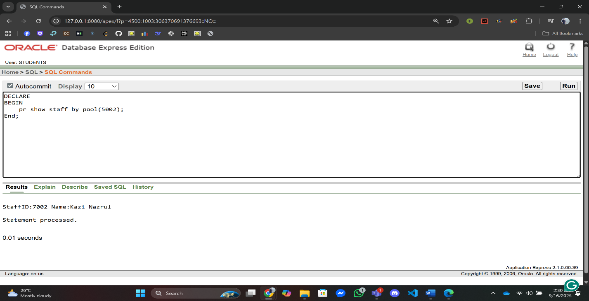END;

**Q2:** Create a procedure that checks how many bookings a member has. If more than 5, update their RedStatus to 'YES'.

**Answer:**

**Procedure Creation:**

CREATE OR REPLACE PROCEDURE pr_check_and_update_redstatus(p_memberid IN NUMBER) IS

v_count NUMBER;

v_email MemberInfo.Email%TYPE;

BEGIN

SELECT Email INTO v_email FROM MemberInfo WHERE MemberID = p_memberid;

SELECT COUNT(*) INTO v_count FROM MemberBookingInfo WHERE MemberID = p_memberid;

IF v_count > 5 THEN

UPDATE MemberContactInfo SET RedStatus = 'YES' WHERE Email = v_email;

COMMIT;

DBMS_OUTPUT.PUT_LINE('Updated RedStatus=YES for MemberID='||p_memberid);

ELSE

DBMS_OUTPUT.PUT_LINE('MemberID='||p_memberid||' bookings='||v_count||' (no update)');

END IF;

EXCEPTION

WHEN NO_DATA_FOUND THEN DBMS_OUTPUT.PUT_LINE('Member not found: '||p_memberid);

WHEN OTHERS THEN

ROLLBACK;

DBMS_OUTPUT.PUT_LINE('pr_check_and_update_redstatus error: '||SQLERRM);

END pr_check_and_update_redstatus;

**Query:**

--Swimming Pool Management System,Summer,Advance Database Management System,A

DECLARE

BEGIN

pr_check_and_update_redstatus(1);

END;

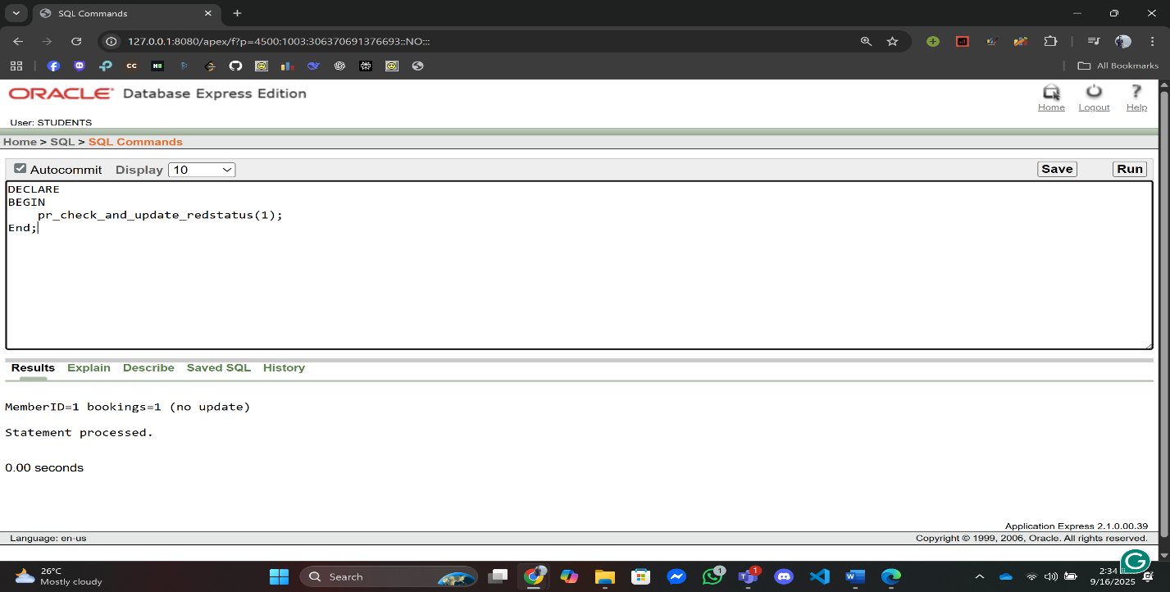

1. **Table-based Record:**

**Q1:** Store one row of MemberInfo in a record and display it.

**Answer:**

--Swimming Pool Management System,Summer,Advance Database Management System,A

DECLARE

rec MemberInfo%ROWTYPE;

BEGIN

SELECT * INTO rec FROM MemberInfo WHERE MemberID = 1;

DBMS_OUTPUT.PUT_LINE('MemberID:'||rec.MemberID||' Name:'||rec.Name||' Email:'||rec.Email||' JoinDate:'||TO_CHAR(rec.JoinDate,'YYYY-MM-DD'));

EXCEPTION

WHEN NO_DATA_FOUND THEN DBMS_OUTPUT.PUT_LINE('Member 1 not found');

WHEN OTHERS THEN DBMS_OUTPUT.PUT_LINE('Error: '||SQLERRM);

END;

/

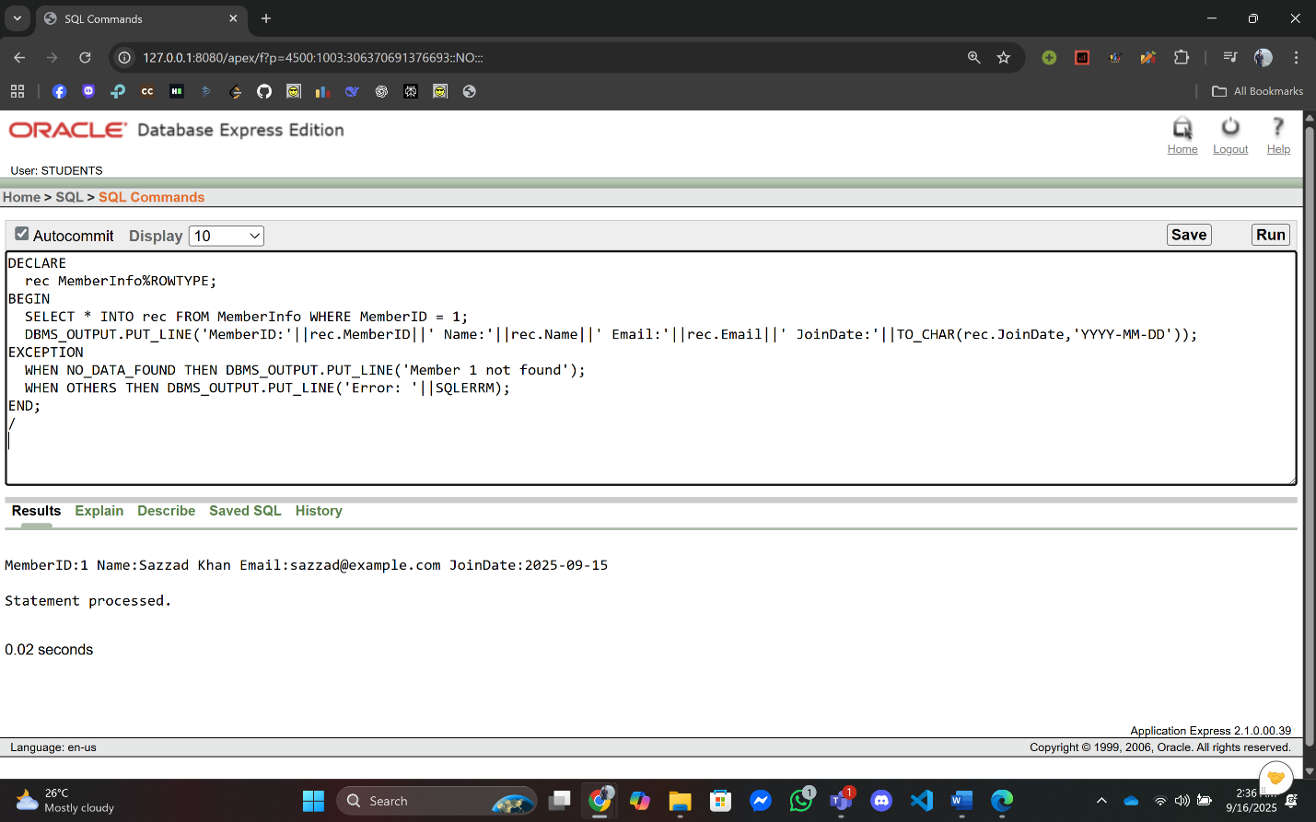

**Q2:** Fetch one TransactionInfo row into a record and print.

**Answer:**

--Swimming Pool Management System,Summer,Advance Database Management System,A

DECLARE

rec TransactionInfo%ROWTYPE;

BEGIN

SELECT * INTO rec FROM TransactionInfo WHERE TransactionID = 2001;

DBMS_OUTPUT.PUT_LINE('TxnID:'||rec.TransactionID||' Date:'||TO_CHAR(rec.TransactionDate,'YYYY-MM-DD')||' Amount:'||rec.Amount||' MemberID:'||rec.MemberID);

EXCEPTION

WHEN NO_DATA_FOUND THEN DBMS_OUTPUT.PUT_LINE('Transaction 2001 not found');

WHEN OTHERS THEN DBMS_OUTPUT.PUT_LINE('Error: '||SQLERRM);

END;

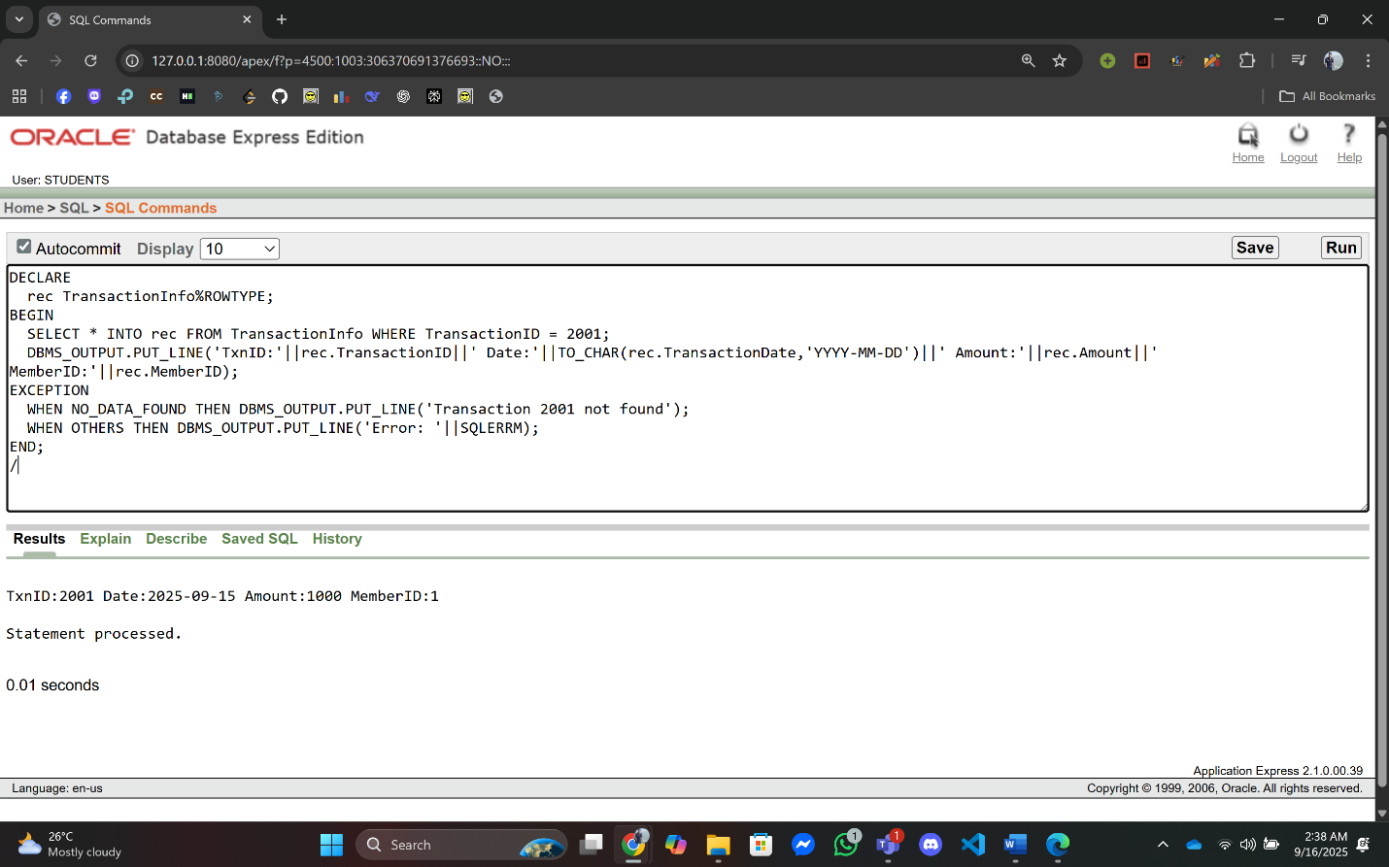

1. **Cursor-based Record:**

**Q1:** Write a PL/SQL program using a cursor-based record to fetch all bookings of a given MemberID and display BookingID and BookingDate.

**Answer:**

--Swimming Pool Management System,Summer,Advance Database Management DECLARE

CURSOR c_bookings(p_mid NUMBER) IS

SELECT b.BookingID, b.BookingDate FROM BookingInfo b JOIN MemberBookingInfo mb ON b.BookingID = mb.BookingID WHERE mb.MemberID = p_mid;

rec c_bookings%ROWTYPE;

v_memberid NUMBER := 1;

BEGIN

OPEN c_bookings(v_memberid);

LOOP

FETCH c_bookings INTO rec;

EXIT WHEN c_bookings%NOTFOUND;

DBMS_OUTPUT.PUT_LINE('BookingID:'||rec.BookingID||' Date:'||TO_CHAR(rec.BookingDate,'YYYY-MM-DD'));

END LOOP;

CLOSE c_bookings;

EXCEPTION

WHEN OTHERS THEN

IF c_bookings%ISOPEN THEN CLOSE c_bookings; END IF;

DBMS_OUTPUT.PUT_LINE('Error: '||SQLERRM);

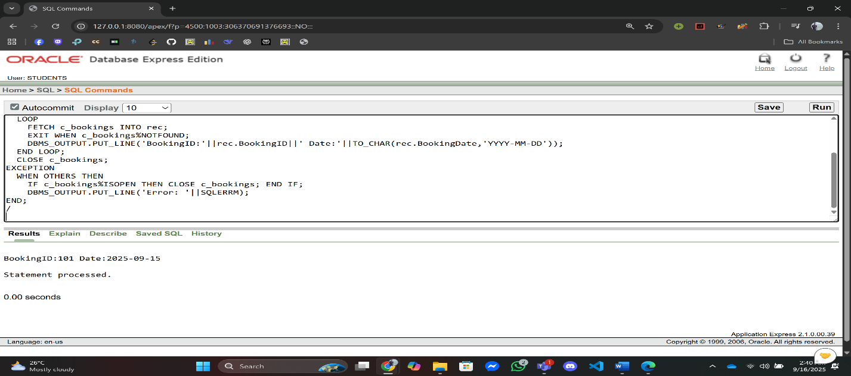END;

**Q2:** Write a PL/SQL program to fetch each member’s total transaction amount using cursor-based record.

**Answer:**

--Swimming Pool Management System,Summer,Advance Database Management System,A

DECLARE

CURSOR cur_trans IS

SELECT m.MemberID, m.Name, SUM(t.Amount) AS TotalAmount

FROM MemberInfo m

JOIN MemberTransactionInfo mt

ON m.MemberID = mt.MemberID

JOIN TransactionInfo t

ON mt.TransactionID = t.TransactionID

GROUP BY m.MemberID, m.Name;

rec_trans cur_trans%ROWTYPE;

BEGIN

OPEN cur_trans;

LOOP

FETCH cur_trans INTO rec_trans;

EXIT WHEN cur_trans%NOTFOUND;

DBMS_OUTPUT.PUT_LINE('Member: ' || rec_trans.Name ||

', Total Transaction: ' || rec_trans.TotalAmount);

END LOOP;

CLOSE cur_trans;

EXCEPTION

WHEN OTHERS THEN DBMS_OUTPUT.PUT_LINE('Error: '||SQLERRM);

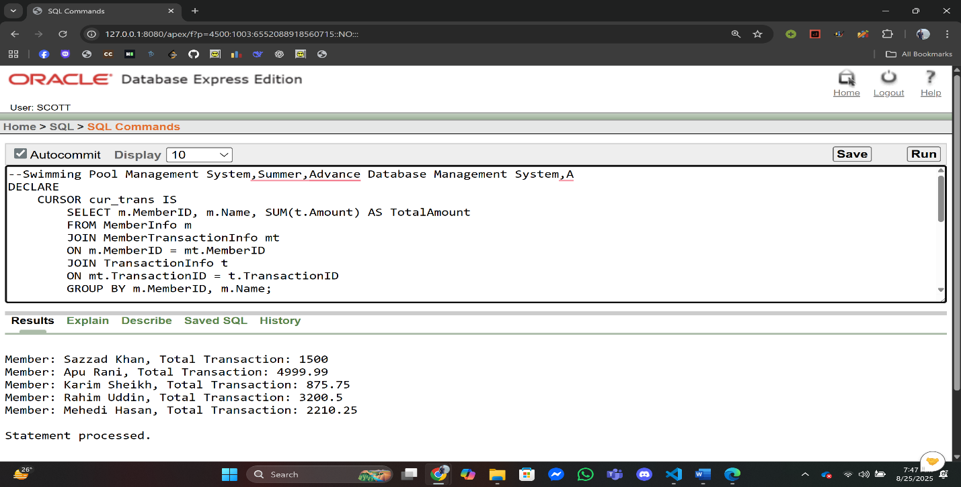END;

1. **Explicit Cursor:**

**Q1:** Print all Member names using a cursor.

**Answer:**

--Swimming Pool Management System,Summer,Advance Database Management System,A

DECLARE

CURSOR c IS SELECT Name FROM MemberInfo;

v_name MemberInfo.Name%TYPE;

BEGIN

OPEN c;

LOOP

FETCH c INTO v_name;

EXIT WHEN c%NOTFOUND;

DBMS_OUTPUT.PUT_LINE('Member: '||v_name);

END LOOP;

CLOSE c;

EXCEPTION

WHEN OTHERS THEN

IF c%ISOPEN THEN CLOSE c; END IF;

DBMS_OUTPUT.PUT_LINE('Error: '||SQLERRM);

END;

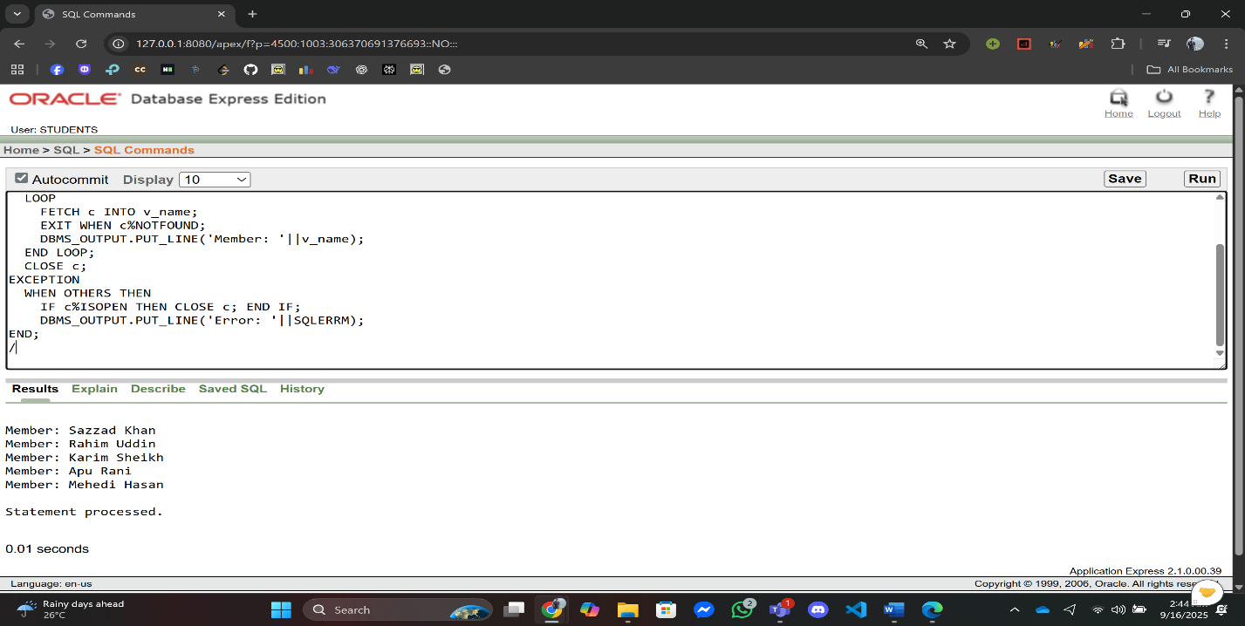

**Q2:** Print all booking dates using a cursor.

**Answer:**

--Swimming Pool Management System,Summer,Advance Database Management System,A

DECLARE

CURSOR c IS SELECT BookingDate FROM BookingInfo;

v_date BookingInfo.BookingDate%TYPE;

BEGIN

OPEN c;

LOOP

FETCH c INTO v_date;

EXIT WHEN c%NOTFOUND;

DBMS_OUTPUT.PUT_LINE('BookingDate: '||TO_CHAR(v_date,'YYYY-MM-DD'));

END LOOP;

CLOSE c;

EXCEPTION

WHEN OTHERS THEN

IF c%ISOPEN THEN CLOSE c; END IF;

DBMS_OUTPUT.PUT_LINE('Error: '||SQLERRM);

END;

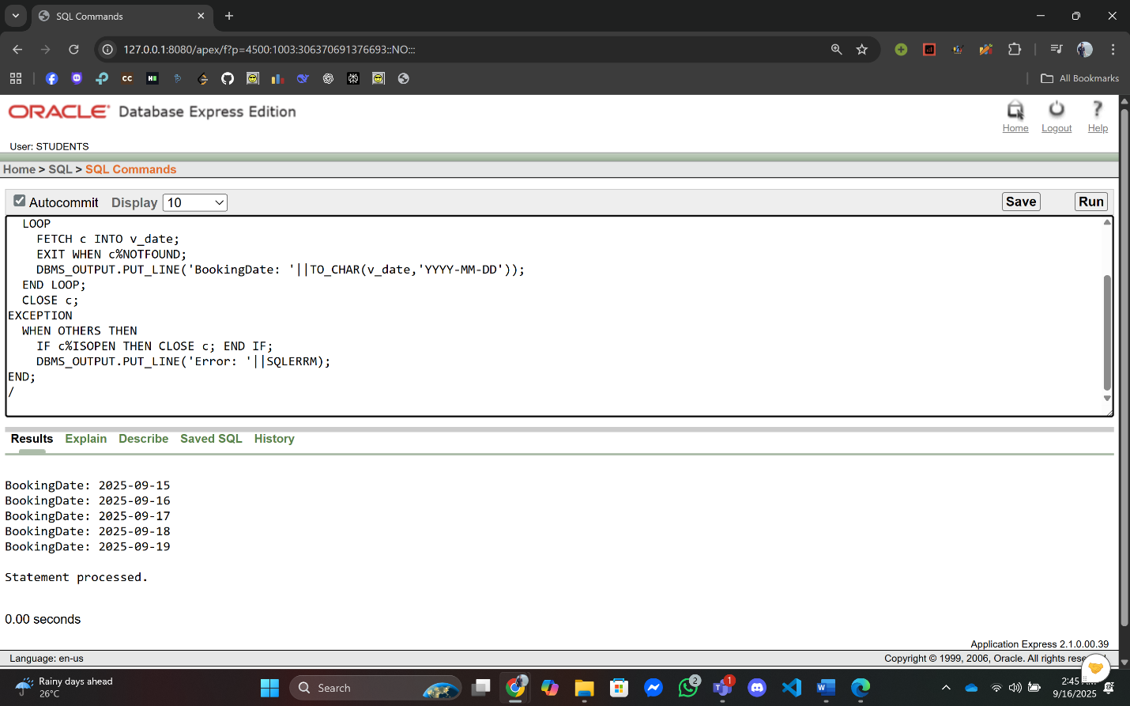/

1. **Row Level Trigger:**

**Q1:** Create a row-level trigger that prevents adding a booking if the pool capacity is already full.

**Answer:**

**Trigger Creation:**

--Swimming Pool Management System,Summer,Advance Database Management System,A

CREATE OR REPLACE TRIGGER trg_prevent_overbook

BEFORE INSERT ON MemberBookingInfo

FOR EACH ROW

DECLARE

v_poolid PoolInfo.PoolID%TYPE;

v_capacity PoolInfo.Capacity%TYPE;

v_count NUMBER;

BEGIN

BEGIN

SELECT PoolID, Capacity INTO v_poolid, v_capacity FROM PoolInfo WHERE BookingID = :NEW.BookingID;

EXCEPTION

WHEN NO_DATA_FOUND THEN

-- no pool linked to booking: allow or block as per policy; here allow

RETURN;

END;

SELECT COUNT(*) INTO v_count FROM MemberBookingInfo WHERE BookingID = :NEW.BookingID;

IF v_count >= v_capacity THEN

RAISE_APPLICATION_ERROR(-20001, 'Cannot insert: pool capacity reached.');

END IF;

EXCEPTION

WHEN OTHERS THEN

RAISE; -- let Oracle handle unexpected errors

END;

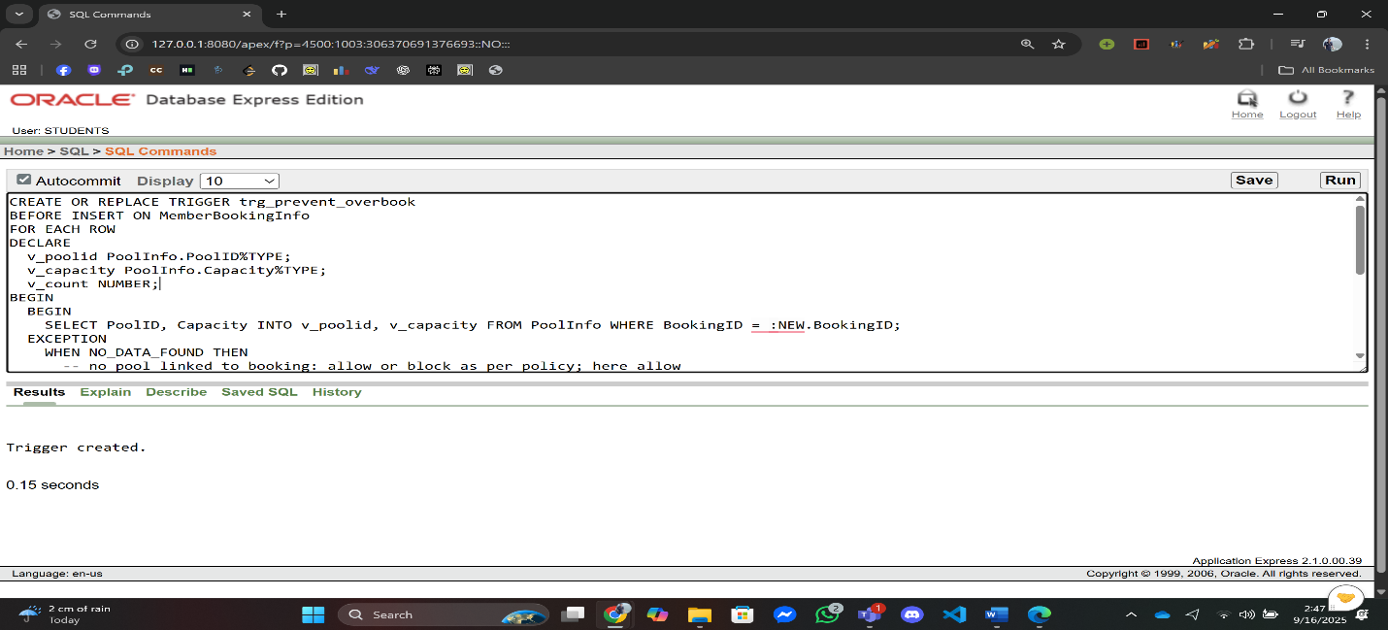

**Q2:** Create a row-level trigger that shows a message whenever a booking record is updated in BookingInfo.

**Answer:**

**Trigger Creation:**

--Swimming Pool Management System,Summer,Advance Database Management System,A

CREATE OR REPLACE TRIGGER trg_booking_update_msg

AFTER UPDATE ON BookingInfo

FOR EACH ROW

DECLARE

BEGIN

DBMS_OUTPUT.PUT_LINE('Booking updated: ID='||:OLD.BookingID||' OldDate='||TO_CHAR(:OLD.BookingDate,'YYYY-MM-DD')||' NewDate='||TO_CHAR(:NEW.BookingDate,'YYYY-MM-DD'));

EXCEPTION

WHEN OTHERS THEN

NULL; -- avoid blocking update due to logging

END;

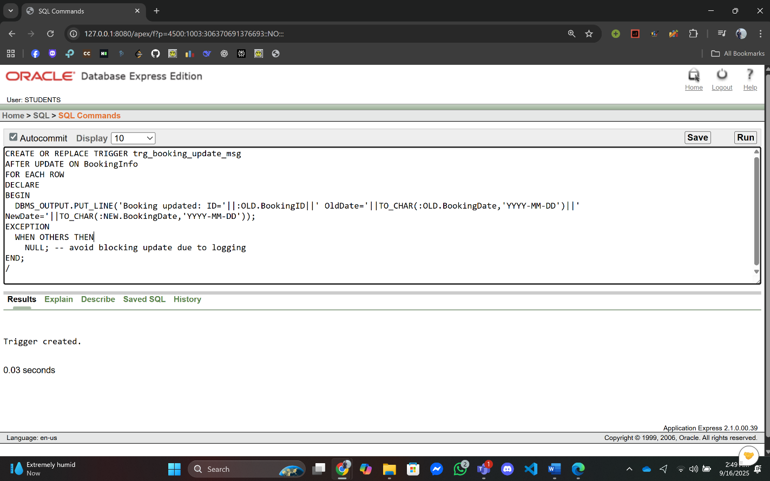

1. **Statement Level Trigger:**

**Q1:** Log whenever a booking is inserted.

**Answer:**

**Trigger Creation:**

--Swimming Pool Management System,Summer,Advance Database Management System,A

CREATE OR REPLACE TRIGGER trg_booking_log

AFTER INSERT ON BookingInfo

BEGIN

DBMS_OUTPUT.PUT_LINE('A new booking has been added.');

EXCEPTION

WHEN OTHERS THEN

NULL;

END;

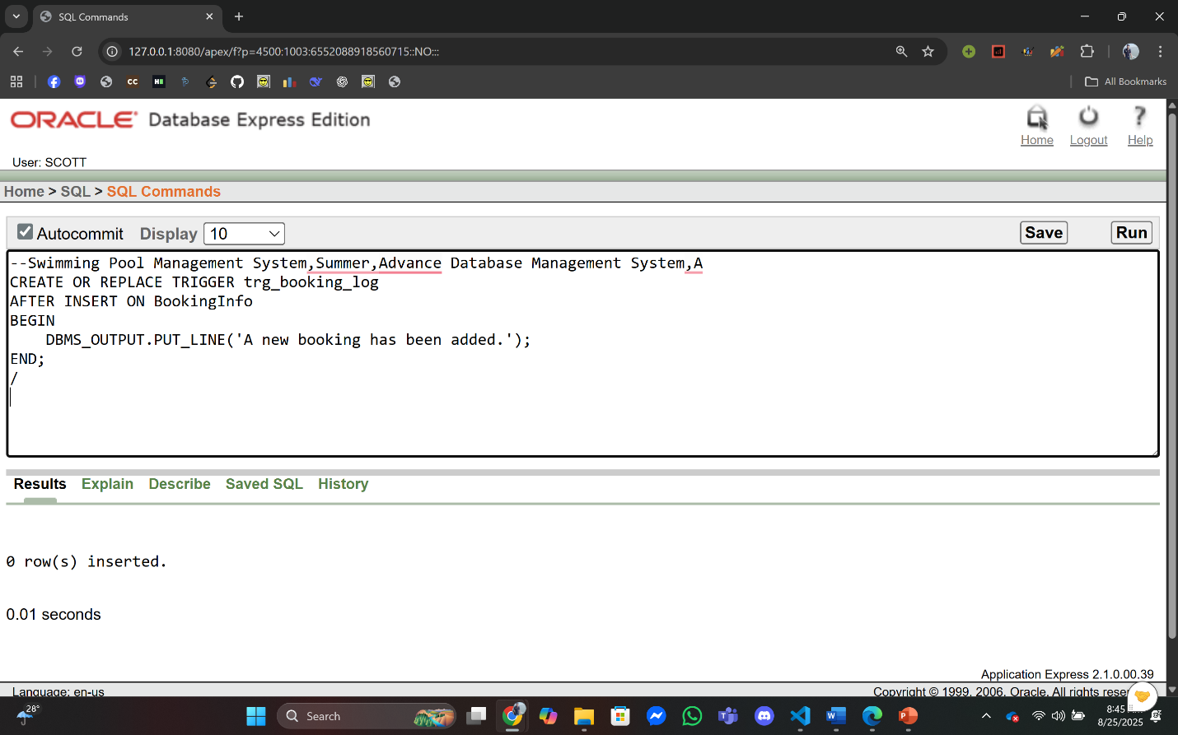

**Q2:** Log whenever a trainer is deleted.

**Answer:**

**Trigger Creation:**

--Swimming Pool Management System,Summer,Advance Database Management System,A

CREATE OR REPLACE TRIGGER trg_trainer_delete

AFTER DELETE ON TrainerInfo

BEGIN

DBMS_OUTPUT.PUT_LINE('A trainer record has been deleted.');

EXCEPTION

WHEN OTHERS THEN

NULL;

END;

/

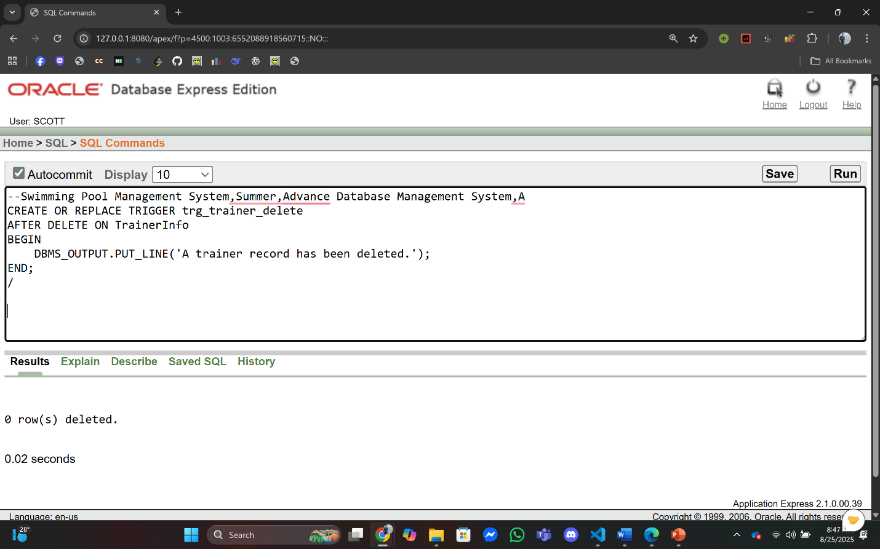

1. **Package:**

**Q1:** Create a package for **Reporting**, showing total bookings per pool and member details.

**Answer:**

**Package Specification:**

--Swimming Pool Management System,Summer,Advance Database Management System,A

CREATE OR REPLACE PACKAGE pkg_reporting IS

PROCEDURE show_total_bookings_per_pool;

PROCEDURE show_member_details(p_memberid IN NUMBER);

END pkg_reporting;

/

**Package Body:**

--Swimming Pool Management System,Summer,Advance Database Management System,A

CREATE OR REPLACE PACKAGE BODY pkg_reporting IS

PROCEDURE show_total_bookings_per_pool IS

BEGIN

FOR r IN (

SELECT p.PoolID, p.Location, NVL(COUNT(mb.BookingID),0) NumBookings

FROM PoolInfo p

LEFT JOIN MemberBookingInfo mb ON p.BookingID = mb.BookingID

GROUP BY p.PoolID, p.Location

ORDER BY p.PoolID

) LOOP

DBMS_OUTPUT.PUT_LINE('PoolID:'||r.PoolID||' Location:'||r.Location||' Bookings:'||r.NumBookings);

END LOOP;

EXCEPTION WHEN OTHERS THEN DBMS_OUTPUT.PUT_LINE('show_total_bookings_per_pool error:'||SQLERRM);

END;

PROCEDURE show_member_details(p_memberid IN NUMBER) IS

v_name MemberInfo.Name%TYPE;

v_email MemberInfo.Email%TYPE;

BEGIN

SELECT Name, Email INTO v_name, v_email FROM MemberInfo WHERE MemberID = p_memberid;

DBMS_OUTPUT.PUT_LINE('MemberID:'||p_memberid||' Name:'||v_name||' Email:'||v_email);

EXCEPTION

WHEN NO_DATA_FOUND THEN DBMS_OUTPUT.PUT_LINE('Member not found: '||p_memberid);

WHEN OTHERS THEN DBMS_OUTPUT.PUT_LINE('show_member_details error:'||SQLERRM);

END;

END pkg_reporting;

/

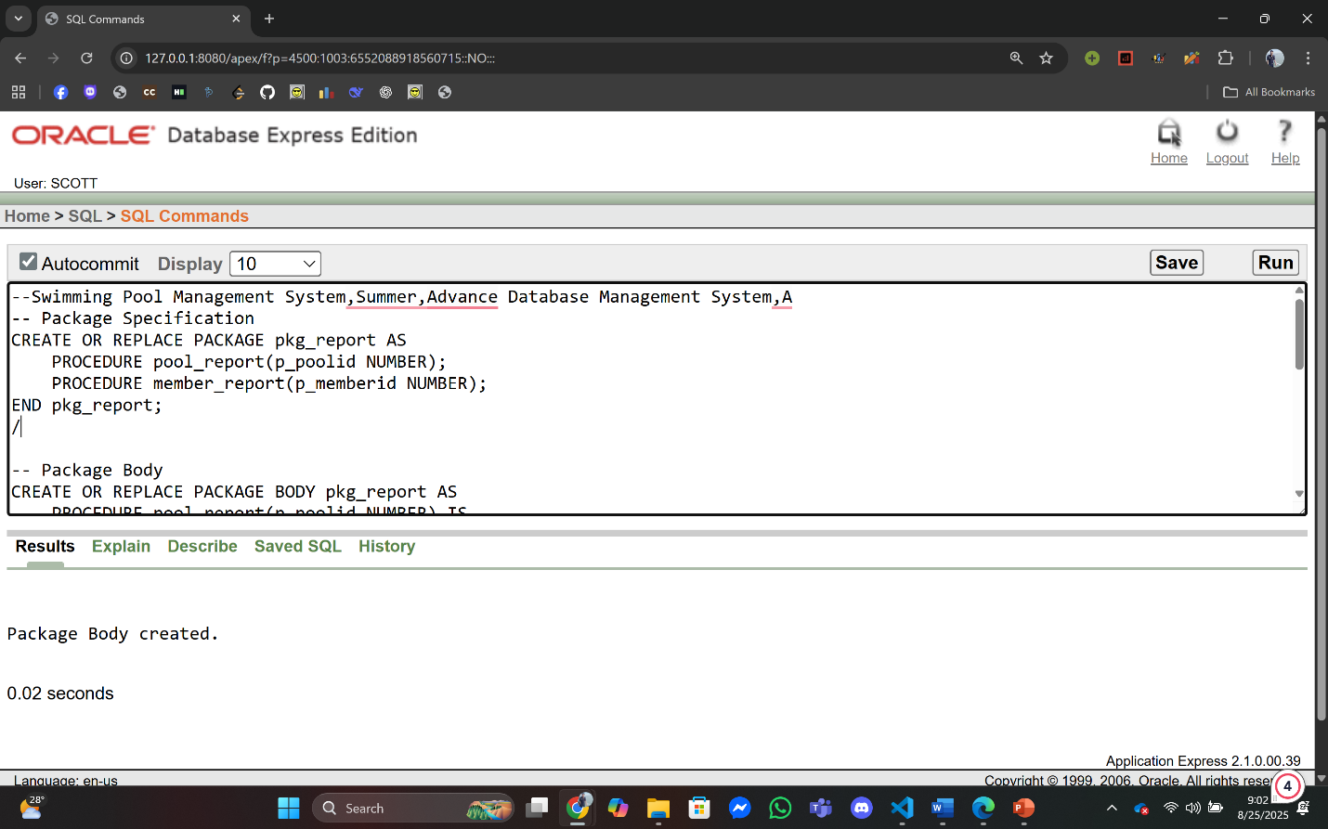

**Q2:** Create a package with two procedures show_total_bookings – Display total bookings for a member.show_member_email – Display the email of a member.

**Answer:**

**Package Specification:**

--Swimming Pool Management System,Summer,Advance Database Management System,A

CREATE OR REPLACE PACKAGE pkg_member_reports IS

PROCEDURE show_total_bookings(p_memberid IN NUMBER);

PROCEDURE show_member_email(p_memberid IN NUMBER);

END pkg_member_reports;

/

**Package Body:**

--Swimming Pool Management System,Summer,Advance Database Management System,A

CREATE OR REPLACE PACKAGE BODY pkg_member_reports IS

PROCEDURE show_total_bookings(p_memberid IN NUMBER) IS

v_count NUMBER;

BEGIN

SELECT COUNT(*) INTO v_count FROM MemberBookingInfo WHERE MemberID = p_memberid;

DBMS_OUTPUT.PUT_LINE('MemberID:'||p_memberid||' TotalBookings:'||v_count);

EXCEPTION

WHEN OTHERS THEN DBMS_OUTPUT.PUT_LINE('show_total_bookings error:'||SQLERRM);

END;

PROCEDURE show_member_email(p_memberid IN NUMBER) IS

v_email MemberInfo.Email%TYPE;

BEGIN

SELECT Email INTO v_email FROM MemberInfo WHERE MemberID = p_memberid;

DBMS_OUTPUT.PUT_LINE('MemberID:'||p_memberid||' Email:'||v_email);

EXCEPTION

WHEN NO_DATA_FOUND THEN DBMS_OUTPUT.PUT_LINE('Member not found:'||p_memberid);

WHEN OTHERS THEN DBMS_OUTPUT.PUT_LINE('show_member_email error:'||SQLERRM);

END;

END pkg_member_reports;

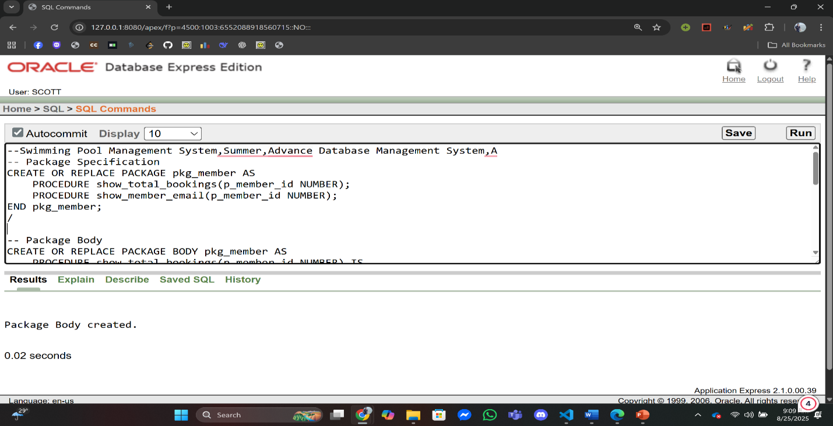/

**Relational Algebra**

**Q1:** Find the MembershipType of the Member whose Email is ‘sazzad@example.com' (Table Name:MemberContactInfo)

**Answer:**

Õ*MembershipType* (s*Email*= “sazzad@example.com” (*MemberContactInfo*))

**Q2:** Find Name of the Member whose MemberID is 3.(Table Name:MemberInfo)

**Answer:**

Õ*Name*(s*MemberID*= “3” (*MemberInfo*))

**Q3:** Find the PoolID of the pool where pool location in Khulna .(Table Name:PoolInfo)

**Answer:**

Õ*PoolID*(s*Location*= “Khulna” (*PoolInfo*))

**Q4:** Find the date of the event “Winter Training”.(Table Name:EventInfo)

**Answer:**

Õ*EventDate*(s*Name*= “Winter Training” (*EventInfo*))

**Q5:** Find the Email of the trainer whose Name is Tahsin.(Table Name:TrainerInfo)

**Answer:**

Õ*Email*(s*Name*= “Tahsin” (*TrainerInfo*))

**Graphical User Interface**

**Login:**

**Proposed Interface**

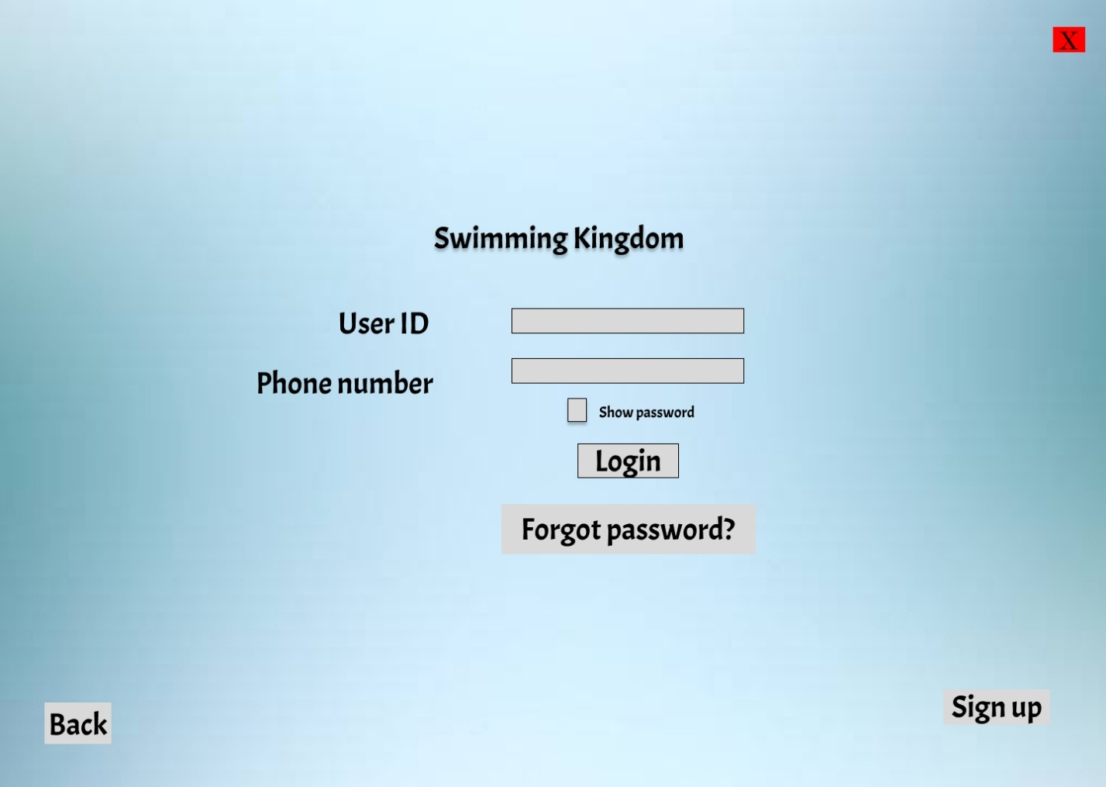

**Implemented Interface**

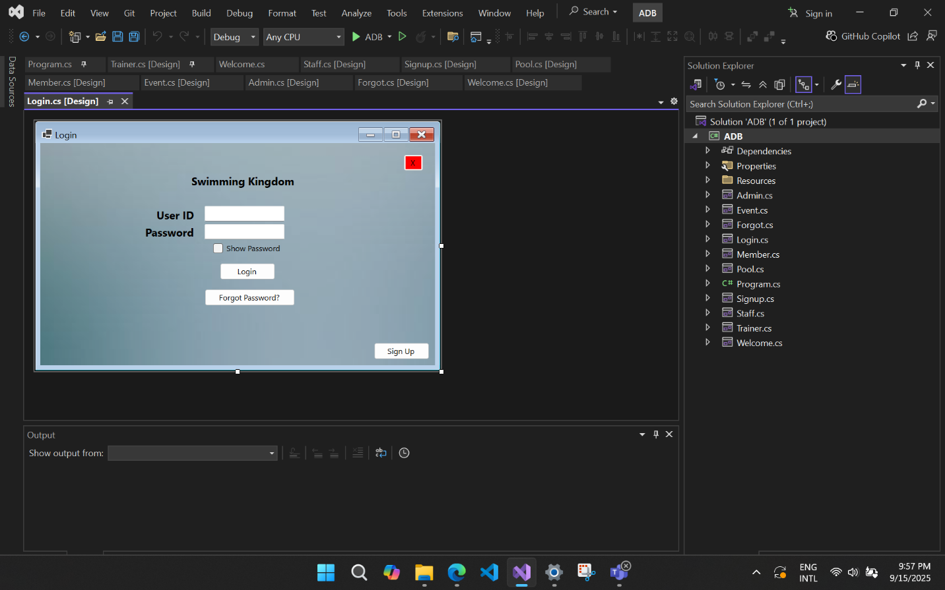

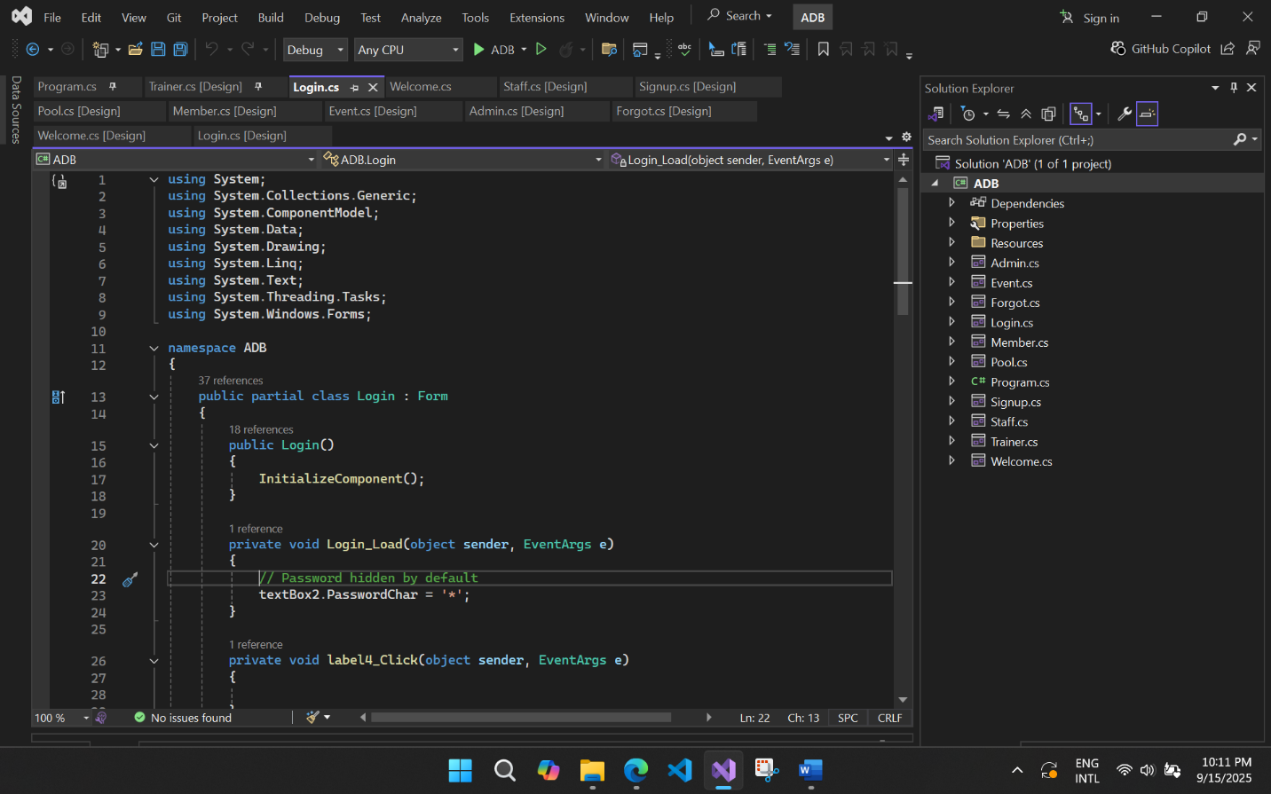**Code**

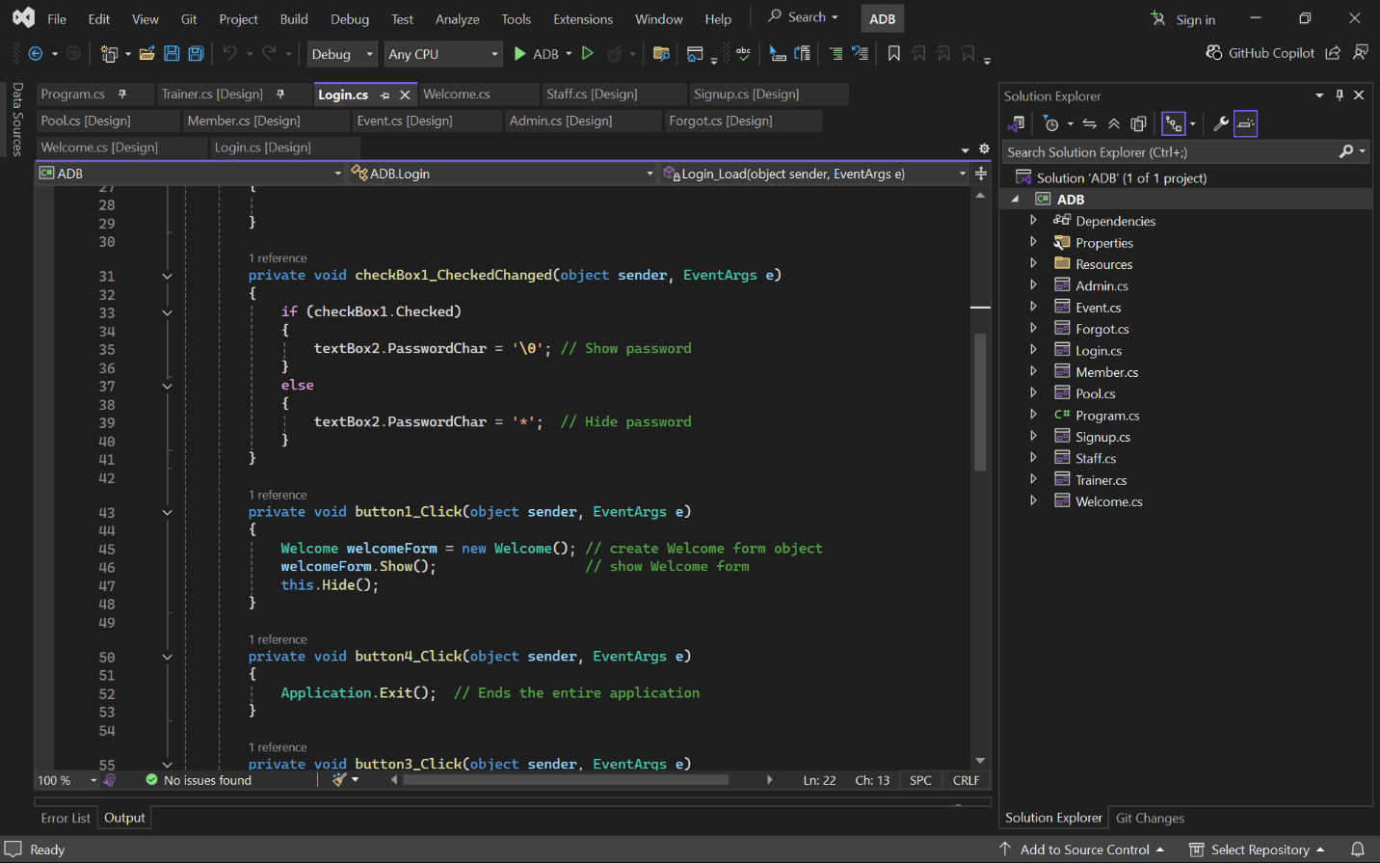

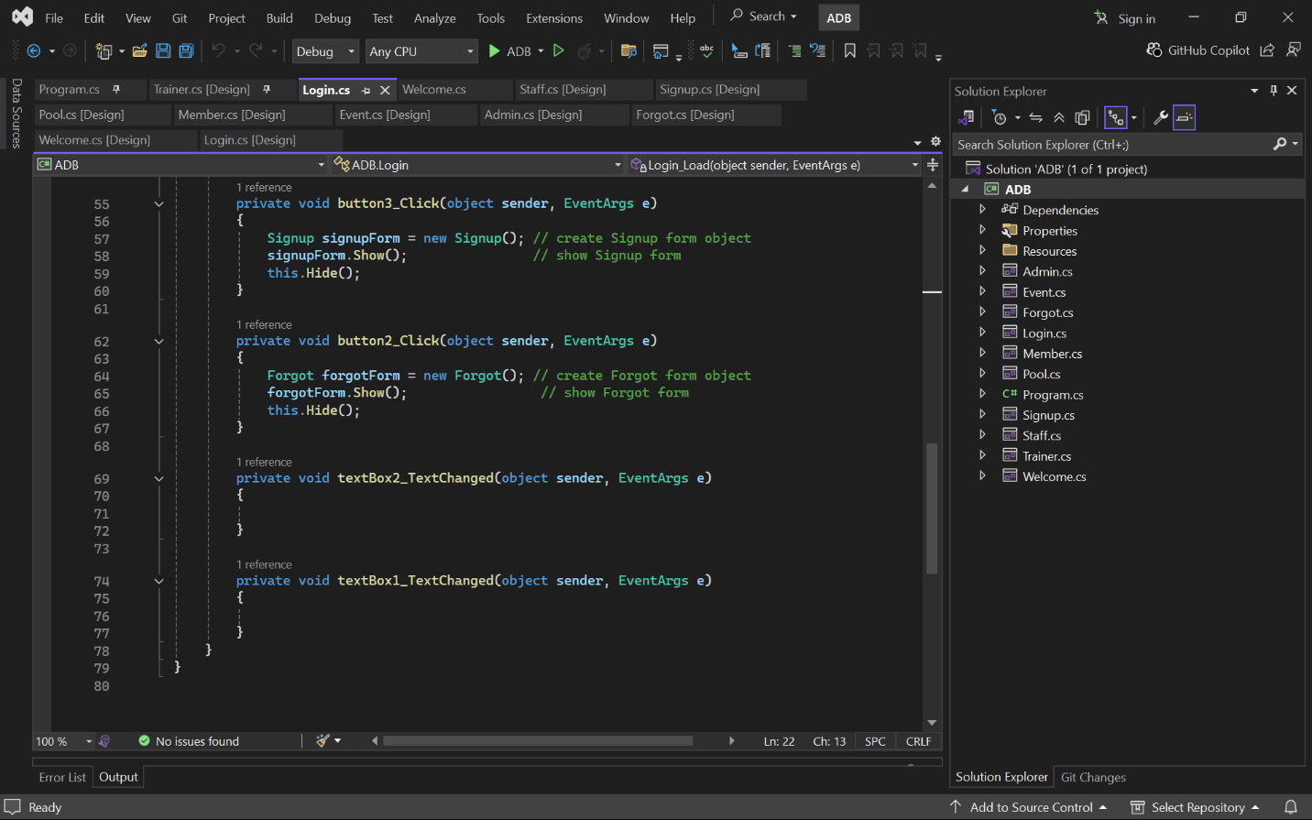

**Signup:**

**Proposed Interface**

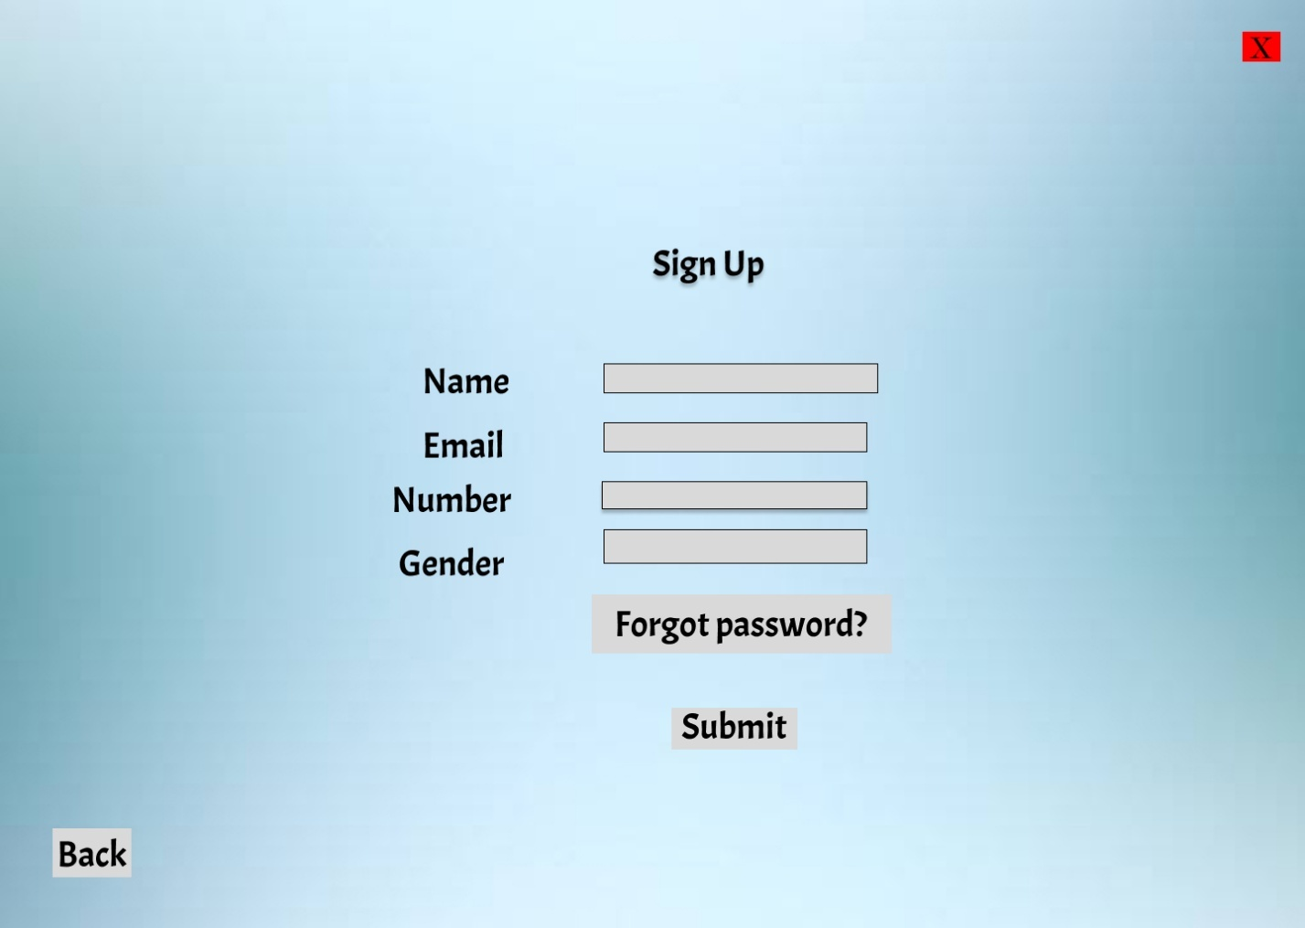

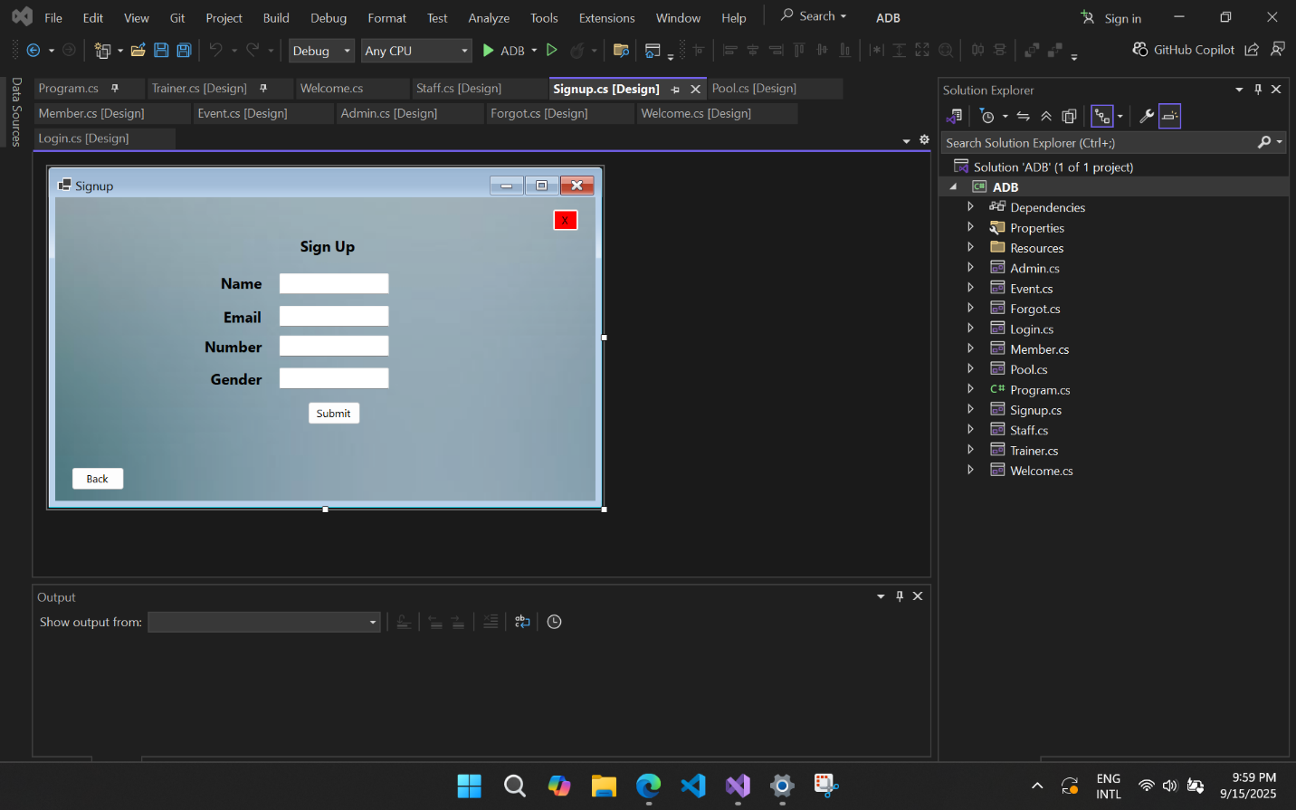**Implemented Interface**

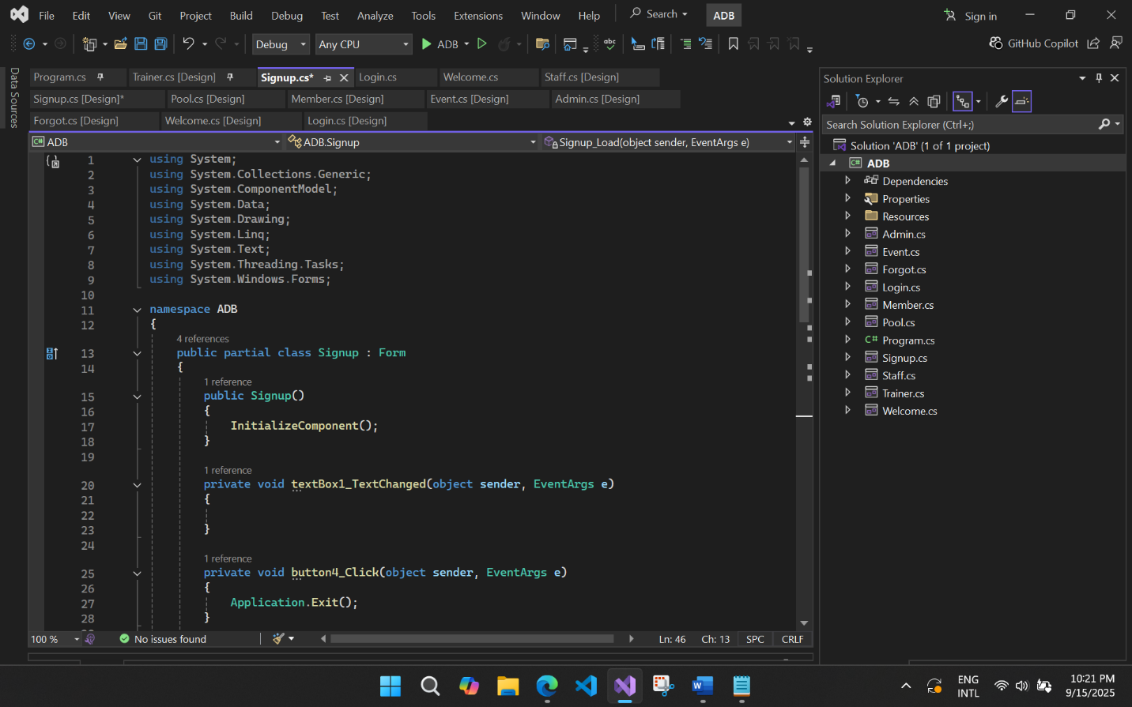**Code**

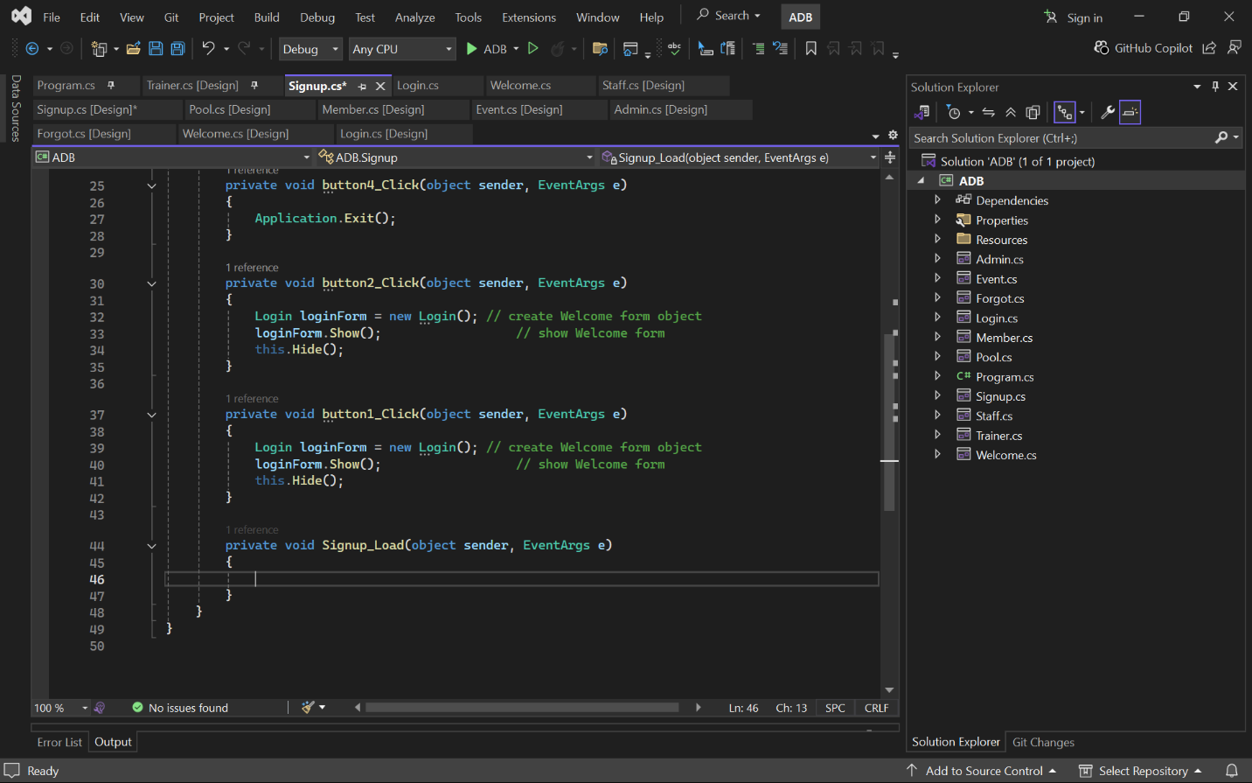

**Welcome:**

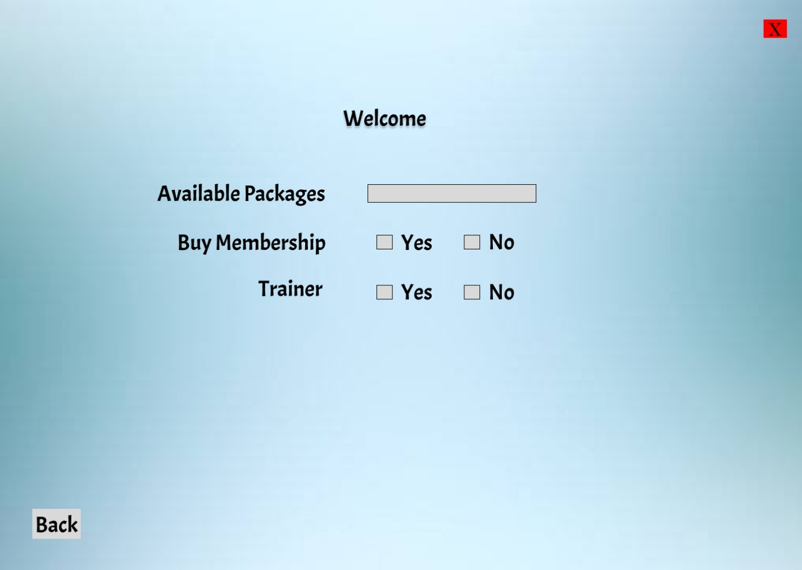**Proposed Interface**

**Implemented Interface**

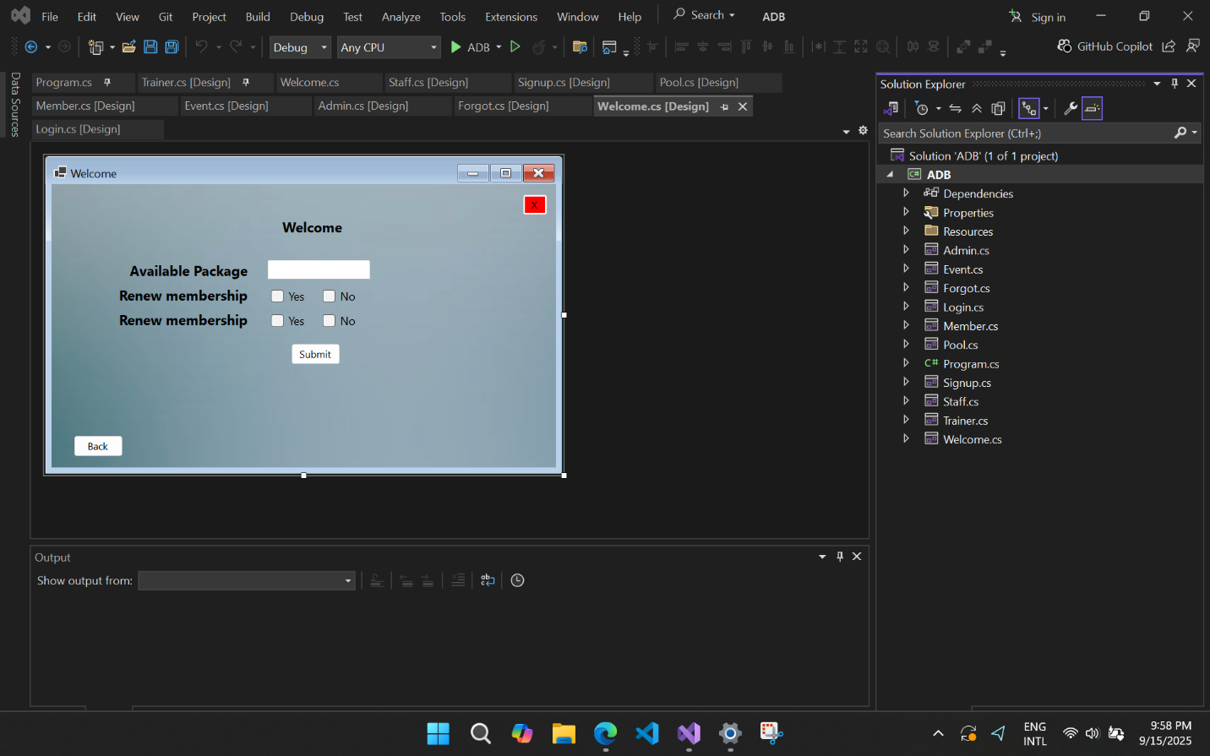

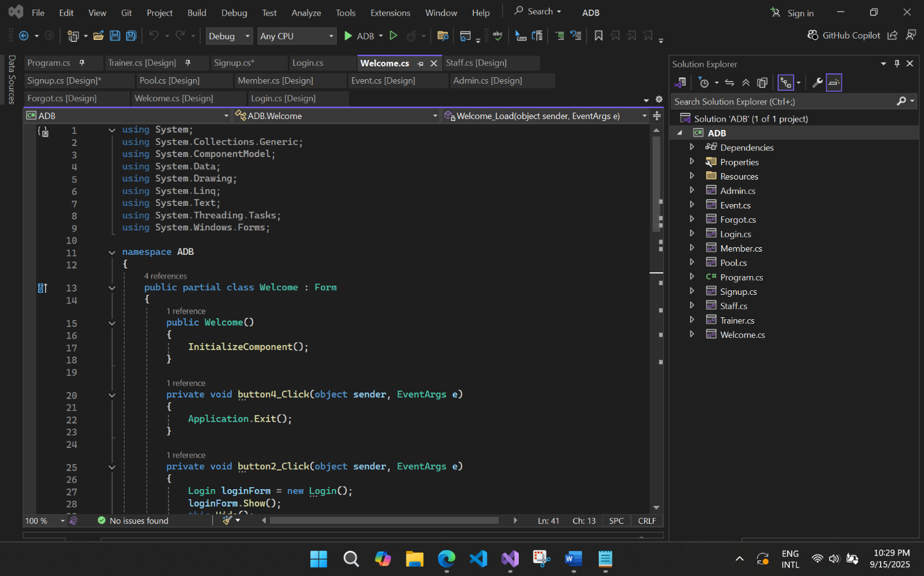**Code**

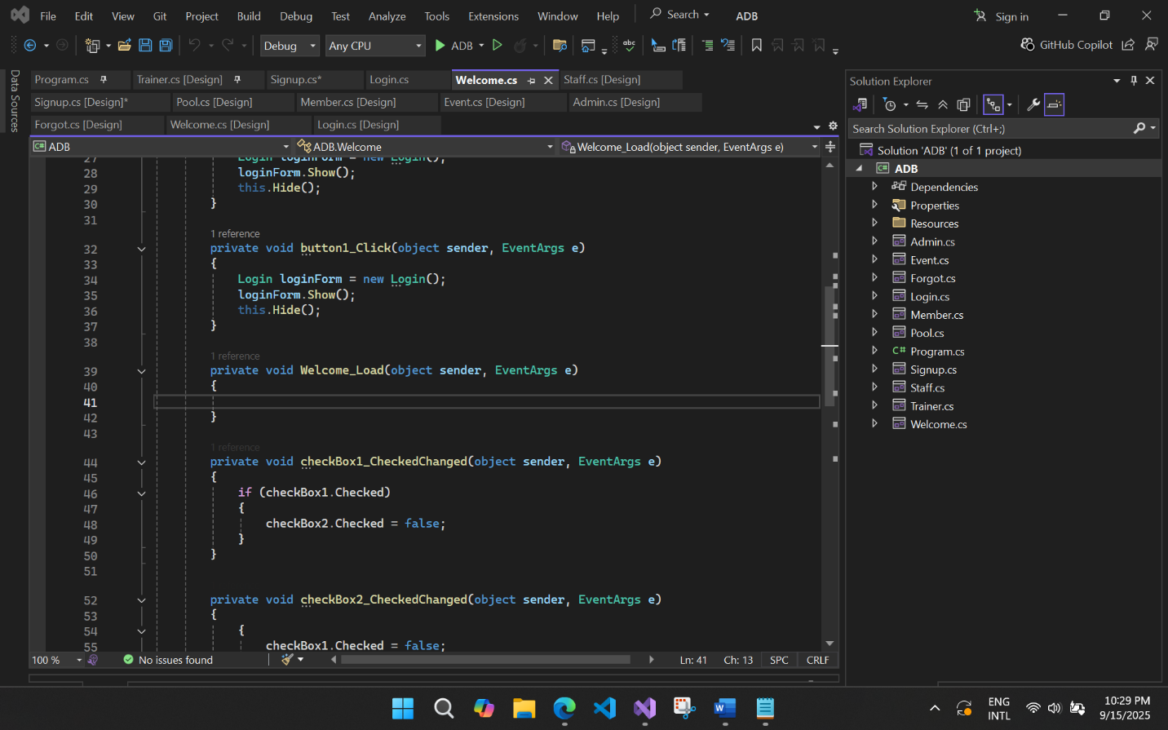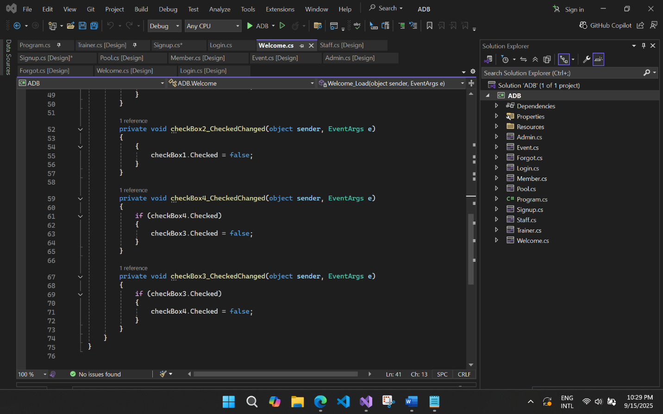

**Admin Dashboard:**

**Proposed Interface**

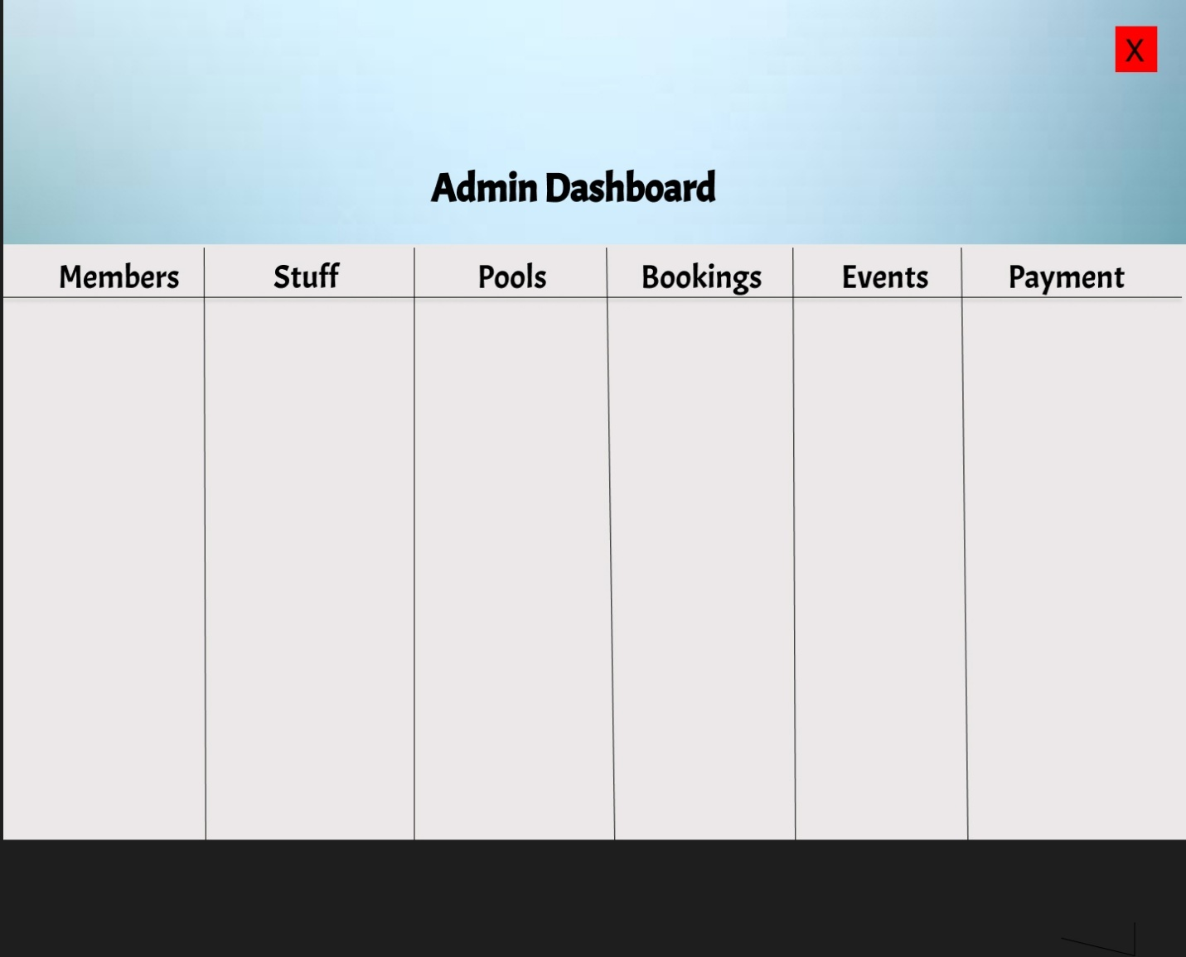

**Implemented Interface**

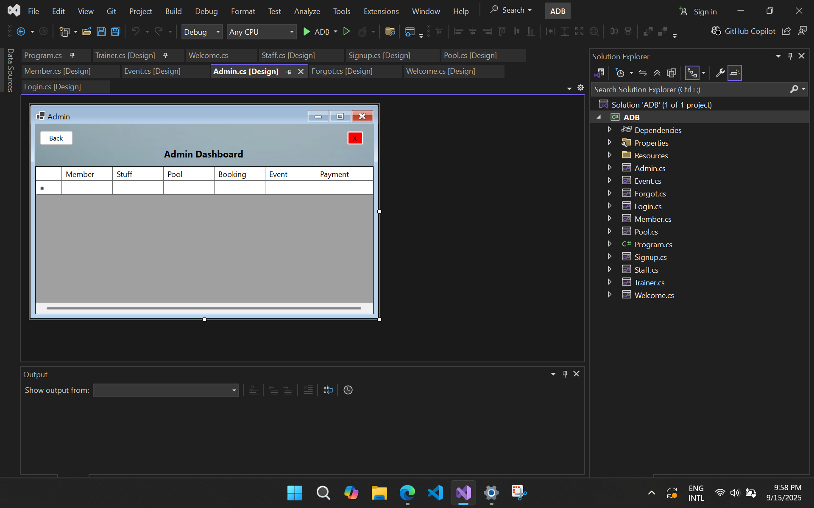

**Code**

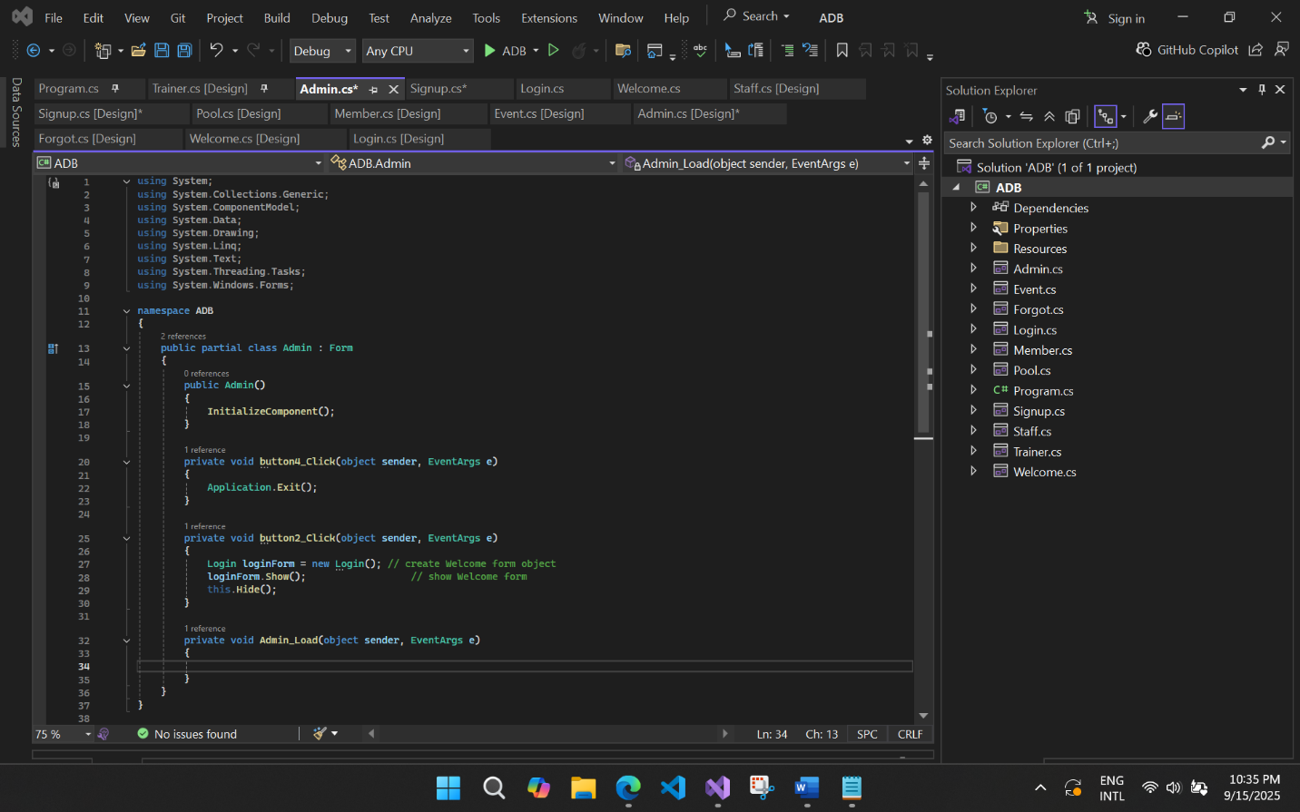

**Event Dashboard:**

**Proposed Interface**

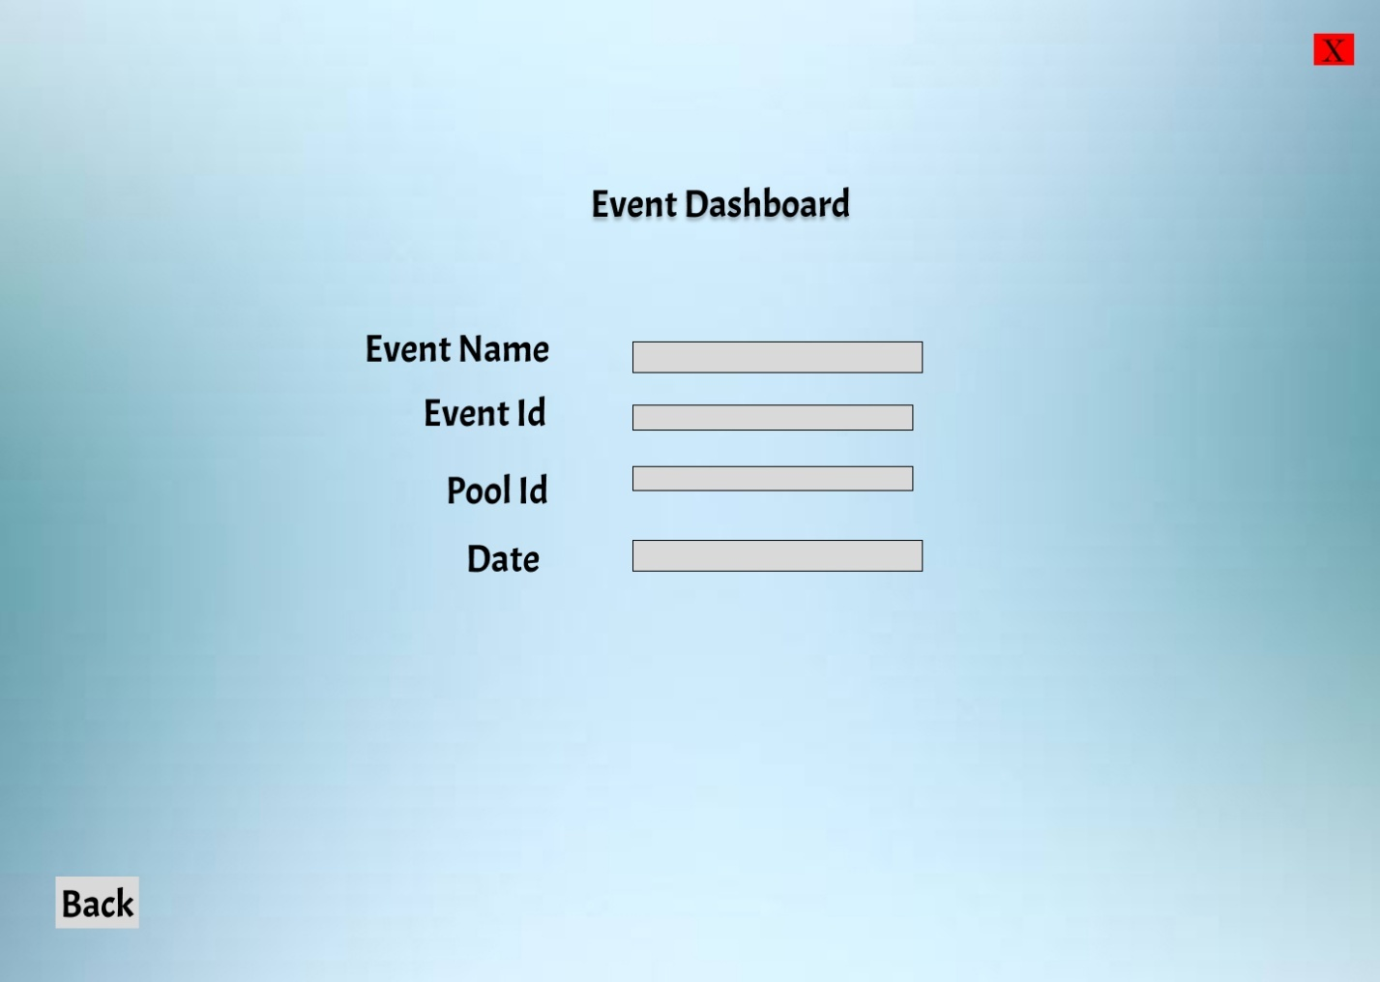

**Implemented Interface**

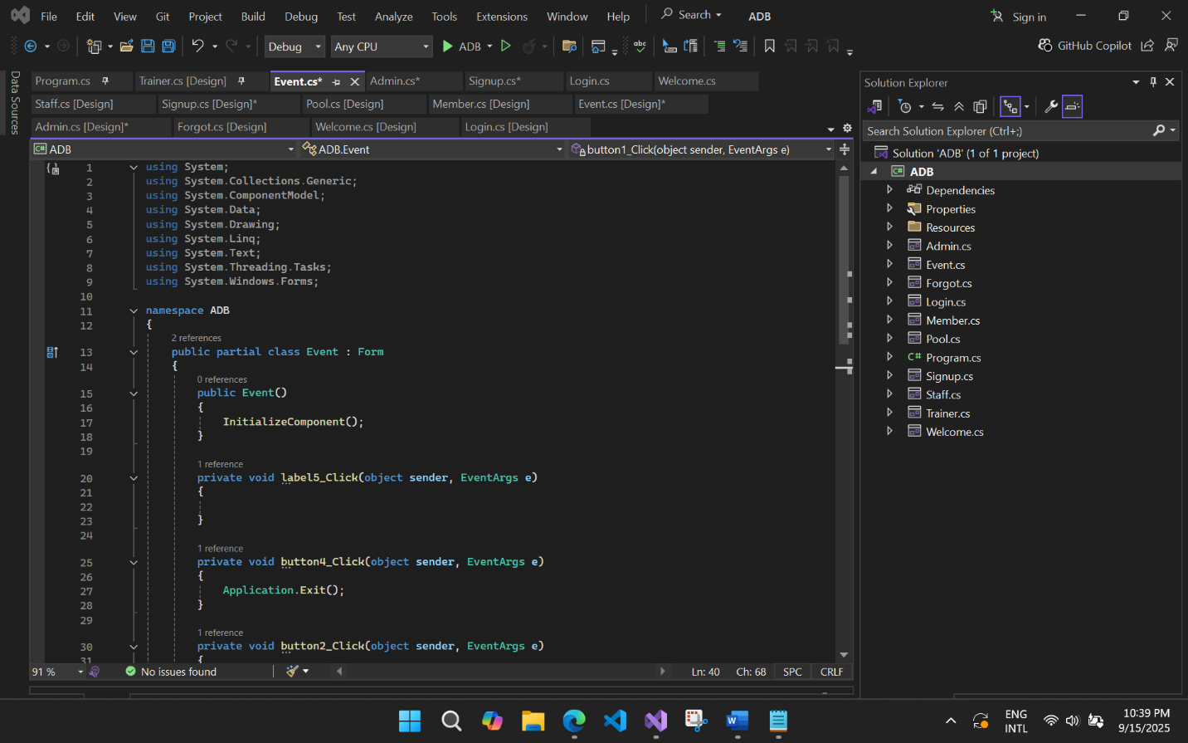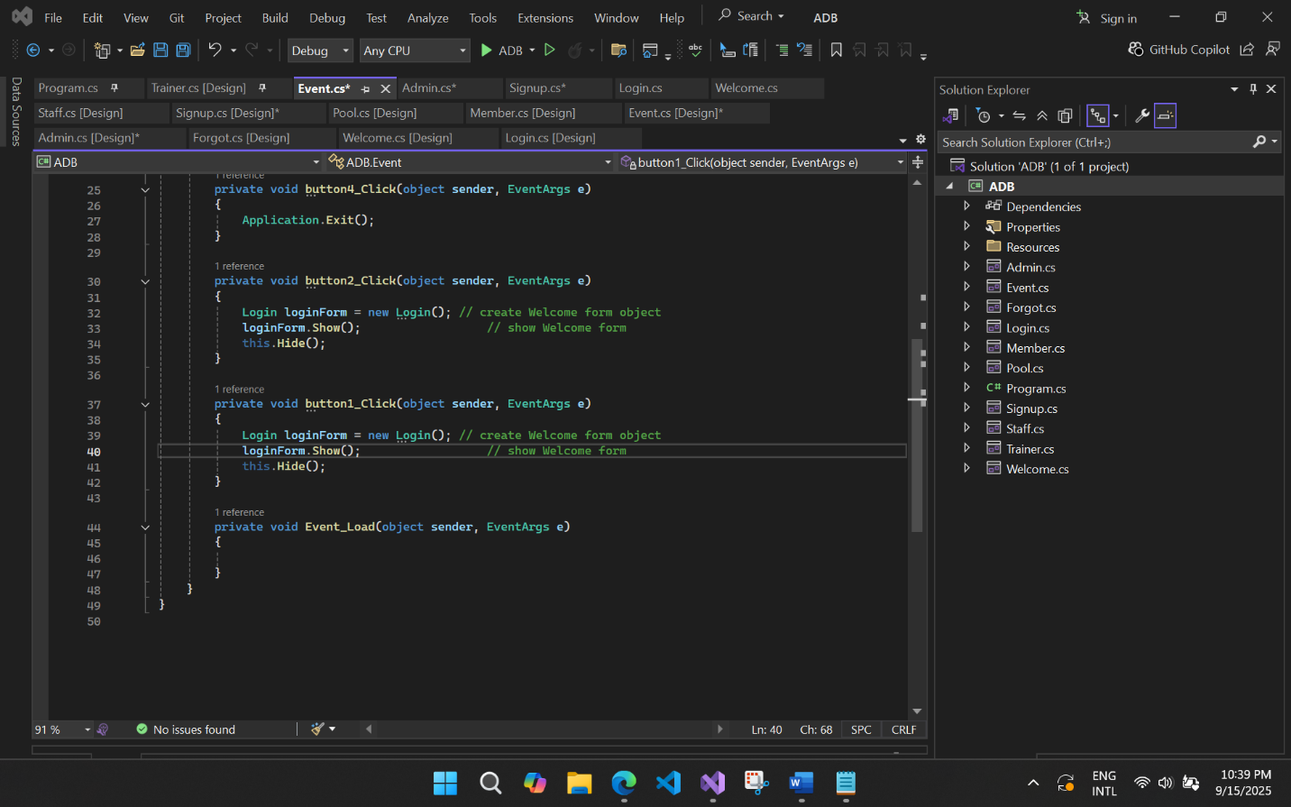

**Member Dashboard**:

**Proposed Interface**

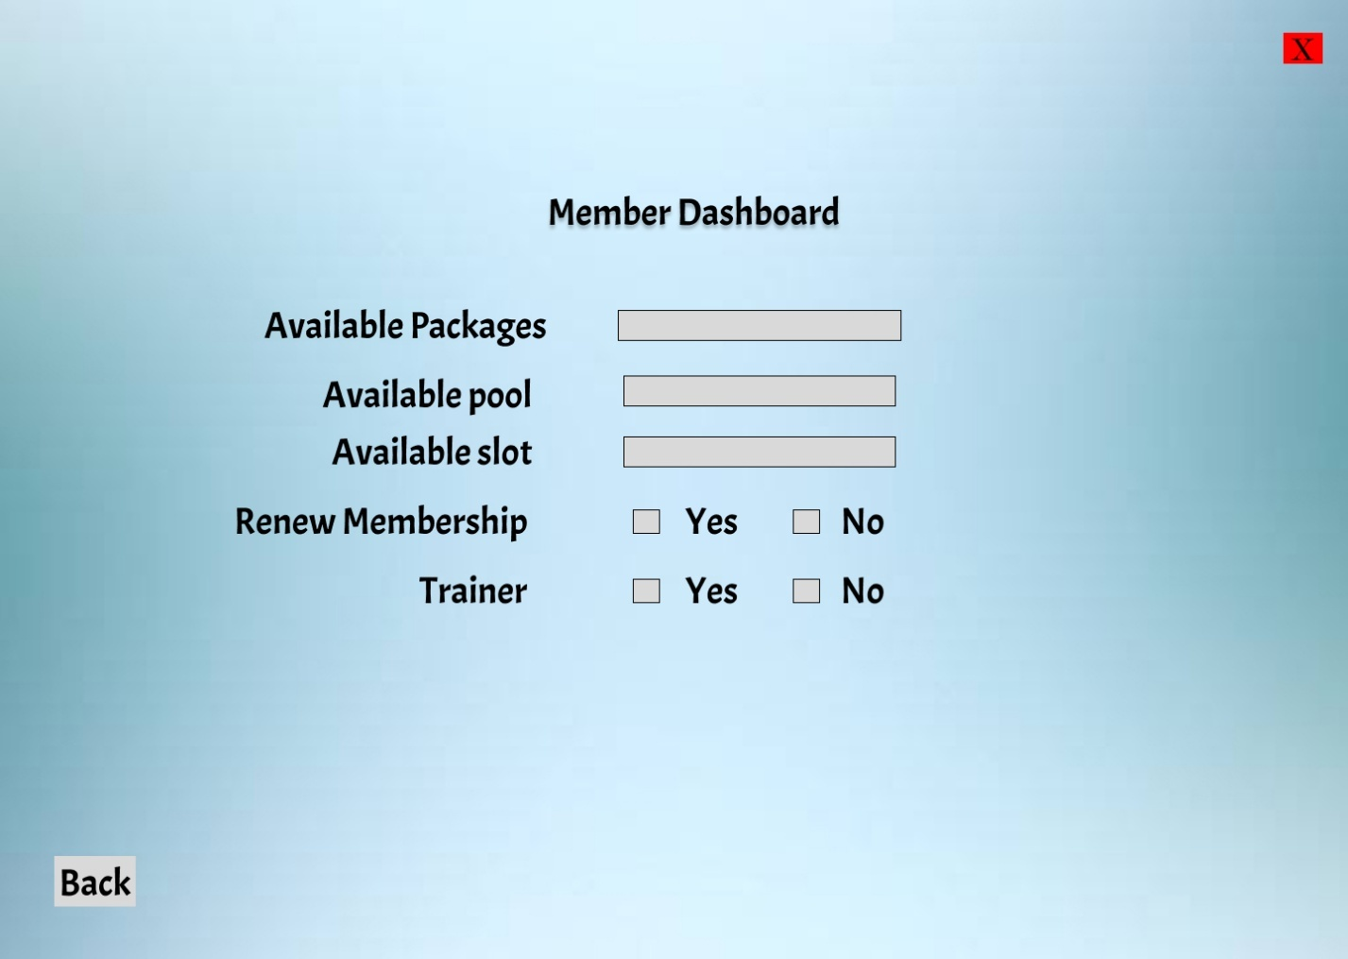

**Implemented Interface**

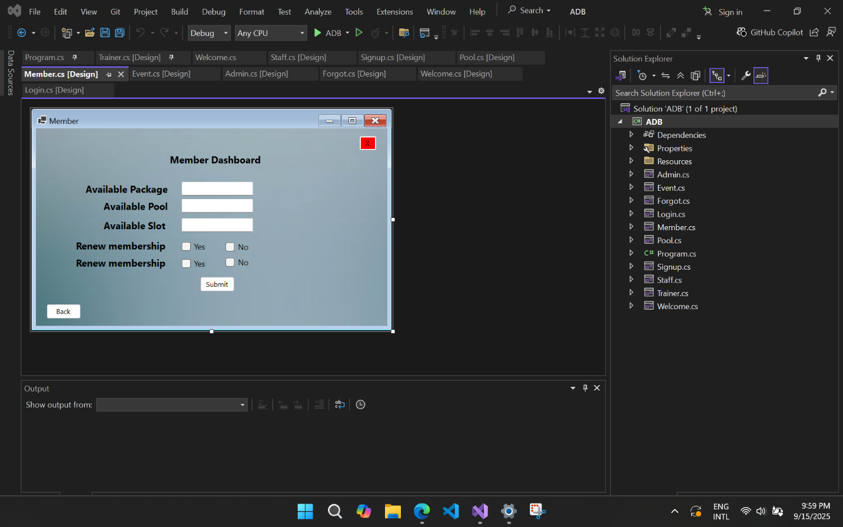

**Code**

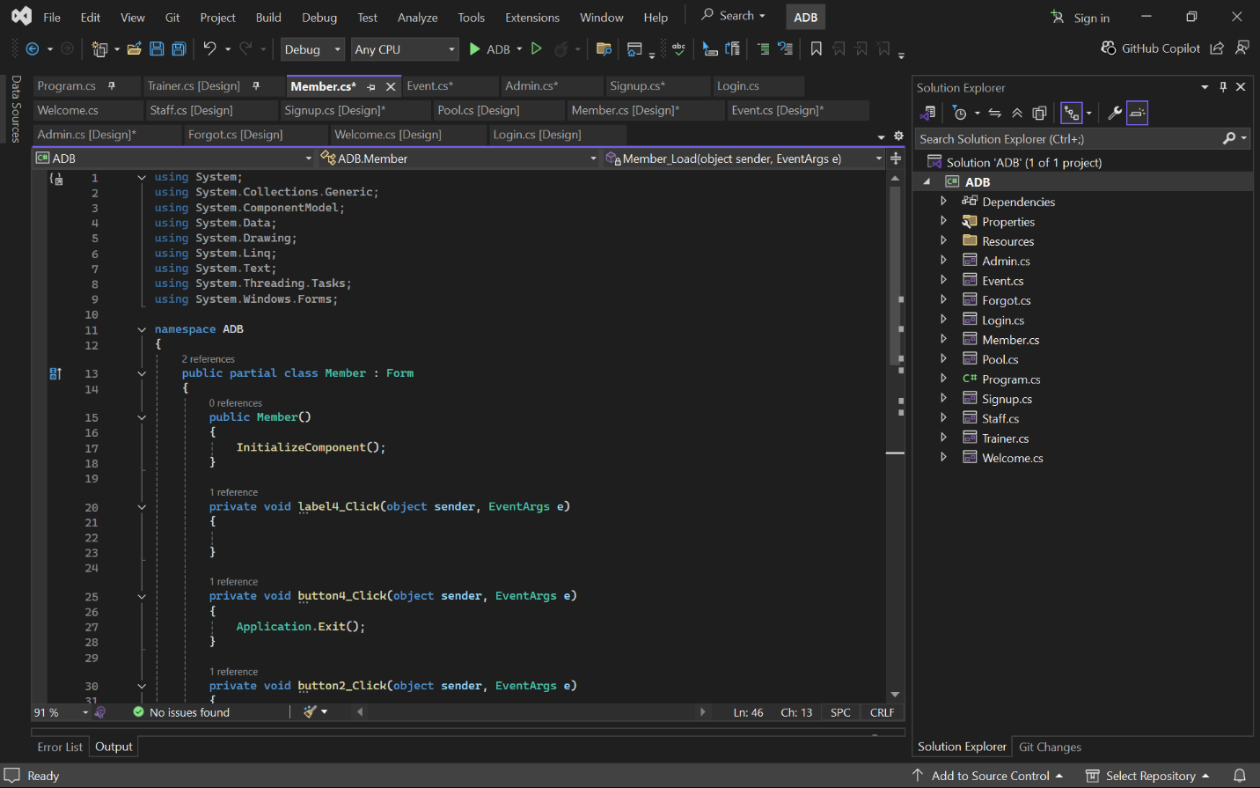

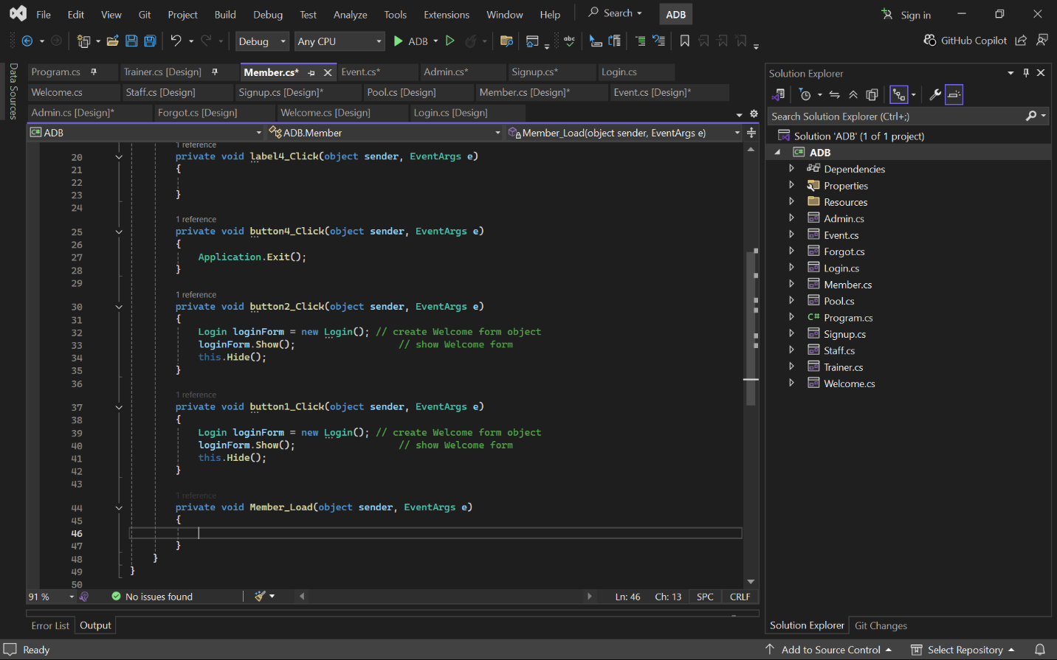

**Pool Dashboard:**

**Proposed Interface**

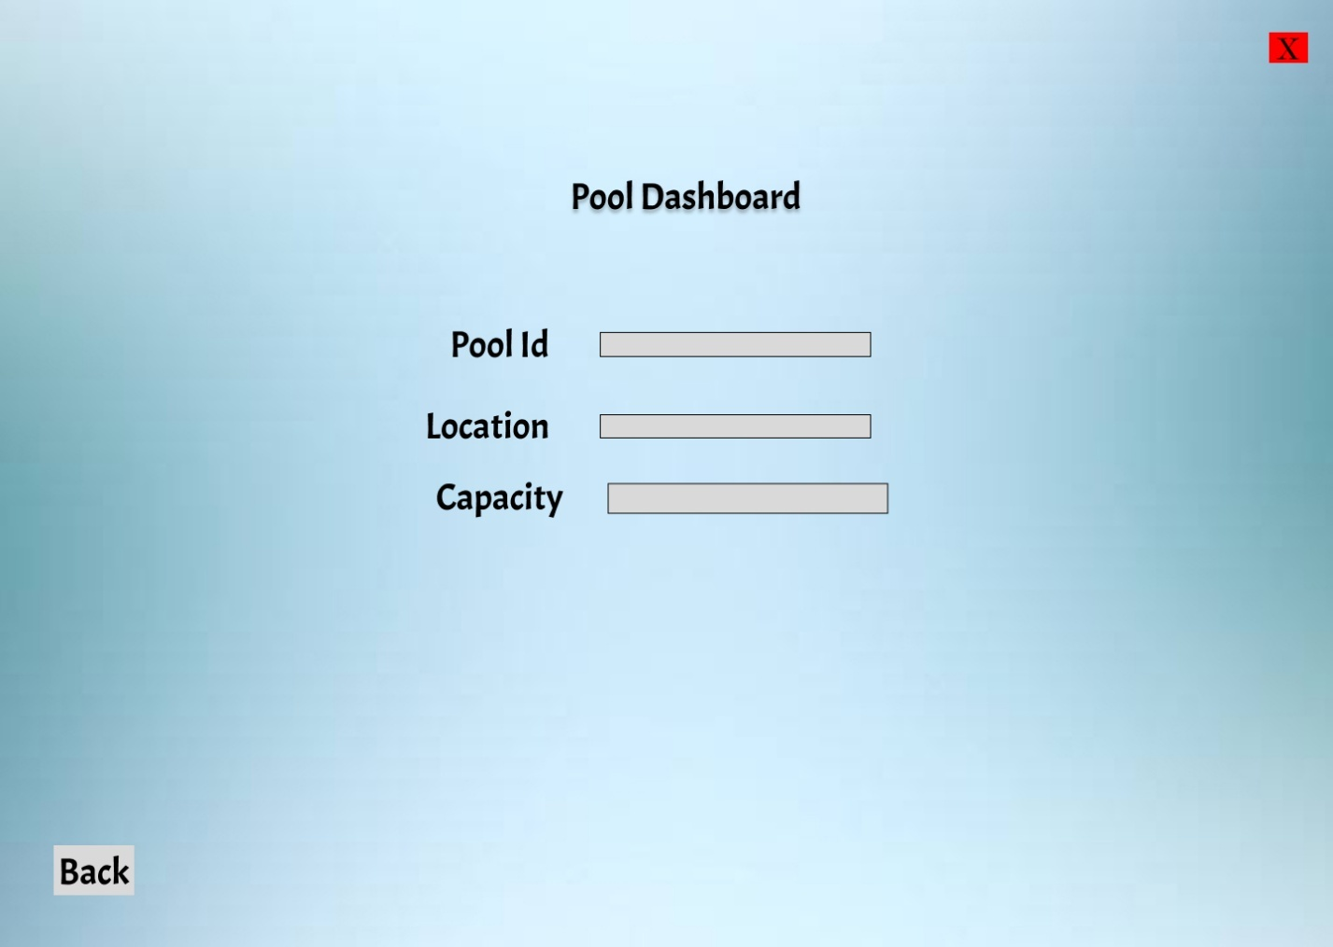

**Implemented Interface**

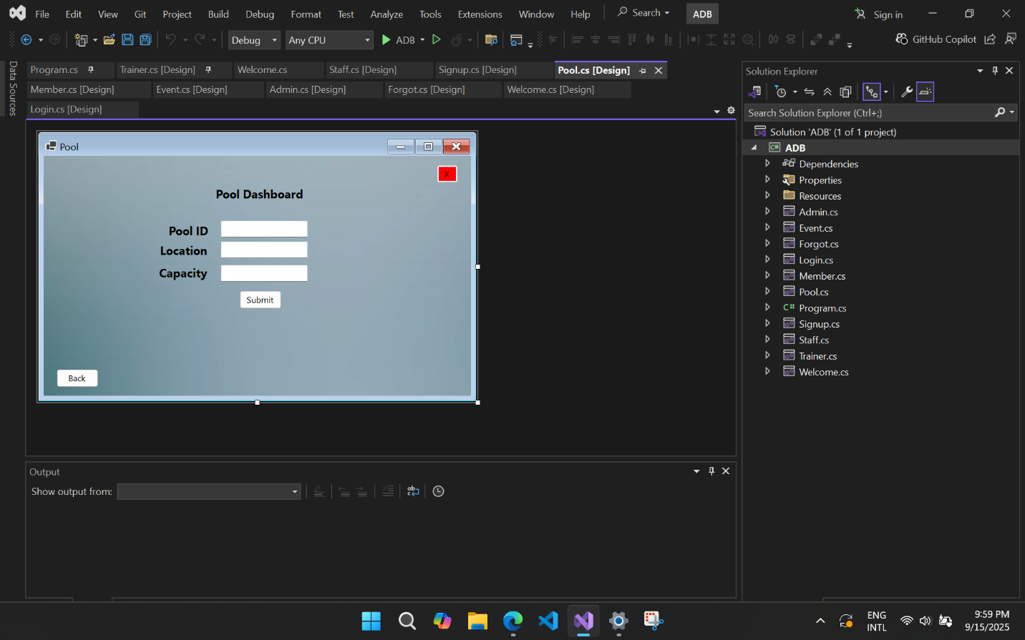

**Code**

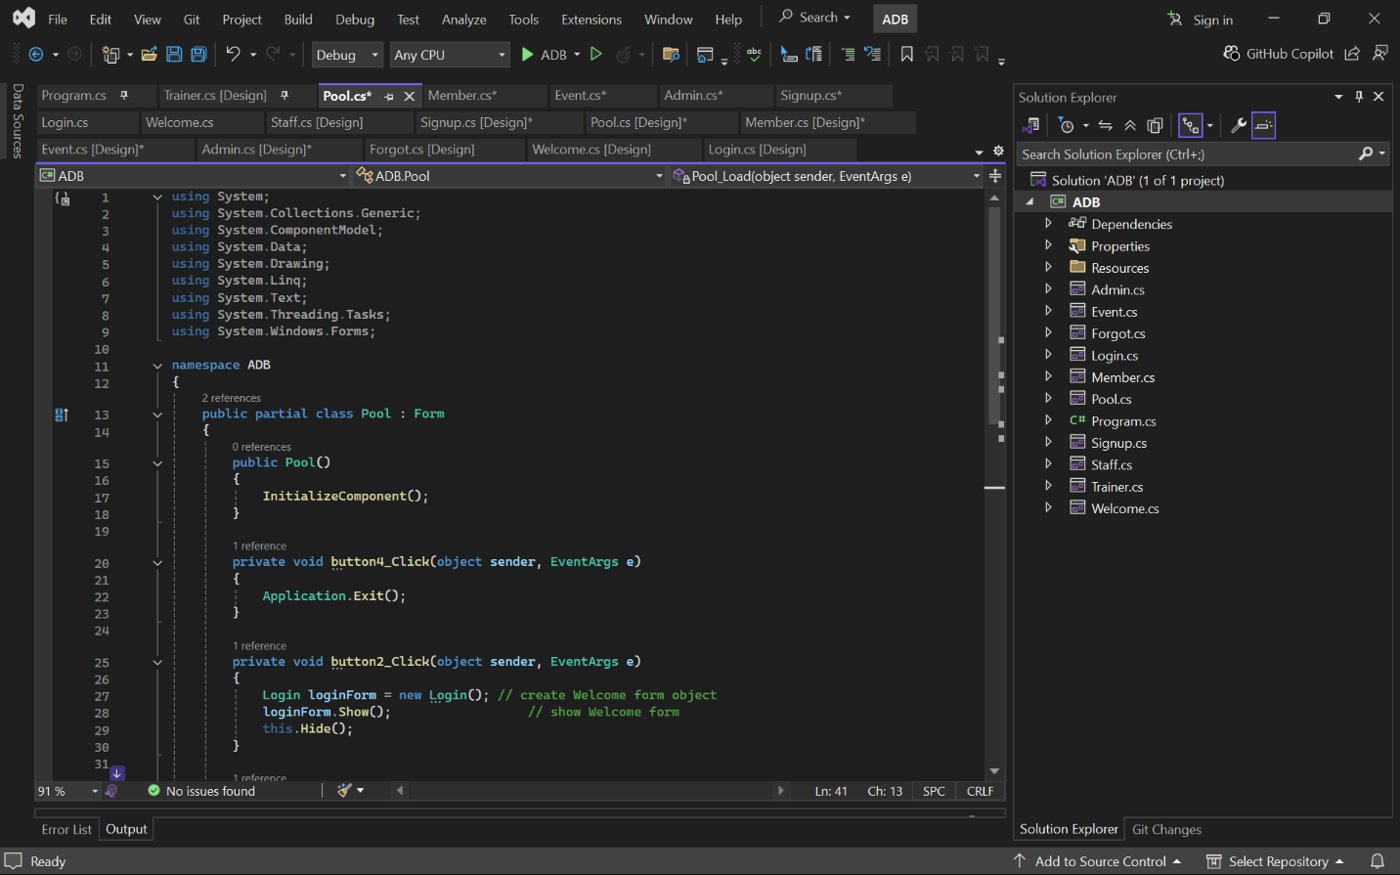

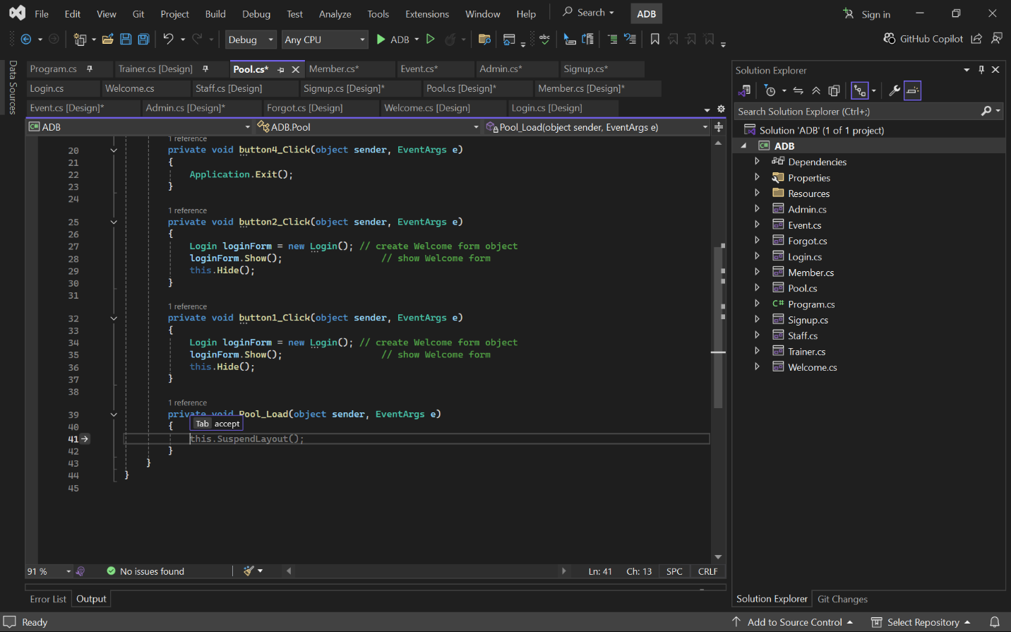

**Staff Dashboard:**

**Proposed Interface**

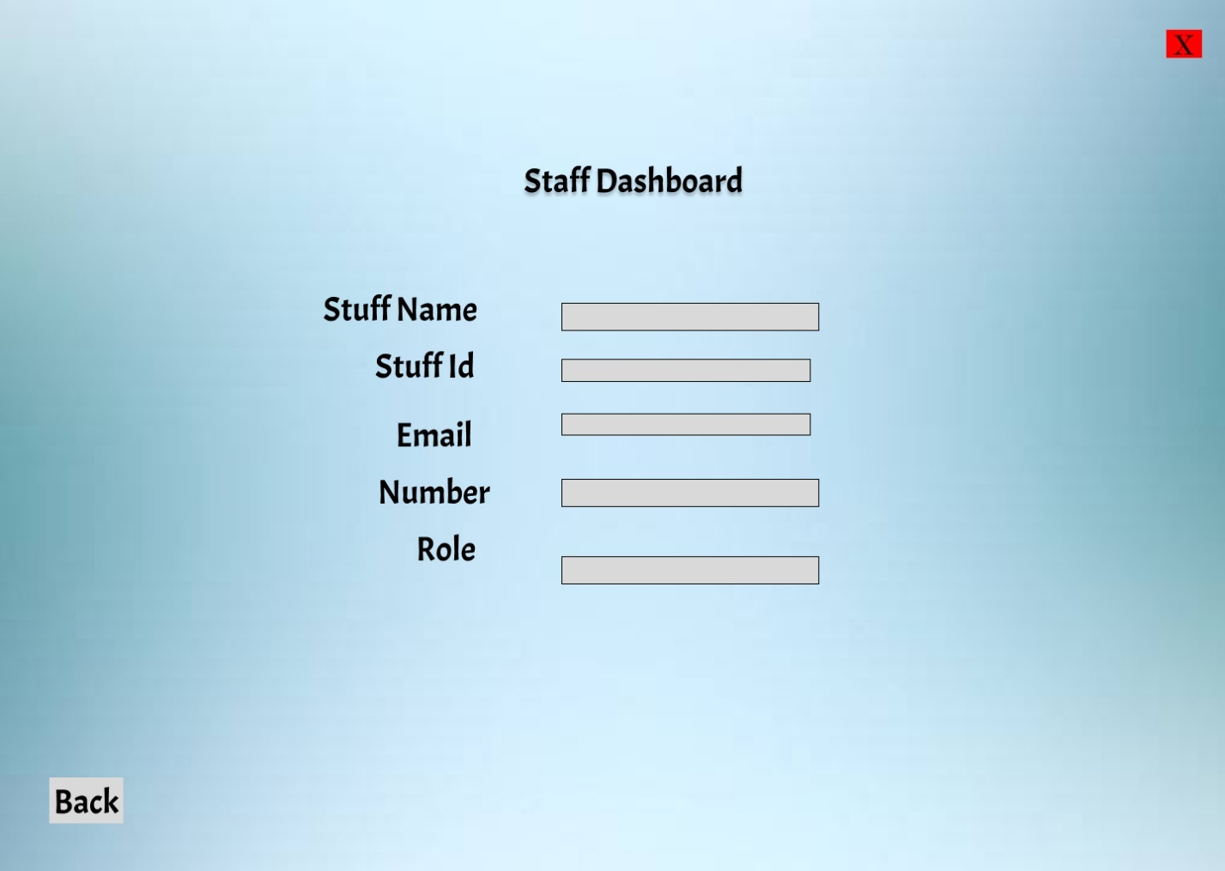

**Implemented Interface**

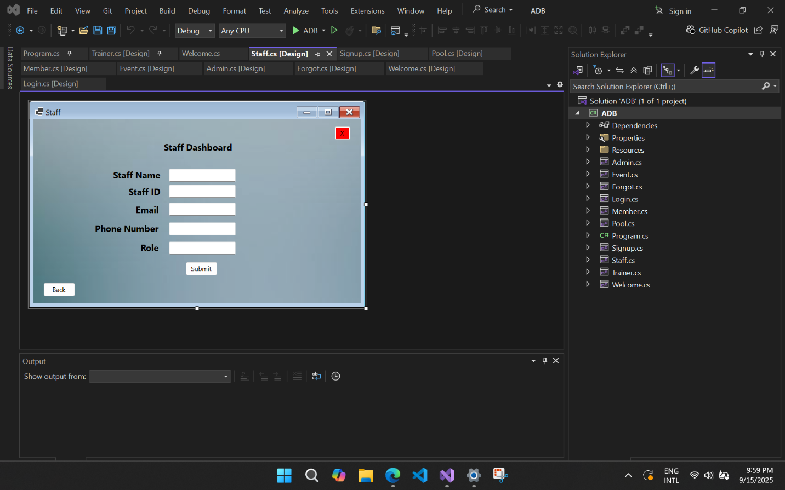

**Code**

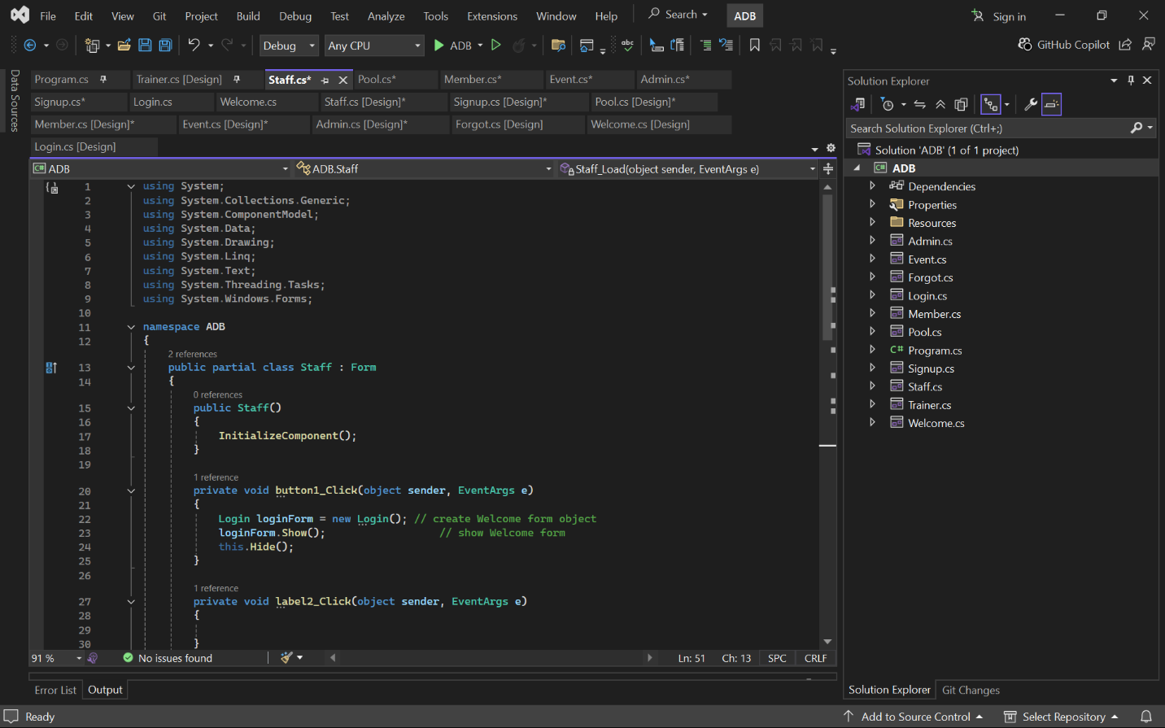

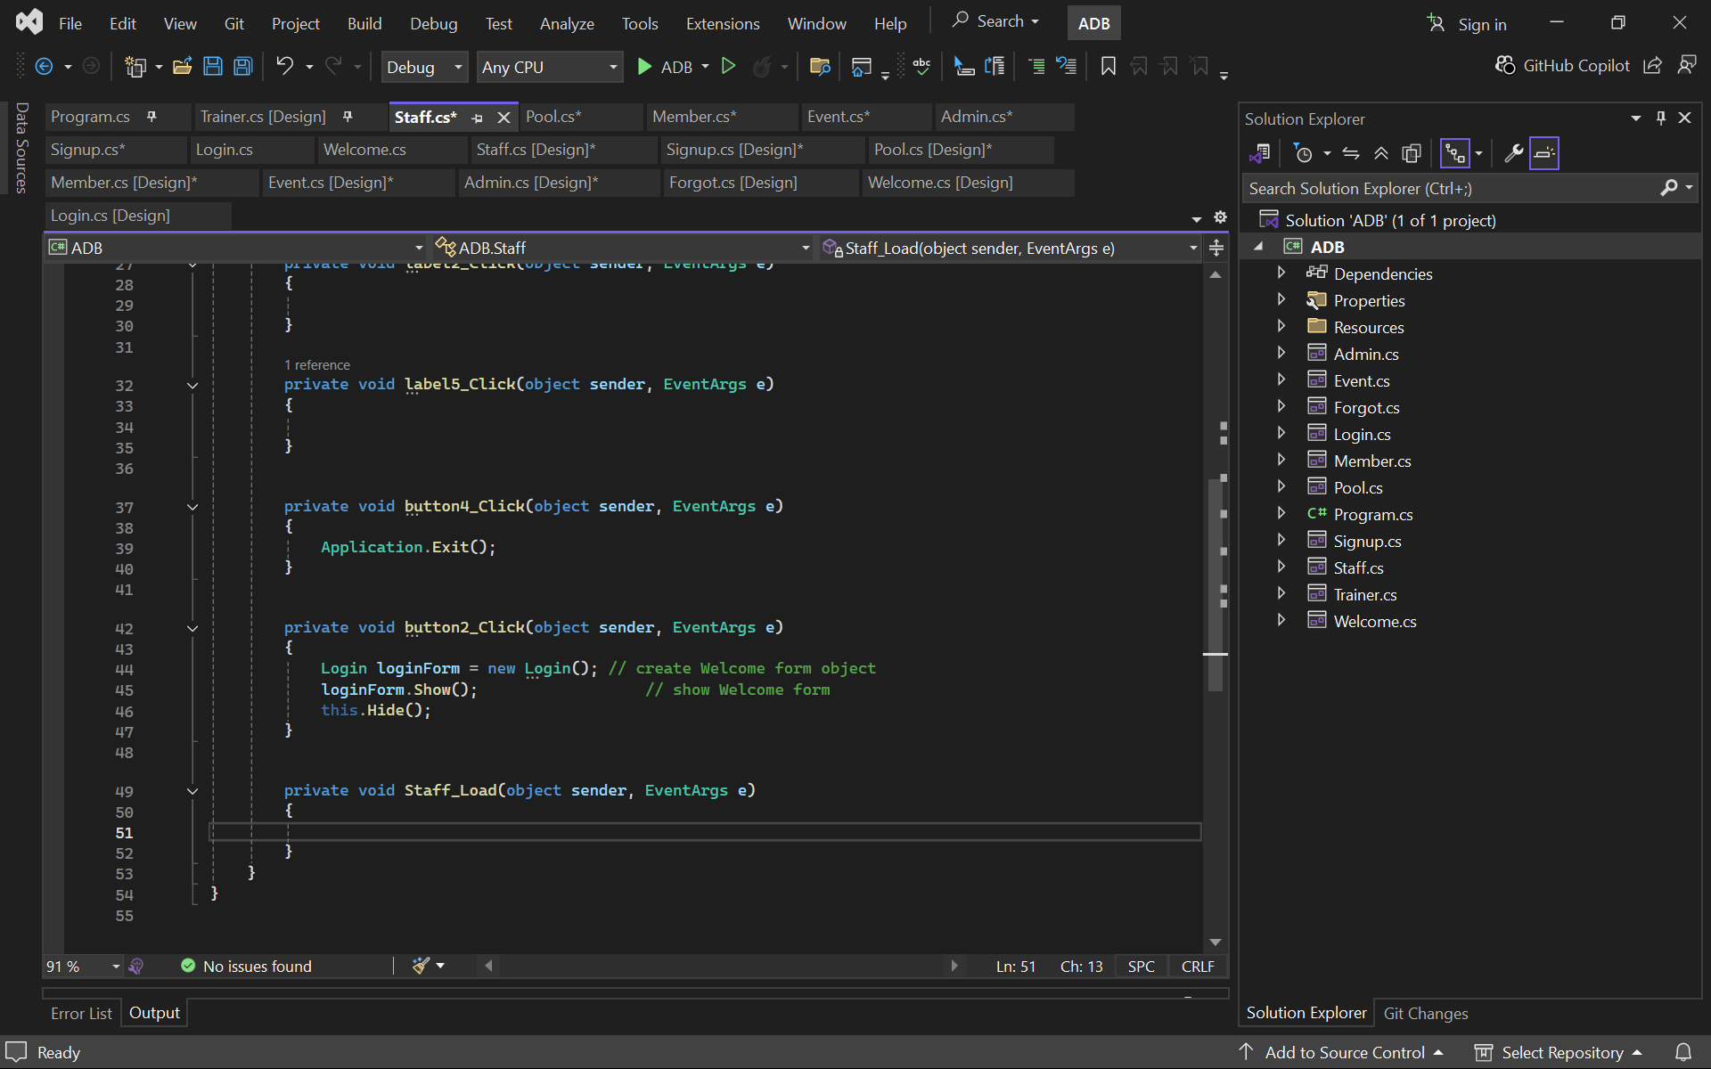

**Main Function:**

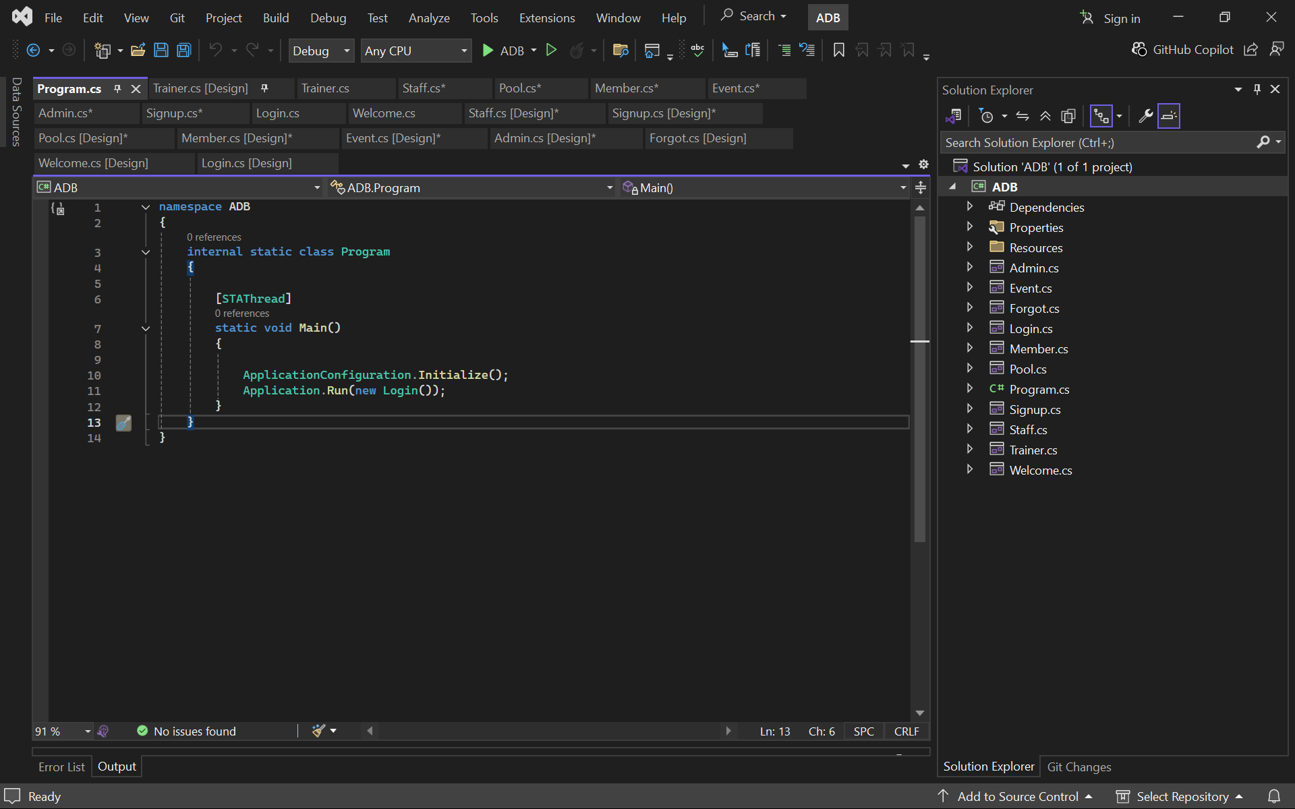

**Forgot Password:**

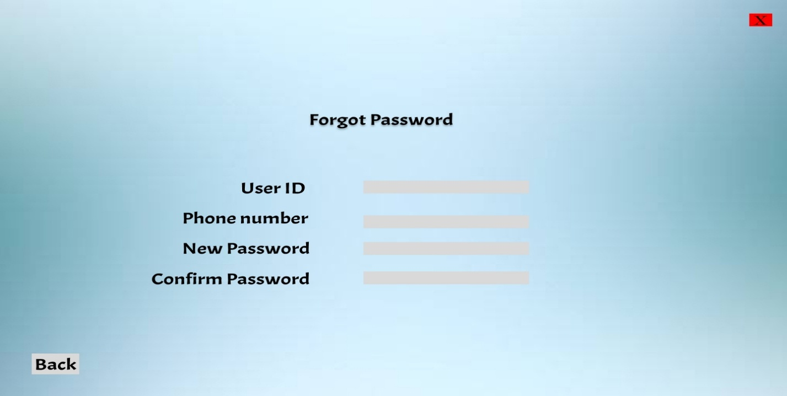Proposed Interface

**Implemented Interface**

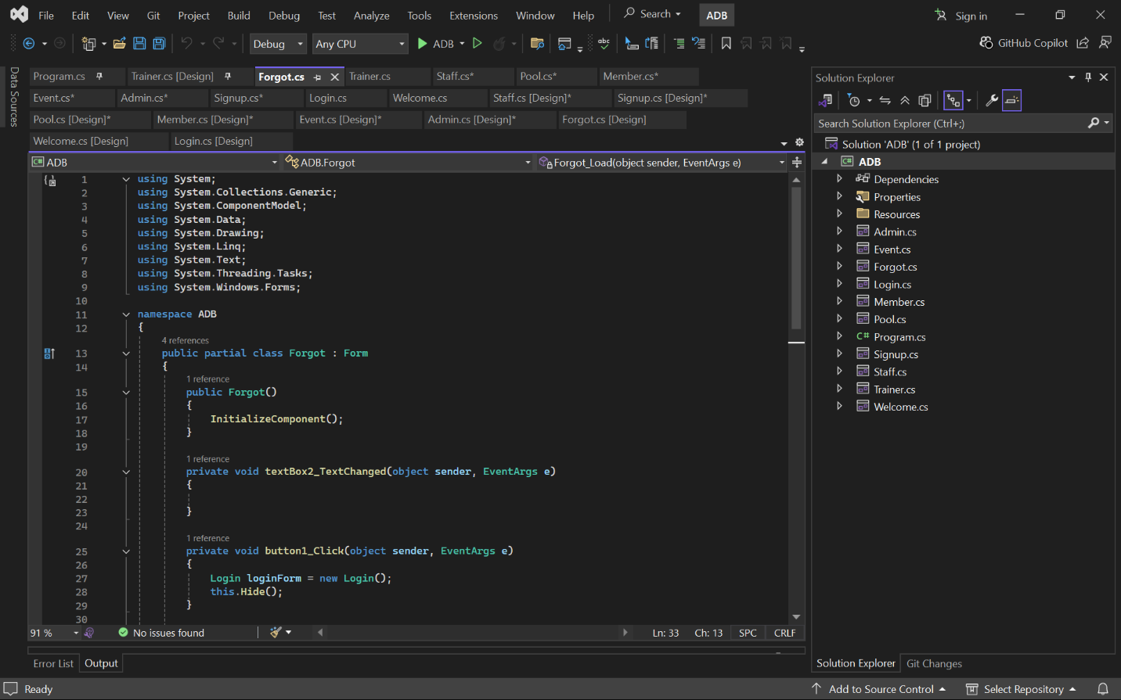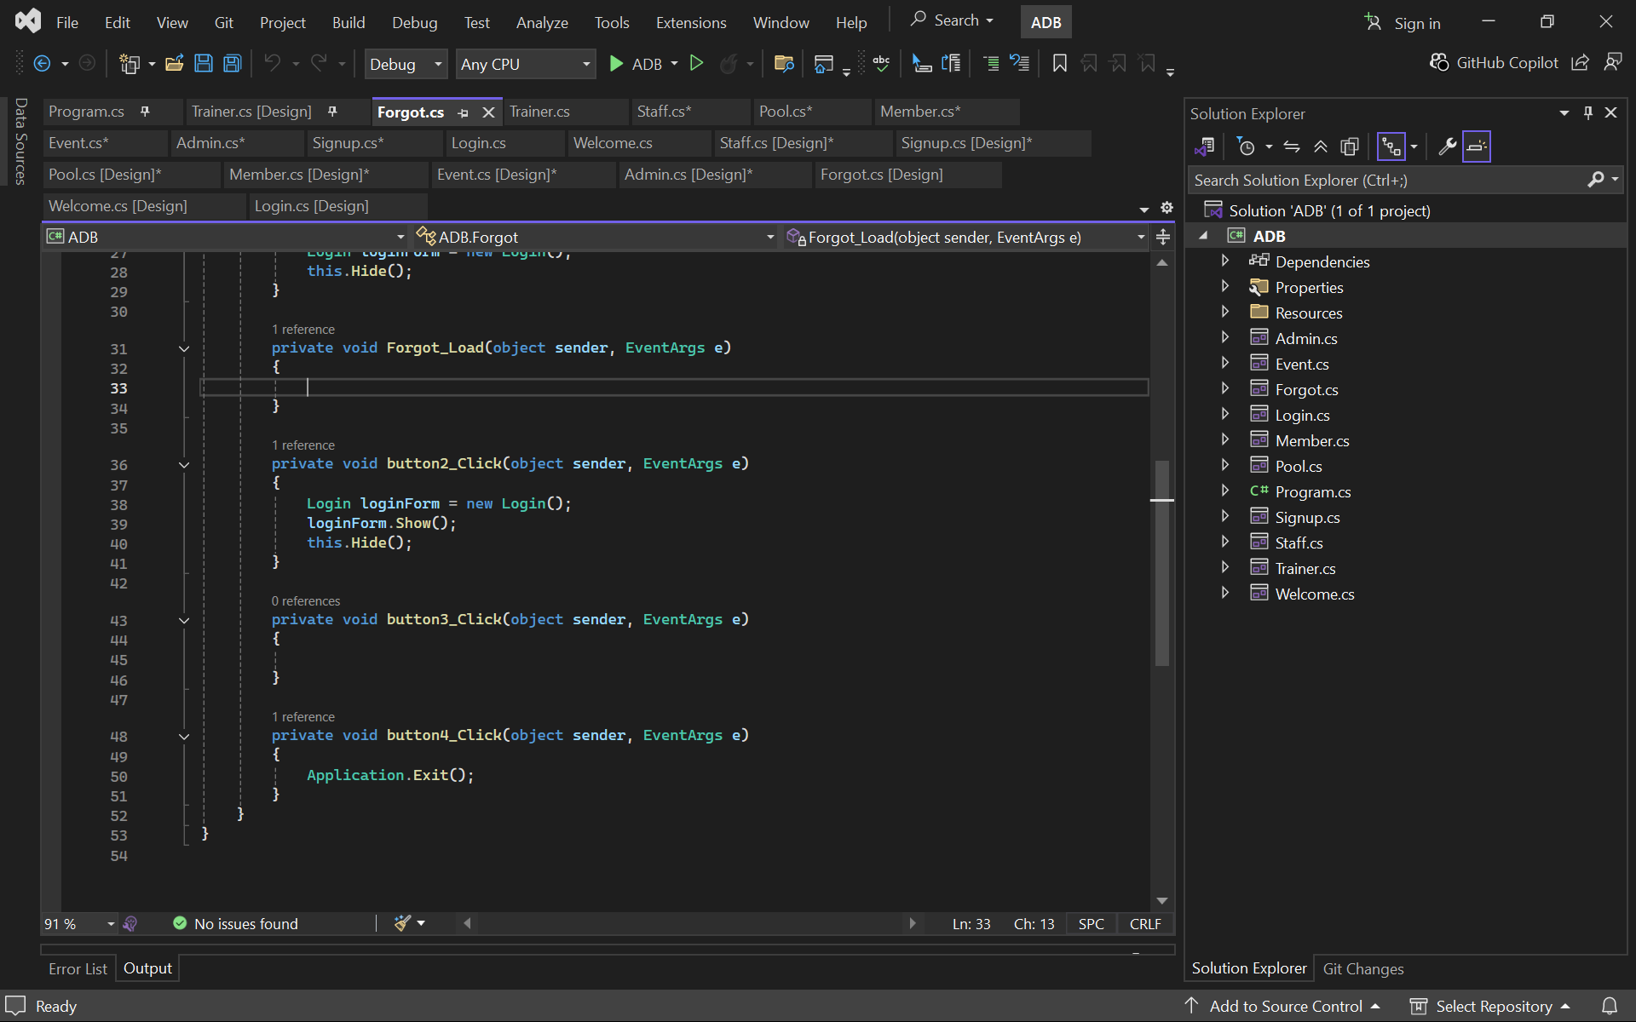

**Trainer Dashboard:**

**Proposed Interface**

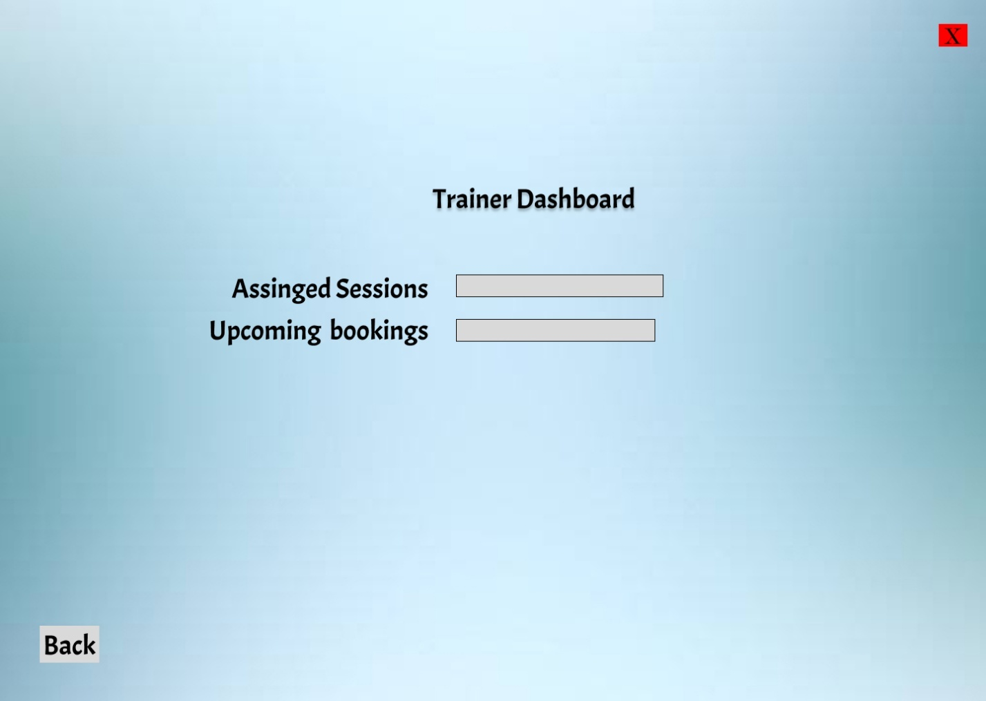

**Implemented Interface**

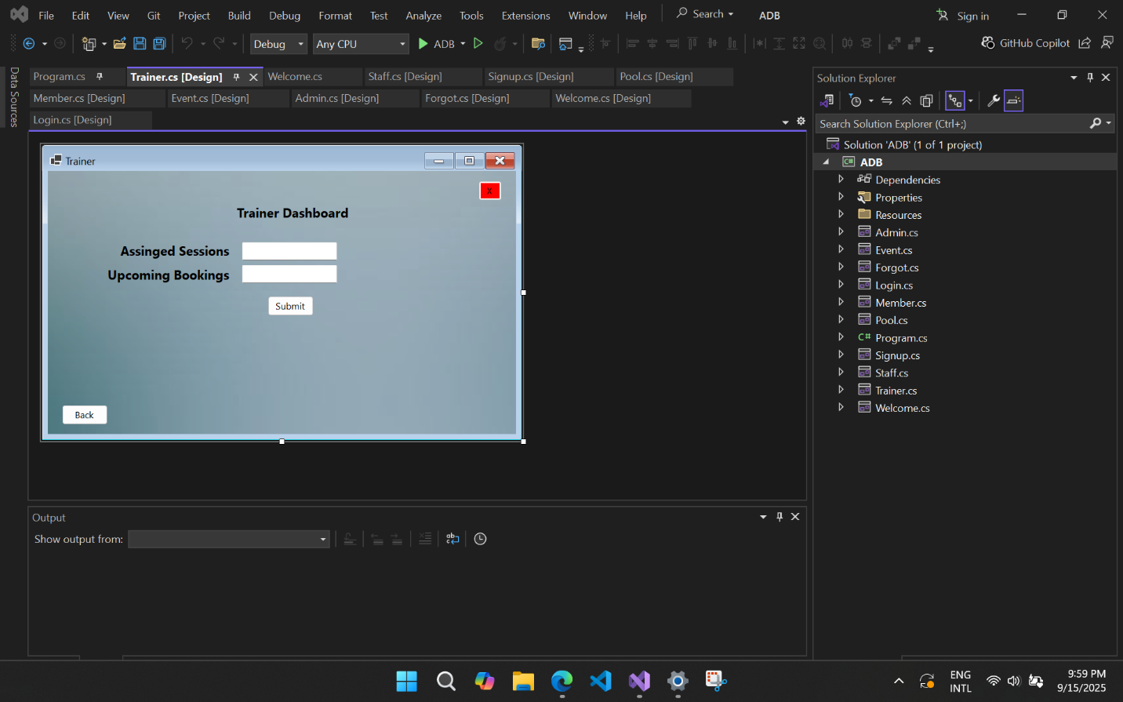

**Code**

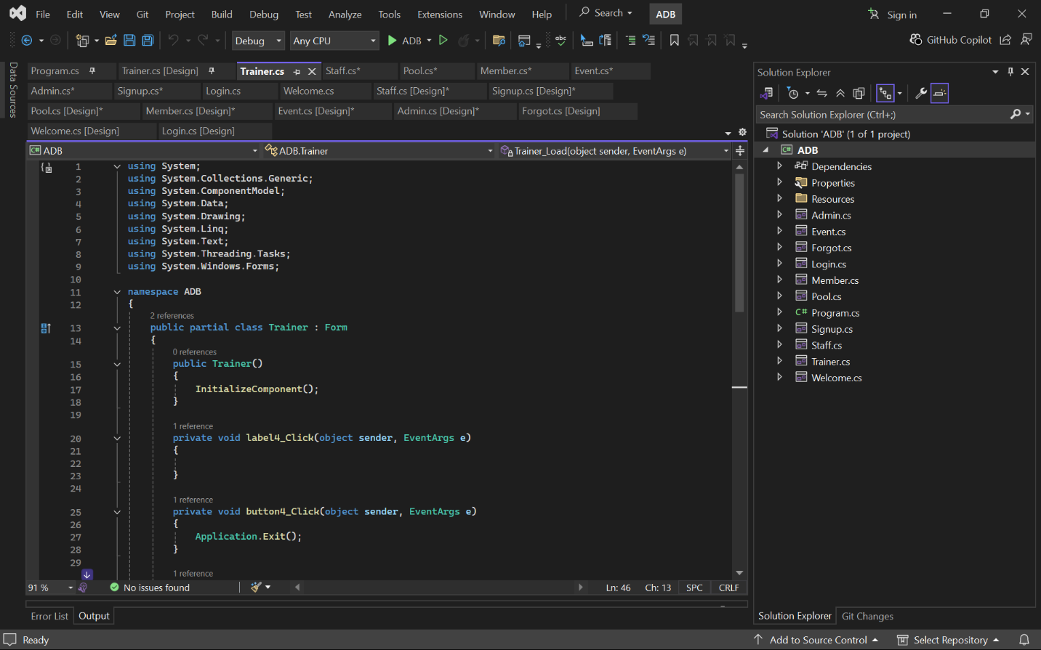

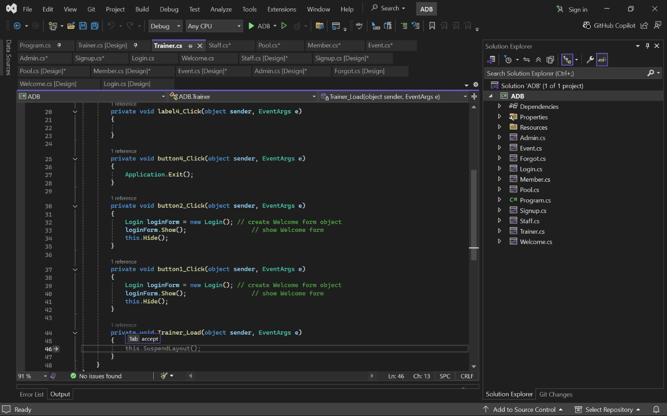

**Main Function:**



**Forgot Password:**

**Proposed Interface**

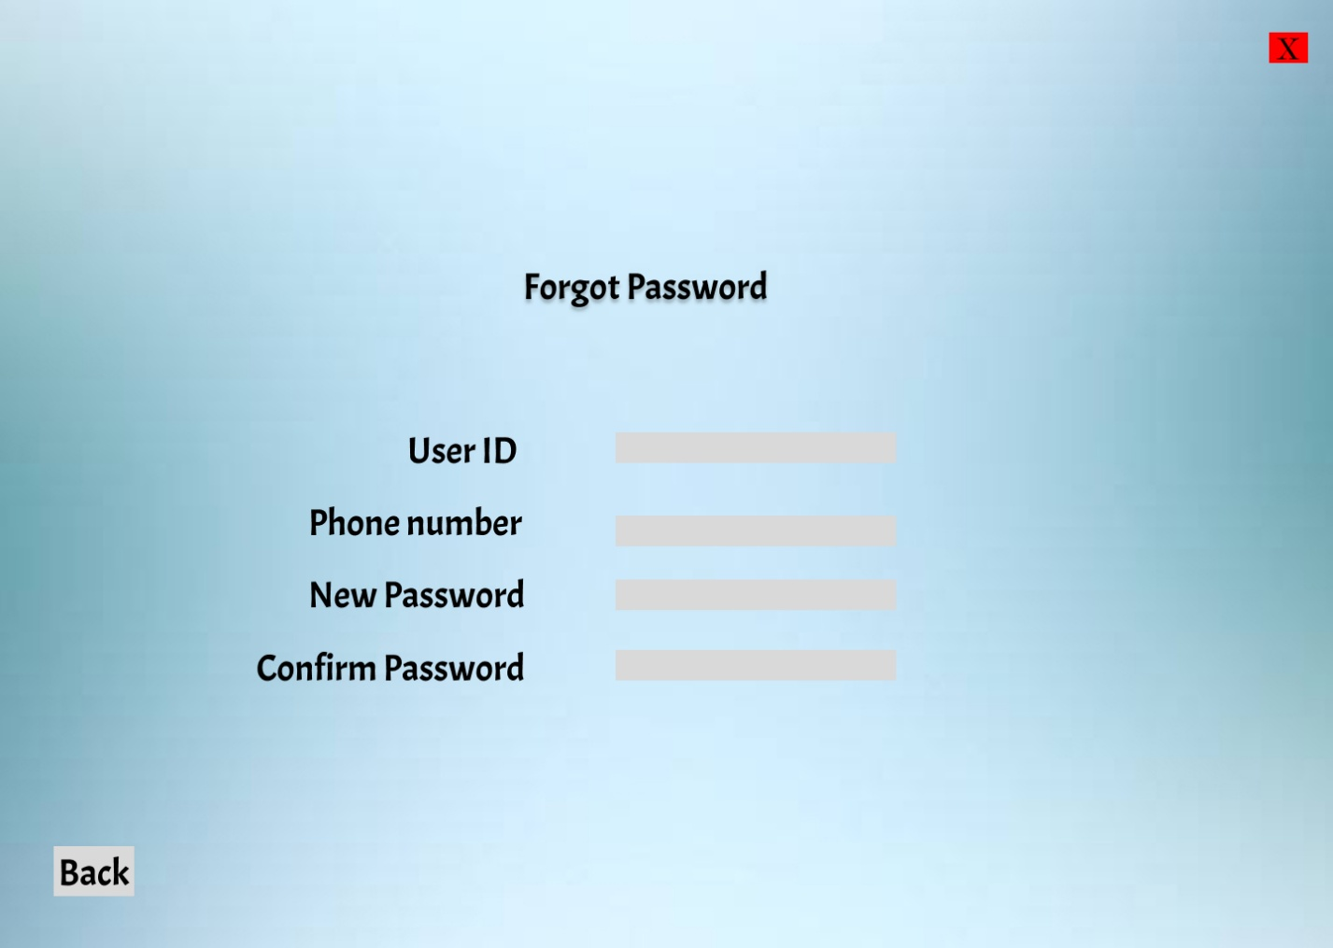

**Implemented Interface**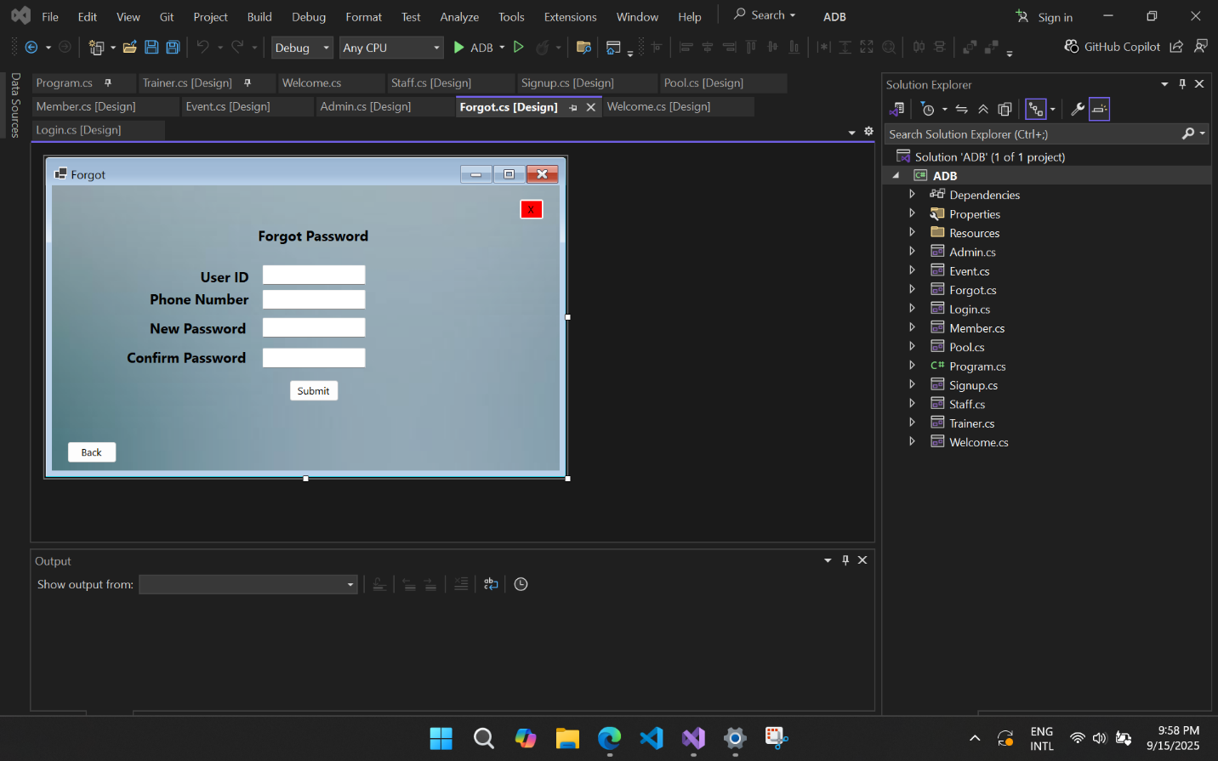

**Code **

**THANK YOU**

**THE END**